Knowledge audit

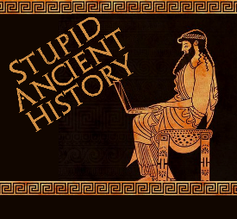
The Persians: 15 Behistun Inscription

Most of these questions can be short answers- the intention is knowledge acquisition and recall rather than
higher level conceptual thinking. Questions marked with a * will require prose answers.

- What is the Behistun inscription and where would you find it?
- What story does it tell?
- What warning does it give?
- Annotate/ label the key aspects of the central image of the inscription

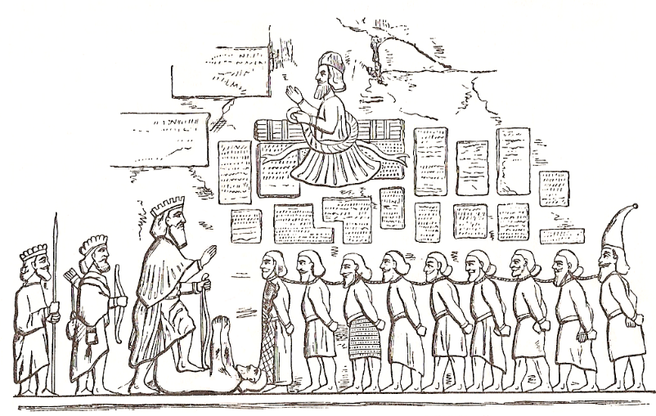

- What languages is the Behistun Inscription written in?
- Why?
- Who is Gaumata?
- What does the inscription say about what happened to those who revolted against Darius?
- What does Darius say about how he will rule his empire?
- Why might the events outlined in the Behistun inscription not be 100% reliable?

