Knowledge audit

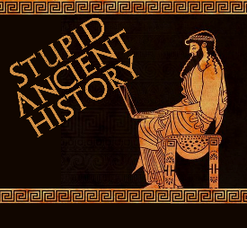
The Persians: 17 Darius and the
Scythians

Most of these questions can be short answers- the intention is knowledge acquisition and recall rather than
higher level conceptual thinking. Questions marked with a * will require prose answers.

- Name 2 places conquered by Cyrus and one by Cambyses.
- Aside from living up to the standards set by Cyrus, why else did the Persian Empire need to expand?

- Briefly outline why it was more difficult for Darius to expand his empire than previous kings.*

- Whilst in bed, what does his wife Atossa suggest he should do?
- Who does Darius think he should attack first?
- Where are the Scythians?
- What is Scythian land like?
- How have the Scythians adapted to live on these lands?

- Briefly outline why the Darius and the Persians thought they would be easy to conquer*.

- How many men does Darius gather to invade?
- How do the Persians cross the Danube- the natural border between Persia and Scythia?
- Which people, led by Histiaeus, are left at the Danube to protect any retreat.

- Briefly outline what happened when the Persians tried attacking the Scythians.*
- How does Darius further anger the Scythians?
- What does Histiaeus persuade his men to do?

Extension

- Compare the military campaigns (so far) Of Cyrus, Cambyses and Darius. What are the key similarities and differences between them.

Reasons why they were significant | Other things that were significant

