Knowledge audit

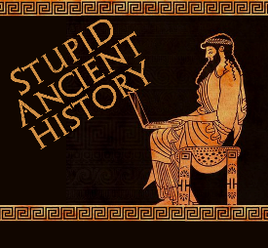
The Persians: 19 The trial of Herodotus

Most of these questions can be short answers- the intention is knowledge acquisition and recall rather than
higher level conceptual thinking. Questions marked with a * will require prose answers.

- What is Herodotus the ‘father’ of?
- What specifically is he writing about?
- Where is Herodotus from?
- Why (broadly) could Herodotus be seen as less reliable when looking at the Persians?

The Trial:
Note down the main accusations about Herodotus in one column, and the key points from the discussion in the other.

 | Accusation | Development
1
2
3
4
5
6
7
8
9

Final summary

Use this box to summarise the key strengths and weaknesses of Herodotus (try and aim for 3 of each)

