Knowledge audit

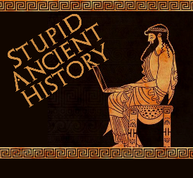
The Persians: 22 Hoplites and
Immortals

Most of these questions can be short answers- the intention is knowledge acquisition and recall rather than
higher level conceptual thinking. Questions marked with a * will require prose answers.

- What could Persian kings rely on in terms of their army?
- As well as archers, what else was important to the Persian army?
- Why do the Greeks have to take a different approach to their armies?
- Why are the Immortals called ‘immortal’?
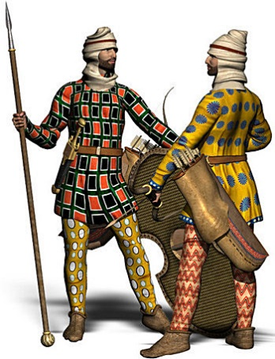
- Annotate the images below with key details.

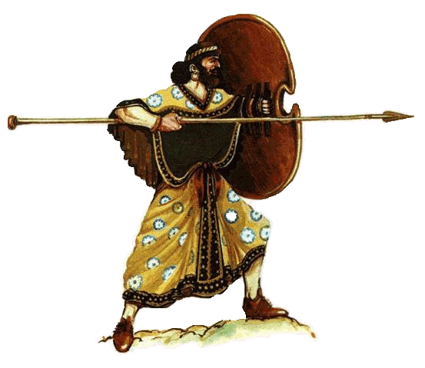
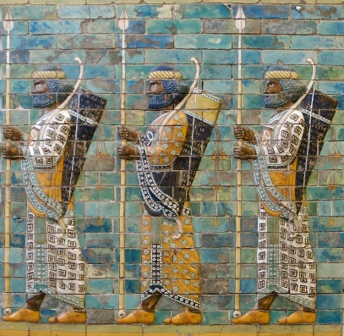

- How was the Persian Cavalry used on the battle field?

- What was the major difference between Greek and Persian soldiers?
- Where would the Greeks prefer to fight (terrain/ landscape)?
- Why did they prefer this type of location?

- Annotate the images below with key details
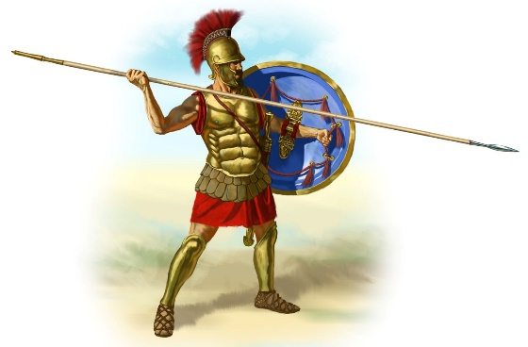
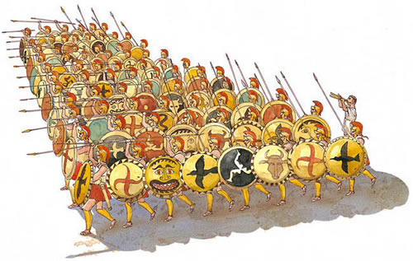
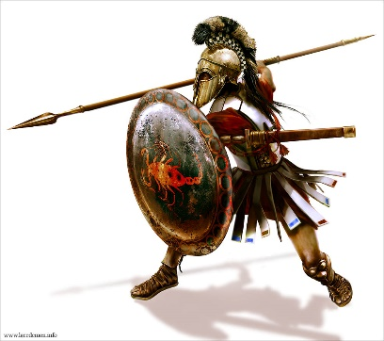

- What is a Phalanx?
- Why didn’t the Greeks use Cavalry as much as the Persians?
- Aside from Hoplites, what other troops did Greek armies have

Extension
- What are the main similarities and differences between the Greek and Persian armies?

Similarities | Differences

