Knowledge audit

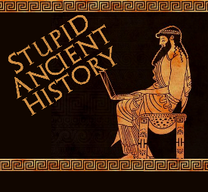
The Persians: 25 Xerxes goes to war

Most of these questions can be short answers- the intention is knowledge acquisition and recall rather than
higher level conceptual thinking. Questions marked with a * will require prose answers.

- Where did Xerxes have to crush rebellions before turning to Greece?
- Who begins to Persuade Xerxes to invade Greece?
- Why does he do this?
- Who speaks out against the planned invasion?
- What is his punishment?
- What finally persuades Xerxes to continue with the invasion?
- What does Xerxes build at the Athos Peninsula?
- Why does he do this?

- Briefly outline what happens when Xerxes tries to build a bridge at the Hellespont.*

- What do Xerxes’ messengers demand from the Greek states?
- Which states do not receive messengers? Why?
- What do the resisting Greeks form? Which states lead this?
- How big is Xerxes’ army according to the Greek sources?

- Briefly outline some of the contingents of Xerxes’ army.*
- How does Xerxes punish Pythias?

Extension

What are the main similarities and differences between Xerxes’ and Darius’ campaigns against Greece?

Differences | Similarities

Extension 2

To what extent does Xerxes campaign represent a continuation of Darius’ attitude to Greece?

Continuation | Change

