Knowledge audit

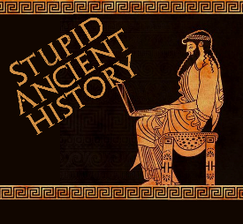
The Persians: 26 The Battle of
Thermopylae

Most of these questions can be short answers- the intention is knowledge acquisition and recall rather than
higher level conceptual thinking. Questions marked with a * will require prose answers.

- Where did Xerxes’ army cross into Europe?
- Where do the Hellenic league first send an army to stop Xerxes?
- Why do they not fight there?
- What prophecy do the Spartans get from the Oracle at Delphi?
- Why can the Spartan army not leave the city to fight Xerxes?

- Briefly outline what king Leonidas does to be able to go and fight the Persians.*

- Name 2 other Greek states who send troops to Thermopylae.

- Briefly outline why Thermopylae was such a good place to fight the Persians.*

- What are the Spartans doing before the battle? Why?
- How many days does Xerxes wait before attacking the Greeks?

- Briefly outline how the events of the first day of the battle.*

- What does Xerxes do in response to the events of the battle?
- What does Ephialtes tell Xerxes about?
- Once the Greeks learn about the betrayal, what does Leonidas do?

- Briefly outline the events of the last day of the battle.*

- What does Xerxes do to the body of Leonidas after the battle?

