Knowledge audit

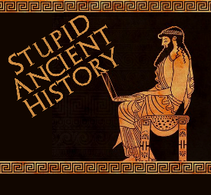
The Persians: 28 The Battle of Salamis

Most of these questions can be short answers- the intention is knowledge acquisition and recall rather than
higher level conceptual thinking. Questions marked with a * will require prose answers.

- What did Xerxes do when he arrived in Athens?
- What did Themistocles think ‘wooden walls’ meant?
- What does he then convince the Athenians to do?
- What does Themistocles worry the other Greek navies will do?
- Where does he think the Greeks should fight?

- Who is Artemesia?
- What advice does she give to Xerxes?
- What is his decision?

- Briefly outline what Themistocles does to trick the Persians (and effectively the greeks).*

- Why are the straits of Salamis and the pass at Thermopylae similar?
- Why are the Greek ships better suited to fight at Salamis?

- Briefly outline what happens to Artemesia during the battle.*

- Where is Xerxes during the battle?
- Does he seem to know how the battle is going?

- Briefly outline what Xerxes does once he realises the battle is lost.*

Extension

How significant was the Battle of Salamis to Xerxes invasion of Greece?

Salamis was significant | Other events that were significant

