Knowledge audit

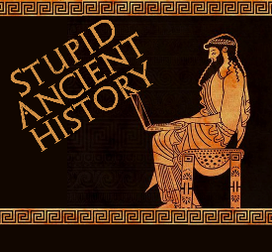
The Persians: 2: The birth of Cyrus

Most of these questions can be short answers- the intention is knowledge acquisition and recall rather than
higher level conceptual thinking. Questions marked with a * will require prose answers.

1) Who is Cyrus’ grandfather?
2) Which country was he king of?
3) Who is Cyrus’ mother?

4) Briefly outline (describe) the dreams mentioned in Herodotus 1.107-8. Try and include at least 3 points.*

5) Who is the infant Cyrus given to?
6) What are his instructions?
7) Who does he give the infant Cyrus to?

5) Briefly outline (describe) what Mitradates does when receiving the infant child. Try and include at least 3 points.*

6) What is the game of kings?
7) How does Cyrus end up before his grandfather?
They came, and Astyages, fixing his eyes upon Cyrus, said: ‘Had you-the son of a slave-the impudence to handle in this outrageous manner a boy whose father is my most distinguished subject?'.
Master, Cyrus replied, ‘there was nothing wrong in what I did to him. We boys in the village- and he was with us-were playing our game, and they made me king, because they thought I was the best man to hold the office. The others obeyed my orders, but he did not; he took no notice of me- until he was punished. That is what happened; and if I deserve to suffer for it, I am ready.'.
Herodotus, Histories: 1.115

8) What impression of the young Cyrus do you think Herodotus is trying to give here? Try and use a quote to support your answer.*

9) Why might Herodotus’ account of this event not be fully reliable?*

10) After realising who Cyrus is, who does Astyages call for?
11) What does he ask him?
12) What does he then ask Harpagus?

13) Briefly outline (describe) what happens when Harpagus is invited to dinner. Try and include at least 3 points.*

14) What does this tell you about the character of Astyages?
15) Bullet point/ plan why might the story of Cyrus’ birth be reliable AND unreliable

Reliable | Unreliable

