Knowledge audit

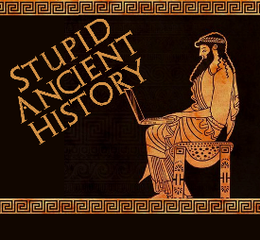
The Persians: 3: Cyrus and the Medes

Most of these questions can be short answers- the intention is knowledge acquisition and recall rather than
higher level conceptual thinking. Questions marked with a * will require prose answers.

1) What year does Cyrus become king of Persia?
2) Where is Media (in relation to Persia)?
3) Where does the earliest account of Cyrus’ conquest come from?
4) How does Herodotus describe Cyrus?
5) Who asks Cyrus for Help to overthrow Astyages

6) Briefly outline (describe) how Cyrus convinces the Persians to rebel against Astyages. Try and include at least 3 points.*

7) How does Cyrus challenge Astyages (according to Herodotus)
8) Who does Astyages put in charge of the Median army?
9) Why was this a bad idea?

10) Briefly outline (describe) How the Persians defeated the Medes. Try and include at least 3 points.*

11) What did Cyrus do to Astyages?

12) One of the key debates about Cyrus is whether he was a ‘conqueror’ or a ‘liberator’. Bullet key arguments for each side of the debate in a table like so. Try and aim for 2-3 points per side if possible.

Cyrus was a conqueror | Cyrus was a liberator
Your opinion

