Knowledge audit

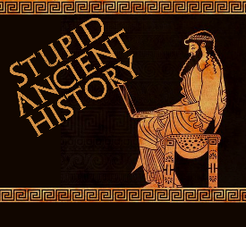
The Persians: 4: Cyrus and the Lydians

Most of these questions can be short answers- the intention is knowledge acquisition and recall rather than
higher level conceptual thinking. Questions marked with a * will require prose answers.

1) Which people had Cyrus previously conquered?
2) Where is Lydia?
3) Where were the Lydia people originally from?
4) Who is the Lydian king?

4) Briefly outline (describe) what the Oracle at Delphi/ Pythian priestess was. Try and include at least 3 points.*

5) What message did the Oracles give Croesus?
6) What does Croesus decide to do?
7) What advice does Sandanis give to Croesus?
8) What are the most famous soldiers the Lydians have?

9) Briefly outline (describe) Harpagus’s plan and how the Persians defeat the Lydians. Try and include at least 3 points.*

10) What city does Croesus retreat to?
11) Who do the Lydians ask to help them?
12) What is their answer?

13) Briefly outline how the Persians were able to capture Sardis? Try and include at least 3 points.*

14) What does Cyrus initially have planned for Croesus?
15) Who else is to suffer the same fate as Croesus?
16) Why does Cyrus change his mind?
17) How is the fire put out?/ who is given credit for this?
18) What role does Cyrus give to Croesus?
19) What practice/ activity does Cyrus put an end to on the advice of Croesus?

20) Cyrus is often regarded as being tolerant to other people and their religion. What evidence from his conquest of the Lydians is there to support this?
Bullet point your answers below.

Extension: Is there any evidence from this to challenge this view?

