Knowledge audit

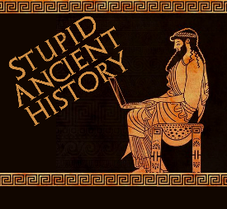
The Persians: 5: Cyrus and Babylon

Most of these questions can be short answers- the intention is knowledge acquisition and recall rather than
higher level conceptual thinking. Questions marked with a * will require prose answers.

1) Which 2 people had Cyrus previously conquered?
2) Which advisor was important in both previous battles?
3) What year does Cyrus begin his campaign against Babylon?

4) Briefly outline (describe) the location and make up of the Babylonian Empire. Try and include at least 3 points.*

5) What does the Nabonidus chronicle say Cyrus’ conquest of Babylon?
6) Which god is named in the Cyrus Cylinder’s account?
7) Who is this god?

5) Briefly outline (describe) what happens between Cyrus and the river?. Try and include at least 3 points.*

6) Where is the Babylonian army waiting to fight Cyrus?
7) What happens to them?
8) Why are the Babylonians well prepared for a long siege?
9) Why is one side of Babylon less protected than the others?
10) What is the name of this river?

8) Briefly outline (describe) how Cyrus gets into Babylon. Try and include at least 3 points.*

“…by means of a cutting he diverted the river into the lake (which was then marsh) and in this way so greatly reduced the depth of water in the actual bed of the river that It became fordable, and Persian army, which had been left at Babylon for the purpose entered the river, now only deep enough to reach about the middle of a man's thigh, and, making their way along got into the town.”
Herodotus, Histories 1.189

9) Using the source and your own knowledge; what can we learn about Cyrus’ military strategies?

From the Source | From your knowledge

10) Why do the Babylonians not realise Cyrus has entered the city?

