Knowledge audit

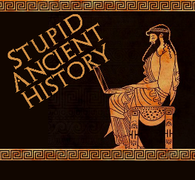
The Persians: 6: Pasargadae

Most of these questions can be short answers- the intention is knowledge acquisition and recall rather than
higher level conceptual thinking. Questions marked with a * will require prose answers.

- Where in the Persian Empire is Pasargadae?
- What mountain range does it look over?
- What Persian word does the name Pasargadae come from?

- What is the main feature of the palace?
- What was built on a hill behind it?
- Describe the ‘winged guardian figure’
- Where would you find it?

- What was the purpose of palace p?
- What was the purpose of palace s?
- What four carvings could be found on the walls of palace s?

- Briefly outline the main features of the central gardens at Pasargadae. Try and include at least 3 points.*

- What was unusual about the material Pasargadae was built from?
- What do we think the pavilions were for?

- Briefly outline the main features of the Zendan at Pasargadae. Try and include at least 3 points.*

- Briefly outline the main features of the Tomb of Cyrus at Pasargadae. Try and include at least 3 points.*

- Bullet point, with some explanation what the Palace can tell us about the character of Cyrus the great. (try and match aspects of the building to aspects of his character)

