Knowledge audit

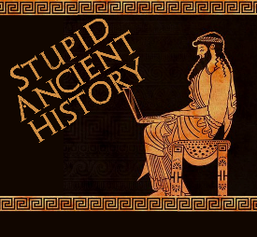
The Persians: 8: King Cambyses II

Most of these questions can be short answers- the intention is knowledge acquisition and recall rather than
higher level conceptual thinking. Questions marked with a * will require prose answers.

- What relation is Cambyses to Cyrus?
- What are the 2 names given to his brother?
- What is Cambyses’ first achievement as king?

- Name the 3 places involved in this.
- Where does Cambyses decide to attack/ invade?
- Give 2 reasons why.
- Briefly outline the explanation Herodotus gives for the invasion.

- Briefly outline what Amasis’ plan is and why it fails.
- What is the first obstacle in Cambyses’ way for this invasion?
- Who does he get to help him with this?

- How do the Persians get across the desert?
- What happens to Amasis?
- What secret weapon does Cambyses use at the battle of Pelusium?
- Where do the Egyptians retreat to after Pelusium?

- Briefly outline how Cambyses brings an end to the siege*

- Extension- bullet point the similarities and differences between Cambyses’ campaign in Egypt and Cyrus’ campaigns of expansion.

Similarities | Differences

