Knowledge audit

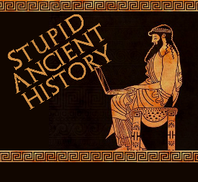
The Persians: 9: Madness of Cambyses

Most of these questions can be short answers- the intention is knowledge acquisition and recall rather than
higher level conceptual thinking. Questions marked with a * will require prose answers.

- What was Cambyses first achievement of Cambyses as king?
- Which country had he successfully conquered?
- What unusual tactic did he use at the battle of Pelusium?

- What happens when he tries to reach Siwah?
- Where does he decide to go to next?
- What is the problem with this plan?
- Briefly outline what happens during this campaign*

- What are the people doing when Cambyses gets back to Memphis?
- What is the Apis Bull?

- Briefly outline what Cambyses does on his return to Memphis*

- Briefly outline some of the actions that Herodotus says demonstrate Cambyses’ madness*

- What happens to the son on Prexaspes?
- Why?
- And Croesus?

- Briefly outline the way in which Cambyses dies*

Extension
- How much continuity and change is there in the rule of Cyrus and Cambyses?

Continuity | Change

