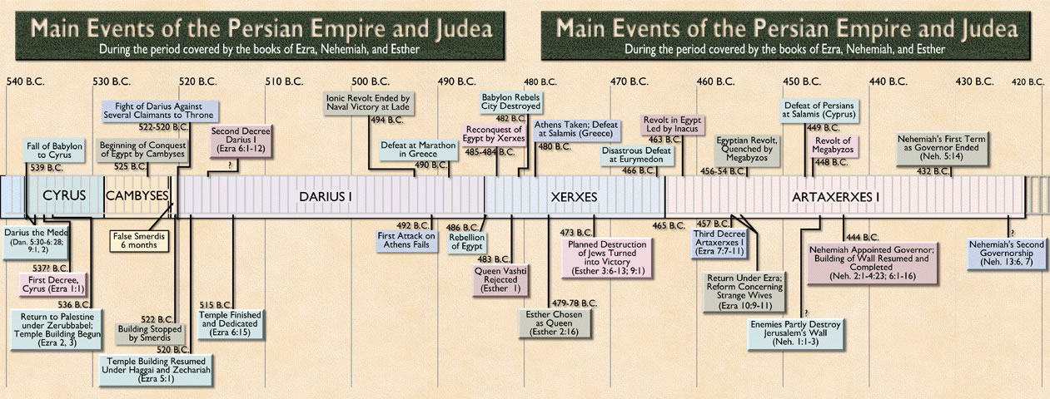
PERSIAN EMPIRE OVERVIEW TIMELINE

