The Persian Kings
Revision Booklet

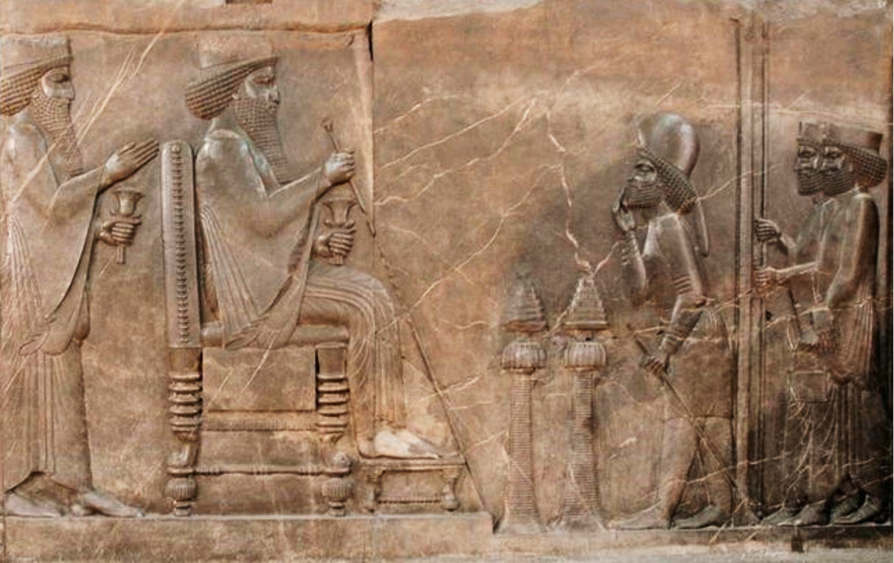

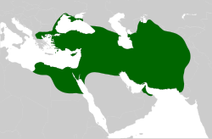

Cyrus the Great, 559-530BC

Herodotus foreshadows Cyrus’ greatness in his childhood
The story of Cyrus’ childhood, as told to us by Herodotus, seems to want to hint to us that Cyrus would be a great king. The first example of this ‘foreshadowing’ Cyrus’ greatness is the dream his own grandfather has about his birth, and the second is how he was discovered fighting with noble boys.
TASK: using p.9, summarise each of the stories that seem to foreshadow Cyrus’ greatness.
Astyages dreams of his daughter’s pregnancy

Cyrus fights and bests the children of noblemen

Cyrus’ Conquest of the Medes

Cyrus’ early life also includes the hugely important event of his conquest of the Medes. This is when, with the help of the general Harpagus, Cyrus overthrows his own grandfather and takes control of the Kingdom of the Medes. A big step in creating the foundations of the Achaemenid Empire.

TASK: using p.9-10,
summarise the events of Cyrus’ conquest of the Medes into 5 main events/ turning points
Event 1
Event 2
Event 3
Event 4
Event 5

The Conquest of Lydia
After conquering his grandfather’s Kingdom of the Medes, Cyrus then moved on to conqueror the wealthy kingdom of Lydia (which is modern-day Turkey). He did this by defeating their King, Croesus, at the battle of Pteria, as well as dealing with Croesus’ trickery afterwards. Ultimately, Cyrus was merciful and spared Croesus from death, even making him a royal advisor.
TASK: using p.11-13 complete a 5-step flow chart explaining the events of Cyrus’ conquest of Lydia. Make sure to include the very end stages where Cyrus spares Croesus/ life, and Cyrus’ treatment of the Ionains.

Outline the key features of Cyrus’ conquest of Lydia. (6)
Outline the key features of Cyrus’ conquest of the Medes. (6)
EXAM PRACTISE

The Conquest of Babylon.
Cyrus’ next point of conquest, and expansion of the Persian Empire, was when he conquered Babylon in 539BC. This was a significant achievement for Cyrus, and he justified this expansion by saying that the Babylonian God, Marduk, had chosen him to come and replace the corrupt King, Nabonidus.
We have a range of sources for this event; Herodotus, the Nabonidus Chronicle and the Cyrus Cylinder.
TASK: using p. 13-16, complete the spider diagram summarising the conquest of Babylon 539BC.

How Cyrus presented himself to the Babylonians, according to the Cyrus Cylinder.
How Cyrus managed to take the city of Babylon
Cyrus’ conquest of Babylon
Why the people of Babylon welcomed Cyrus?
Impact of the conquest of Babylon, for the Persian empire and the Jewish people

The Palace of Pasargadae
Palace P
Palace P
Zendan
Tomb of Cyrus
This palace was one of the greatest achievements of Cyrus’ reign, and is an excellent example of his contribution to infrastructure of the Persian Empire.
TASK: To help you understand the function and shape of the palace, use p. 16-19 to annotate the features on the diagram below. Some features have been included as subheadings for you to write under.

Palace P
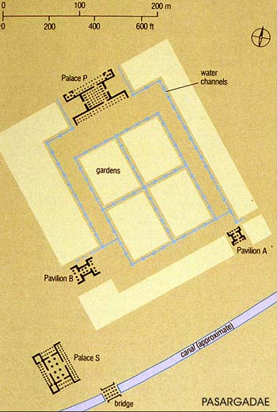
Paradaiza

Zendan

Gate

Tomb of Cyrus
Palace S

Using the features from the diagram of Pasargadae, and your own knowledge, what can we learn about the achievements of Cyrus the Great? (10)
EXAM PRACTISE

The Death of Cyrus the Great.
Cyrus’ death seems to contrast hugely against the type of king he was for the rest of his reign. He challenges the Massagetae tribe, and their Queen Tomyris, refuses to listen to his advisors and then is defeated in battle. According to Herodotus, his head is put in a bag of blood by the queen, to ‘satisfy’ his lust for blood (war).
TASK: using p.19, summarise the two version of Cyrus’ death, as recorded by Herodotus. One of these versions will have much more detail than others!
Version #1 of Cyrus’ death | Version #2 of Cyrus’ death

Cambyses II, 530-522BC

The sources varying hugely on the nature and actions of Cambyses. Herodotus presents Cambyses as a madman, who is unpredictable, aggressive and a poor leader. Whereas Egyptian sources portray him as a kind, respectful and good leader. You will need to decide which you think is correct!

Reasons for the conquest of Egypt.
Herodotus gives us a range of reasons why Cambyses wanted to invade Egypt.
TASK: using p.22, summarise 3 reasons why Cambyses wanted to invade Egypt, order them in the triangle, with the most reliable reason at the top, down to the least reliable reason.

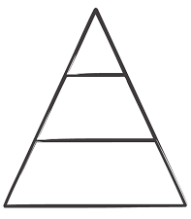

The conquest of Egypt.
The account of Cambyses’ conquest of Egypt is told to us mostly by Herodotus, and is full of examples where Cambyses acts viciously, whereas the Non-Greek/Egyptian sources tell us that he was good and kind in Egypt.
TASK: using p.23-27, fill the table with examples for both interpretations of Cambyses. You table should include; his treatment of Psammetichus, the battle of Pelusium, treatment of the Apis Bull, treatment of his Sister, attempts to take the Oasis at Ammon, and positive examples from the non-Greek sources.
Examples when Cambyses is a violent and poor leader | Examples where Cambyses is a kind and good leader

The Death of Cambyses
Cambyses’ death happens very quickly, and is connected to a plot to overthrow him that he hears about back in Persia. He goes to respond by heading back to Persia, but accidently stabs himself in the thigh when trying to mount his horse. Ironic, considering how he SUPPOSEDLY killed the Apis Bull…
TASK: Using p.25, answer the following questions to explain the death of Cambyses.

Question 1: What was the role of Magis in Persia?

Question 2: What was Patizeithes’ plan?

Question 3: What does Cambyses realise about the prophecy he’d heard before?

Question 4: How did Cambyses de?

Darius I, 522-486BC
The death of Cambyses left a huge power vacuum in Persia. Darius stepped into the power vacuum and managed to secure the throne for himself. There are two versions of how he did this, one by Herodotus and one by Darius himself, carved into a mountain side as the Bisitun Inscription.
TASK: using p.29-31, complete the Venn Diagram summarising each version of events, and including where both versions have the same detail.
Herodotus’ Version of the Accession of Darius

Bisitun Inscription/ Darius’ version of the Accession of Darius
Revolts against Darius
In the early years of his reign, and potentially because of the way in which he’d come to the throne, a number of areas in the Persian empire chose to rebel/ revolt against the new King. Darius put down all of these revolts, and dealt harshly with the leaders. He had to make a point about is strength as a king, even if he wasn’t the most obvious heir to the throne.
TASK: using p.33-34, complete the following practise exam question to revise your knowledge of revolts against Darius.

Outline the key features of the revolts Darius faced in the early years of his reign. (6)
EXAM PRACTISE

The Ideology of Darius

Once he had put down the various rebellions, Darius worked to put in place ideologies for the people in the empire to live by, which would make it easier for him to rule them. This would be because all the ideologies strengthened his position as king, and encourage the people to see him as a good ruler that they would not wanted to reel against, again.
TASK: using p.34-36, complete the table summarising the 4 key areas of ideology that Darius introduced
Ideology | What did this ideology say/ encourage people to think | How would this help strengthen Darius’ rule?
#1 – the idea that he was related to previous kings
# 2 – the idea that Ahuramazda chose him as King
# 3 – the idea of Arta (the truth) and Drauga (the lie)
#4 -the idea to set up Satraps and Satrapies

Building projects under Darius
Of all our Achaemenid Kings, Darius is probably the one who commissioned the most impressive building projects/ examples of infrastructure.
TASK: using p.37-39, complete the revision spider diagram on examples of Darius’ building projects.

Building the Royal roads
Building the royal capital at Persepolis.
Darius’ building projects

The Darius Canal
Developing the royal capital at Susa

Source A. a relief section from the Apadana Staircase. Commissioned by Darius I and found at Persepolis
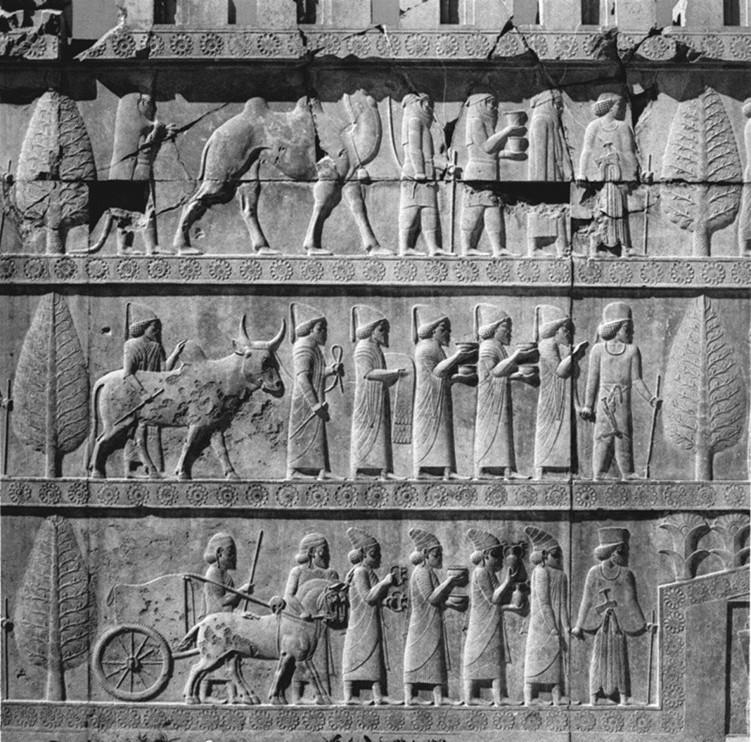
Using features from source A and your own knowledge, what can we learn from the source about the leadership of Darius I? (10)
EXAM PRACTISE

The Invasion of Scythia
Darius had some significant successes in terms of expansion, for example he successfully took the Indus Valley (Western India) and Thrace (Northern Greece), but when he tried to expand into Scythia, it ended in a near disaster and Darius had to retreat back to Persia before his army starved to death.
TASK: using p. 40-42, create a timeline of events for the invasion of Scythia. NOTE; the timeline is slanted downwards; this is because the invasion gets worse for Darius over time. Your chosen events should reflect that it goes badly.
Event #1…

Event #2…

The Ionian Revolt
The most serious revolt that Darius faced came much later in his reign than the others we have studied before. The Ionian Revolt started in 499BC, and took 5 years for the Persians to put down, was led by a man called Aristagoras, in an attempt to keep his power in Ionian after he failed spectacularly to help the local satrap with a planned attack. Aristagoras
TASK: using p.43-46, complete a flow chart on the events of the Ionian Revolt. Your flow chart should include; why Aristagoras went against the Persians, the involvement of Sparta/Athens, the role of Hippias, how the revolt spread, the battle of Lade and consequences of the revolt for Ionia/Persia

The Battle of Marathon
Due to the willing involvement of the Athenians in the Ionian Revolt, Darius commits to challenging mainland Greece and attempting to absorb the area into his empire. The first attempt is made in 492BC, but the fleet Darius sends is lost in a storm.
In 491BC he sends heralds to Greece to demand ‘Earth and Water’ from the cities to show their submission to him.
Then in 490BC, he sends a second invasion which successfully reaches the bay of Marathon in Greece. Darius will lose this battle, and die before he has the chance to launch another attack against Greece.
TASK: using p. 47-48, complete the steps explaining the events of Darius’ challenges to mainland Greece and the Battle of Marathon. Make sure the box on the battle of Marathon explains why his Persian troops lost.
STEP 1 = Darius’ first attempt at invasion in 492BC

STEP 2 = Darius demands earth and water from the Greeks in 491BC

STEP 3 = Darius launches a second invasion in 490BC, which reaches the Bay of Marathon

Xerxes I and the Greeks, 486-465BC

Below is one of the Achaemenid Royal Inscriptions, known as the "Daiva inscription". Found on a large slab of stone in Persepolis.
1. A great god is Ahuramazda, who created this earth, who created yonder sky, who created man, who created happiness for man, who made Xerxes king, one king of many, one lord of many.
2. I am Xerxes, the great king, king of kings, king of countries containing many kinds of men, king in this great earth far and wide, son of king Darius, an Achaemenian, a Persian, son of a Persian, an Aryan, of Aryan stock.
3. King Xerxes says: By the grace of Ahuramazda these are the countries of which I was king apart from Persia. I had lordship over them. They bore me tribute. What was said to them by me, that they did. My law, that held them: Media, Elam, Arachosia, Armenia, Drangiana, Parthia, Aria, Bactria, Sogdia, Chorasmia, Babylonia, Assyria, Sattagydia, Lydia, Egypt, Yaunâ, those who dwell on this side of the sea and those who dwell across the sea, men of Maka, Arabia, Gandara, India, Cappadocia, theDahae, the haoma-drinking Sacae, the Sacae wearing pointed caps, Thrace, men of Âkaufaciyâ, Libyans, Carians, and the Nubians.

C = What similarities are between this inscription by Xerxes, and Darius’ Bisitun inscription?
B = Which tactics does Xerxes’ use to try and cement his power (convince people he should be in control?)
A = Underline and annotate sections of the inscription that emphasise Xerxes’ power

...................................................................................................................................................................
...................................................................................................................................................................
...................................................................................................................................................................
...................................................................................................................................................................
...................................................................................................................................................................
...................................................................................................................................................................
...................................................................................................................................................................
...................................................................................................................................................................
...................................................................................................................................................................
...................................................................................................................................................................
...................................................................................................................................................................
...................................................................................................................................................................

The succession of Xerxes
Unlike Darius, Xerxes’ taking the throne was slightly more simply because he was Darius’ biological son, but there were still complications that he had to overcome.
TASK: read through the section of Herodotus below, where he tell us the supposed story of how Demaratus helped Xerxes argue his way to the throne. Choose one of the options and answer the question in the space below.
The succession of Xerxes. Herodotus, Book 7.
But while Darius was making preparations against Egypt and Athens, a great quarrel arose among his sons concerning the chief power in the land. They held that before his army marched he must declare an heir to the kingship according to Persian law. Three sons had been born to Darius before he became king by his first wife, the daughter of Gobryas, and four more after he became king by Atossa daughter of Cyrus. Artobazanes was the oldest of the earlier sons, Xerxes of the later and as sons of different mothers they were rivals. Artobazanes pleaded that he was the oldest of all Darius' offspring and that it was everywhere customary that the eldest should rule; Xerxes argued that he was the son of Cyrus' daughter Atossa and that it was Cyrus who had won the Persians their freedom… Learning of the contention between the sons of Darius, this man, as the story goes, came and advised Xerxes to add this to what he said: that he had been born when Darius was already king and ruler of Persia, but Artobazanes when Darius was yet a subject; therefore it was neither reasonable nor just that anyone should have the royal privilege before him… Xerxes followed Demaratus advice, and Darius judged his plea to be just and declared him king. But to my thinking Xerxes would have been made king even without this advice, for Atossa held complete sway.

Option A:
Outline the key features of Xerxexs’ ascension to the throne. (6).

Option B:
Using the passage and your own sources, what can we learn about the nature of Xerxes and his ambition? (10).

Planning answers help -
For Option A, think about; what are the 3-4 main points to summarise the events of Xerxes’ rise to power. – keep it in chronological order.
For Option B, think about; what aspects of Xerxes’ ambition are clearly displayed here, which quotes can support these ideas. What further evidence do we have of Xerxes’ ambition from the rest of his reign?

...................................................................................................................................................................
...................................................................................................................................................................
...................................................................................................................................................................
...................................................................................................................................................................
...................................................................................................................................................................
...................................................................................................................................................................
...................................................................................................................................................................
...................................................................................................................................................................
...................................................................................................................................................................
...................................................................................................................................................................
...................................................................................................................................................................
...................................................................................................................................................................
...................................................................................................................................................................
...................................................................................................................................................................
...................................................................................................................................................................
...................................................................................................................................................................

Motivations to invade Greece
There are a range of arguments on why it was that Xerxes wanted to invade Greece, many argue that it was a desire to live up to/better the achievements of his father. It is also worth considering how influential particular advisors were, and how susceptible Xerxes was to pressure from them.
- Name the advisor that was very encouraging of Xerxes invasion into Greece. ..................................
- Xerxes was persuaded to invade Greece to enact revenge on the………..
And to reap the ……………. …………… of gaining a new territory. It is also argued that he wanted to invade to live up to…………………………………………………………………………………………………………
There are some ways in which Xerxes’ motivation were very similar to that of Darius,
TASK; using p.54, and your previous knowledge on why Darius wanted to invade, complete the table comparing their reasons for invading Greece.
Darius’ motivations for invading Greece | Xerxes’ motivations for invading Greece

CHALLENGE: highlight similarities between motivations in one colour, and differences in another colour.
Xerxes’ preparations for invasion
Herodotus tells us that Xerxes undertook some serious preparations for his invasion of Greece, which is not surprising considering how poorly his father’s invasion of 492BC went. According to Herodotus, Xerxes ‘empties Asia’ of its’ men in a bid to have enough soldiers to defeat the Greeks.
- According to Herodotus it took ….. years to finish preparing for Xerxes’ invasion.
- Two great feats of engineering were completed as part of this invasion, they were 1; cutting a …………………………………………………………………………, and 2; bridging the………………………………. Using……………………………………
- The army spent the winter of 481 in …………………, while they were waiting Xerxes sent out……………………………………………………………………….

Herodotus, 7.184-185. Discussing Xerxes’ army gathered to march against Greece.
The ships from Asia were twelve hundred and seven in number, and including the entire host of nations involved, there were a total of two hundred and forty-one thousand and four hundred men, two hundred being reckoned for each ship… These, then, were the ships' companies from Asia, and the total number of them was five hundred and seventeen thousand, six hundred and ten. There were seven hundred thousand and one hundred foot-soldiers and eighty thousand cavalrymen; to these I add the Arabian camel-riders and Libyan charioteers, estimating them to have been twenty thousand in number…. The forces of sea and land added together would consist of two million, three hundred and seventeen thousand, six hundred and ten men. So far I have spoken of the force which came from Asia itself, without the train of servants which followed it and the companies of the grain-bearing craft…When these numbers are added to the numbers from Asia, the sum total of fighting men is two million, six hundred and forty-one thousand, six hundred and ten.

TASK: Either PLAN, or WRITE IN FULL, an answer to…
Using the passage and your own knowledge, how different were Xerxes’ preparations for was from that of Darius? (10).

...................................................................................................................................................................
...................................................................................................................................................................
...................................................................................................................................................................
...................................................................................................................................................................
...................................................................................................................................................................
...................................................................................................................................................................
...................................................................................................................................................................
...................................................................................................................................................................
...................................................................................................................................................................
...................................................................................................................................................................
...................................................................................................................................................................
...................................................................................................................................................................
...................................................................................................................................................................
...................................................................................................................................................................
The Persian Military
- Persian military defended themselves using light wicker………., and fought using swords,………… and ………..
- The Persians were well known for their…………….., who often formed a key part of the Persian battle plans.
- Define the Immortals: …………………………………………………………………………………………………………………………………………………………………………………………………………………………
- Define Hoplites: …………………………………………………………………………………………………………………………………………………………………………………………………………………………
- Explain why the Persian cavalry was so important to Persian military success.
……………………………………………………………………………………………………………………………………………………………………………………………………………………………………………………………………………………………………………………………………………………………………………………………………………………………………………………
Herodotus, Book 7. 61 – 64.2
The men who served in the army were the following: the Persians were equipped in this way: they wore on their heads loose caps called tiaras, and on their bodies embroidered sleeved tunics, with scales of iron like the scales of fish in appearance, and trousers on their legs; for shields they had wicker bucklers, with quivers hanging beneath them; they carried short spears, long bows, and reed arrows, and daggers that hung from the girdle by the right thigh… The Assyrians in the army wore on their heads helmets of twisted bronze made in an outlandish fashion not easy to describe. They carried shields and spears and daggers of Egyptian fashion, and also wooden clubs studded with iron, and they wore linen breastplates… The Bactrians in the army wore a headgear very similar to the Median, carrying their native reed bows and short spears… The Sacae, who are Scythians, had on their heads tall caps, erect and stiff and tapering to a point; they wore trousers, and carried their native bows, and daggers, and also axes which they call “sagaris.”

Write in full:
Using the passage and your own sources, what can we learn about the nature of the Persian military? (10).

The main battles of the Persian Wars – Xerxes vs. The Greeks
Xerxes had 3 major battles against the Greeks, in a series that became known as the Persian Wars – this was the name that GREEK historians later gave to the wards that they won. There is almost NO Persian records of any involvement with the Greeks, at all.

TASK: using p.57-63, fill the table on the following page with revision notes on each of the key battles. Your notes for each battle should include;
- Events from the beginning, middle, and end of each battle
- Successful and unsuccessful tactics used
- Important figures
- Which side won each battle, and why.
The 4th box needs you to explain the impact of the battles on three different groups involved in the war.

A map of the Battle of Salamis has been included to help with you understanding of the history;
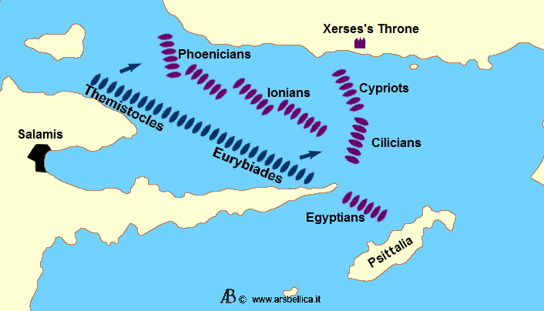

Thermopylae 480BC | Battle of Salamis 480BC
Eurymedon early 460sBC | Consequences of the Battle for Persia, Greece and the Ionians
Plutarch, Life of Cimon, 13.4 – commenting on the consequences of the invasion, for the Persians
These victories of Cimon humbled the King’s pride so much that he undertook, in the terms of the famous peace, always to keep at least a day’s ride away from the Greek sea, and not to bring any long ship or bronze-rammed ship beyond the Cyanean islands and the Chelidonian islands.

Using the passage and your own knowledge, explain how the consequences of Xerxes’ invasion differed between the Persians and the Greeks. (15).
EXAM PRACTISE

...................................................................................................................................................................
...................................................................................................................................................................
...................................................................................................................................................................
...................................................................................................................................................................
...................................................................................................................................................................
...................................................................................................................................................................
...................................................................................................................................................................
...................................................................................................................................................................
...................................................................................................................................................................
...................................................................................................................................................................
...................................................................................................................................................................
...................................................................................................................................................................
...................................................................................................................................................................
...................................................................................................................................................................
...................................................................................................................................................................
...................................................................................................................................................................
..................................................................................................................................................................
...................................................................................................................................................................
...................................................................................................................................................................
...................................................................................................................................................................
...................................................................................................................................................................
EXAM PRACTISE
‘Xerxes sought to continue the work and policies of Darius in every way’.
How far do you agree with this view? (20) + (5) SPaG.
Come to a firm conclusion, one way or the other, that is supported by your argument!

Evidence that Xerxes DID continue Darius’ policy | Evidence that Xerxes had differences from Darius
- E.g. Xerxes put down rebellions in Egypt and Babylon, and then carried out the second invasion of Greece, which was originally Darius’ policy…  - In the question, note that is says ‘in every way’. It may be that you think that Xerxes continued Darius’ policies in some ways but not others.  - Aim to make 4 points of discussion, but make sure you do at least 2, one for each side of the argument.  - Make sure that you always link back every point you make to the statement, and explain how significant the points you have made are.  - When you link back to the question, this should explain how far that evidence agrees with the statement. | - E.g. Xerxes headed the invasion of Greece himself, whereas Darius had left it to others…

