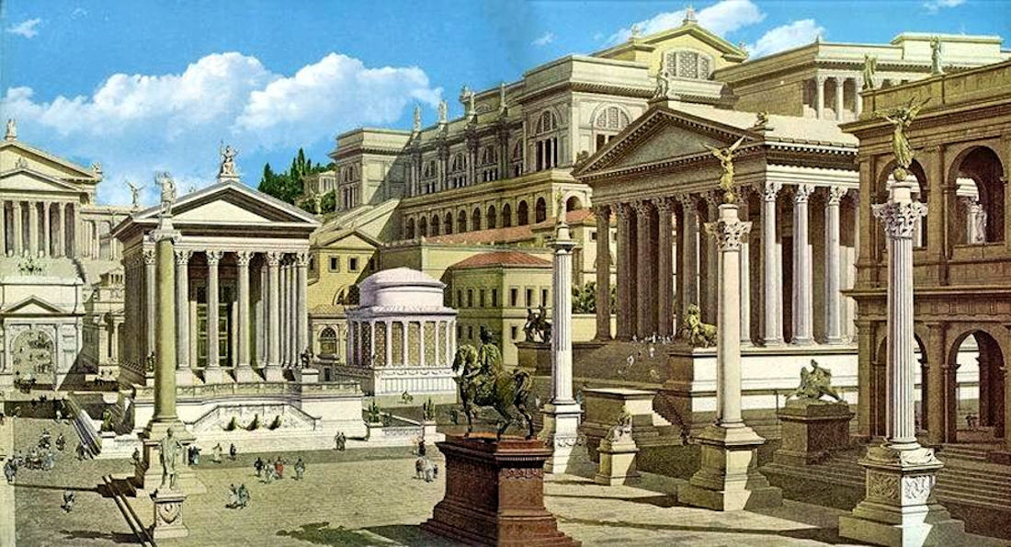
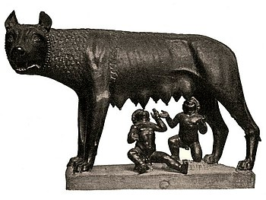
The Foundations of Rome
Revision Booklet

  - – The Legendary Kings and the Foundations of Rome

The Aeneas Myth
Later Roman historians made the decision to include the myth of the Greek warrior, Aeneas, into the story of the Foundation of Rome, because they wanted to link the origins of Rome to the epic writing of Homer’s ‘The Iliad’. If the historians connected Rome to such an incredible soldier from the Trojan Wars, they linked the very beginnings of Rome to a great military power. – prestige by association!
Task: using the internet/ p. 7-8 of the textbook, complete the summary of the Aeneas myth so that you know the events. - always bear in mind the ways in which this story would reflect well on Rome!
2.

1.

3.

How was Rome Founded – The Legend of Romulus and Remus
According to Livy, the origins of Rome lie in the actions and lives of the twins, Romulus and Remus. Romulus is ultimately responsible for choosing the site of Rome, beginning buildings and establishing the poitical/social and religious systems of the city.
Much like the Aeneas myth, it is HUGLY unlikely that any of this is true (wolves raising babies instead of eating them? I don’t think so…), but what it important about this legend is that a; it is the only written record we have, and b; it shows us how later Roman writers felt about themselves and their origins. Mighty origins = mighty later people.
Modern archaeology has made clear that the earliest origins of Rome ACTUALLY go back to the 12/13th Centuries BC, which is when the earliest settlements have been found. This, obviously, is much earlier than the 753BC date that Livy gives us.
TASK: using the internet and p.9-11 of the textbook, summarise the legend of Romulus and Remus into 9 main bullet points. The first bullet point has been started for you. Your summarises should include key peoples and actions.

- Romulus and Remus’ grandfather, had been king of the kingdom, Alba Longa. He ruled successfully until he was removed by his brother, …

EXAM PRACTISE
Outline the key features of the legend of Romulus and Remus. (6)

For this exam practise question, go to p.10 of the textbook and read Livy, 1.6-1.7.

EXAM PRACTISE
Using the passage and your own knowledge, what can we learn about how Romulus became the first legendary King of Rome? (10).

Legendary King #1 – Romulus 753-714BC
After killing his own brother, Romulus becomes the first (legendary) King of Rome. We call these kings legendary, as there is no certain historical evidence that they existed, unlike the later Etruscan kings. According to Livy, Romulus is credited with having created some of the most important parts of Roman life. This isn’t surprising, as when Livy was writing in the much later 1st C, he would want the Romans to feel that the most important parts of their city originated with the most important of the Kings!
TASK: using the internet, your notes and p.12-16, complete the spider diagram summarising the initiatives that Romulus supposedly started.

The Rape of the Sabine Women.
Although Romulus had successfully established a new city, and populated it thanks to his promise of asylum for criminals, he had a serious problem in that there were not enough women in his city. At this rate there would only be one generation in Rome. The events of the Rape of the Sabine women solved this problem.
TASK: using the images as prompts, summarise the events of the Rape of the Sabine women. Think about how this event turned out very well for Romulus! Use p.16-17 to help you.



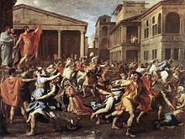

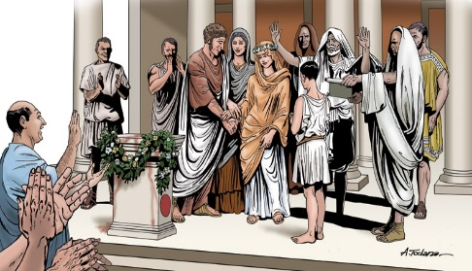
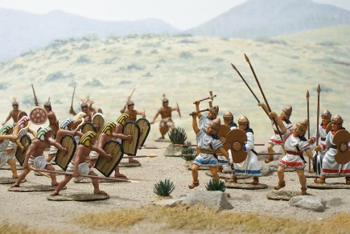

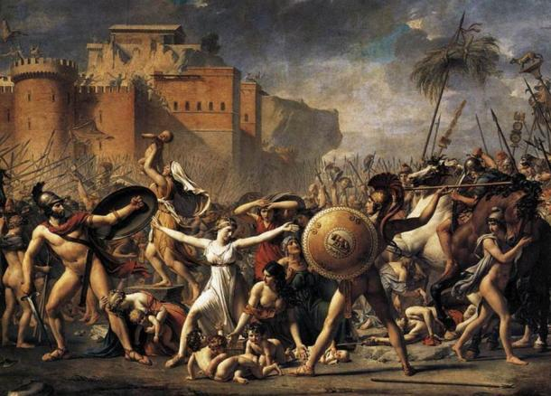

Legendary King #2 – Numa, 715-673BC
Numa was the next king to follow after Romulus, choosen by the Senate after they attempted to rule Rome by themselves for a year – this was called the Interregnum, which failed. Numa was chosen from the Sabine, population, which kept them happy, and he was VERY different to Romulus. Numa had a reputation for being pious (religious) and just (he was fair). According to Livy, when Numa died, Rome had been at peace for over 40 years.
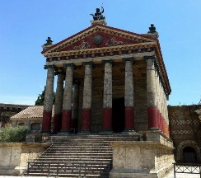
TASK: using the internet, and p. 17-19, make notes summarising Numa’s religious initiatives and examples of his excellent diplomacy. – THE HISTORY OF ROME PODCAST IS SUPERB FOR HELPING WITH THIS ACTIVITY, give it a listen again!
The Temple of Janus – in the Forum
Religious Initiatives

Excellent Diplomacy



In preparation for 15-marker questions, that may well ask you to compare features/characteristics across the Kings, think about what your answers would be to the following points. – Grade 5+ = make some notes to answer each of these questions.
- How much do the people of Rome seem to change from Romulus to Numa?
- What does Numa introduce that is NEW to Rome?
- How does Numa make Rome a more peaceful place?
- Which of the two kings do you think is the more successful? – think about what you mean by SUCCESS!
Legendary King #3 – Tullus Hostilius, 673- 642BC
Tullus Hostilius came after Numa, and is presented as being very much the opppsite to Numa. Tullus was aggressive and military-minded, in comparison to Numa’s peaceful and diplomatic nature. Tullus is presented as having shaken Rome from its’ idleness (being a bit lazy and distracted), and helping Rome beat the Etruscans who had been building their army while Numa had focused on peace. A key example of this, is when Tullus led Rome to victory against the Albans, and the story of the 2 sets of triplets fighting eachother.
TASK: using the images as prompts, summarise the events of the war with Alba and the story of the Three Albans. Think about how this event reinforced Rome as a military power! – particularly for later readers in Livy’s time. Use p.20, the internet and notes from the lesson to help you. Remember Mettius’ betrayal right before the final victory!





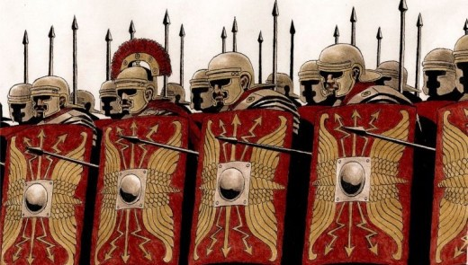











TASK: using p.21, make notes on the other features of Tullus’ reign; is legal initiatives, his political initiatives and the events surrounding his death.

Legendary King #4 – Ancus Marcius, 642-617BC
Anucs followed from Tullus, and was actually the grandson of the second King, Numa. Livy tells us that Ancus worked hard to be part Romulus AND part Numa in the way he ruled. We don’t have a huge amount of information about him, but it would seem as though he looked to bring back an element of peace to Rome after the military-focused reign of Tullus Hostilius. Anucs wanted to offer security and religious guidance after war, but he knew that Rome also needed a soldier who could keep them safe from further challenges.
TASK: using p.21-22, and the internet, complete the diagram summarising Ancus’ military, political and religious achievements and expansions of Roman territory.

  - – The Etruscan Kings, 616-509BC
The Etruscans were a real, and developed, group of peoples that archaeologists have clear evidence for. They adopted many Greek practises in terms of art, and had an extensive trade network in the Mediterranean. According to Livy, Tarquinius Priscus, who was an Etruscan, became the 5th King of Rome and began the reign of Etruscan Kings. He was followed by his adopted son, Servius Tullius, who was killed by Tarquinius Superbus, who would be the last King of Rome.
Livy presents the Etruscan Kings as being increasingly corrupt as we work out way through them, subtly explaining to his own readers why it was that Rome decided to get rid of Kings, even though the great Romulus had been King, himself. It is worth noting, that there are some really positive developments, initiatives and forms of expansion credited to the Etruscan Kings, although we may not be able to say with certainty if the king that Livy tells us was responsible for that development actually did it.
Etruscan King, #5 – Tarquinus Priscus, 616-578BC
Tarquinius Priscus’ succession to the throne.
Tarquinius Priscus was not Roman by birth, nor was his birth name Tarqunius Priscus, but according to Livy a series of auspicious (favourable) events led to him becoming the 5th King of Rome. Some of these events start to lay ideas of the Etruscan Kings being more immoral than the legendary kings before them!
TASK: using p.26-27 and your own notes, summarise the events surrounding Tarquinius Priscus’ journey to the throne. – make sure to focus on any questionable behaviour or immoral influences in this story!

Tarquinius Priscus’ reforms and military record.
As mentioned on the previous page, there are a range of changes and developments that were brought in by the active Etruscan Kings, and Tarquinius Priscus made some big, positive changes to Rome.
TASK: using p.28-29, the internet and your own notes, complete the diagram summarising the changes made by Tarquinius Priscus. – Grade 5+ = highlight those changes that you would argue are the most significant, give a sentence for each explaining WHY!
Then complete the table assessing Tarquinius Priscus’ military
Evidence that Tarquinius Priscus had a successful military record | Evidence that Tarquinius Priscus had an unsuccessful military record
 | Think; was he a successful, or unsuccessful King overall??

Etruscan King, #6 – Servius Tullius, 578-535BC
The supernatural origins of Servius Tullius and his succession to the throne
Servius Tullius was not Tarquinius Priscus’ biological son, but managed to come to the throne for a series of unfortunate events (for T. Priscus) and encouragement from Tarquinius Priscus’ wife, Tanaquil. However, even from an early age, Livy records that there were indicators of Servius Tullius special nature and divine origins. Clearly, the divine elements are not true, but it tells us a lot about the Romans that they believed their kings were special/chosen for greatness.
It is also worth thinking about where the origin stories of previous kings are also divine, e.g. Romulus. There is clearly a trend in how the Romans viewed the Kings!
TASK: using each image as a prompt, use p.30 and your own notes to explain each of the stories connected to Servius Tullius’ origins. Two are supernatural, one is not.


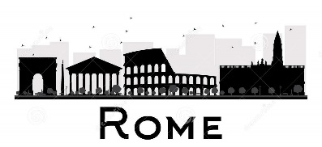

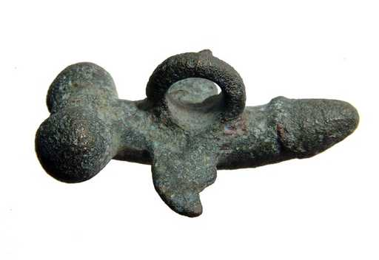

TASK: using p.30, Livy 1.41 and your notes, complete the flow chart summarising the events of Servius Tullius succession to the throne. Make sure to include discussion of the role of Tannaquil, she is hugely influential here!

The Servian Reforms
There is quite a substantial list of reforms credited to Servius, many of which were actually good for the city and helped the people of Rome lead more equal lives – as best as the Plebeians could hope for against the Patricians!
TASK: using p.31-33, the internet and your own notes, complete the diagram summarising Servius’ reforms to Rome. – Grade 5+ = highlight those changes that you would argue are the most significant, give a sentence for each explaining WHY

Etruscan King, #7 –Tarquinius Superbus, 535-509BC
Superbus reigned as the final, and most immoral, king of Rome. He took power from Servius Tullius and ruled as tyrant when he got to the throne. One Roman writer, Dionysius, says that Servius reforms on military and tax had made him unpopular, therefore the patricians supported Superbus’ bid for power. Whereas Livy says that this wasn’t true, and Superbus was helped by Servius’ daughter, Tullia, to overthrow the King when he was old and weak.
Either way, Tarquinius Superbus took power and began a tyrannical reign as the last King of Rome.
TASK: using p.34 and your notes, complete the flow chart summarising the events of Tarqunius Priscus’ succession to the throne.

Tarquinius Superbus’ reforms
As said before, Superbus is considered to have ruled Rome as a tyrant, this means he was an all-powerful king who refused to listen to the Senate and used his power to gain personal wealth/control. He managed to do this by enacting reforms that reduced the power of the Senate and the power of the people, although it should be remembered that not ALL of his reforms did this.
TASK: using p.35-37, Livy 1.50-1.56 and your notes, complete the table summarising Superbus’ reforms/actions. Highlight the reforms/changes that you believe enabled Superbus to become more powerful and rule like a tyrant.
Political Reforms | Military successes | Religious and Social change

In preparation for 15-marker questions, that may well ask you to compare features/characteristics across the Kings, think about what your answers would be to the following points. – Grade 5+ = make some notes to answer each of these questions.
- To what extent did the Etruscan Kings become more immoral as they went on?
- Did Superbus rule Rome like a tyrant?
- How did Superbus compare to Romulus in terms of personality/ characteristics.
- Were the Etruscan Kings actually GOOD for Rome? – if so, how were they?
- Which of the Kings would you say was LEAST successful in terms of leadership of Rome?

  - – Origins of the Republic, 509-494BC

The removal of Tarquinius Superbus by Lucius Brutus led to the establishment of the Roman Republic. The move from King to Republic was a difficult one for the city. The position of King was replaced with the position of Consul, which would be two men who shared leadership of the army. Each set of consuls had to deal with subsequent civil unrest, threats from Rome’s hungry enemies, and attempts from Superbus to regain the throne.

The Rape of Lucretia

Superbus had been ruling Rome as a tyrant for some time, and the people were (according to Livy) already very unhappy with his rule, however it was the events of the Rape of the Patrician woman, Lucretia, that sealed the fate of the Kings.
TASK: using p.42-43, the internet and your own notes, summarise the Rape of Lucretia into 6 key stages. Make sure to include the parts where Brutus takes charge and Superbus is refused entry back into the city/ sent into exile.

The Tarquin Conspiracy
Unfortunately for Rome, and particularly Brutus, exiling the Tarquins did not mean the end of their involvement with Rome. Superbus and his family were desperate to regain control of the city, and they approached disgruntled and angry young, Patrician men to join in on a conspiracy to Kill Brutus.
TASK: using p.44, the internet and your notes, complete the flow chart of events of the Tarquin Conspiracy. Make sure to focus on WHY this was such a difficult thing for Brutus, and the actions he chose to take in response.
THINK ABOUT; why might later Romans hold Brutus up as a hero, and a true Roman?
Practise for a 10marker by making notes on what these two events tell us about the nature of the Tarquins, or about the nature of Tarquinius Superbus as a king of Rome?
EXAM PRACTISE
Outline the Key features of the Rape of Lucretia. (6)
Outline the key features of the Tarquin Conspiracy. (6)

Main features/ roles in the new Republic
TASK: using p.45, summarise the responsibilities of the different features/ roles in the new Republic. Some have continued on from the time of the Kings, but many were new and were needed to replace the position of King. You must decide which position belongs at which point on the scale, some are more powerful than others.
- Lictors
- Consuls
- Censors
- Dictators
- Master of the Horse
- The Senate.
Less Powerful
More Powerful

The Battle of Silvia Arsia and the role of Valerius Publicola
Tarquinius Superbus was not put off by the failure of the Tarquin Conspiracy, and he approached the Etruscan city of Veii for support in recapturing Rome. The Veii supported him and the first major battle of Rome’s Wars of Independence (as in, independence from Kings) began. This was called the Battle of Silvia Arsia, and it had some auspicious, divine events surrounding it, as well as an important death.
After the battle a new figure emerged, Valerius Publicola, who was hugely important for the Plebeians, who were feeling hard done by after the tyranny of Superbus and then being forced into the Roman army to fight in the Wars of Independence.
TASK: using p.46-47, the internet and your notes, summarise the main events of the Battle of Silvia Arsia, and the ways in which Valerious Publicola was good to the Plebeians.

Actions of Valerius Publicola
Battle o Silvia Arsia

The Wars of Independence continue – Lars Porsena gets involved
Despite losing at the battle of Silvia Arsia, Superbus continued his efforts to regain the city, and this time turned to Lars Porsena, the king of the neighbouring kingdom of Clusium. Superbus had Porsena contact Rome and demand that Superbus be put back on the throne or at least have his lands and possession returned to him. When Rome, as expected, refused this, Porsena declared war and began to attack the city.
The story of the defeat of Lars Porsena is full of references to heroic Romans, which readers in Livy’s time would have LOVED as it would have made them feel that their ancestors were great people – therefore they could think of themselves as great people as descendents.
TASK: using p.47-49, and your own notes, summarise the key events of the defeat of Lars Porsena. Make sure the include the actions of Horatius Cocles, Mucius Scaevola and Cloelia.
6. – read p.49, and summarise the events of the end of the Wars of Independence.

1.4 Origins of the Republic, 509-494BC
After the defeat of the Tarquins, Rome should hve secured its future. The Wars of Independence had, however, had a hugely negative impact on the lives of the Plebeians by causing them to fall into debt and poverty which the Senate would not do anything about. This led to the Conflict of the Orders, where the Plebeians challenged the ruling Patricians, and on two occasions seceded from Rome. The address the problem, the position of Pebeian tribune and the Twelve Tables of laws were created to rebalance power.

Causes of the Plebeian unrest
The Conflict of the Orders is most likely based on stories from the later Roman Republic, that Livy would have been aware of, with the events of the 2nd Century BC being the best match. In this century, the Roman plebeians had been made poor and heavily indebt after the Second Punic Wars that Rome had been fighting. This led to a call for land reform (exactly like we see in this unit!) and the rise of powerful figures that supported the rights of the Plebeians (like we see in this unit!).
Going back to the 509-494BC period of this unit, Livy records that the causes of Plebeian unrest relate back to the suffering caused by the continuous fighting of the Wars of Independence, particularly following the last battle, Battle of Lake Regilius.
TASK: using p.52, summarise the reasons identified by Livy as causing Plebeian unrest. Order these reasons in terms of significance in the triangle. – most significant at the top, least at the bottom. - Grade 5+ = for each factor, exalain WHY it has been placed at that level in the triangle.

Build up to the First Secession – Story of the War Veteran
Like many parts of this history, modern day historians are fairly sure that the story of the War Veteran is a fabrication (it’s not true) on Livy’s part. But what this story DOES show us is that issues of debt and poverty caused by the Wars in Independence were at the heart of the Conflict of the Orders.
TASK: using p.54-56, the internet and your notes, complete the 3-stage summary of the story of the War Veteran. Make sure to incude detail of the Publius Servilius/ Appius Claudius debate at the end!


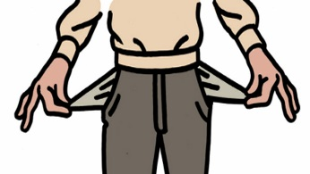



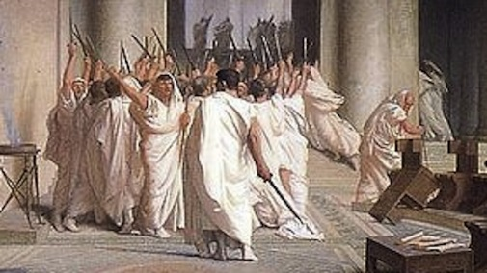

Events of the First Secession
The debate between Publius Servilius and Appius Claudius had only increased the tensions between the Plebeians and the leading Patricians. In the end, a range of people acted in a way that either encouraged or caused the First Secession, when the Plebeian’s left Rome and occupied the Sacred Mount (outside of the city) as a form of protest. If we study the actions of these people, we can understand the events of the First Secession.
TASK: using p.56-58, complete the table analysing the role of different figures in encouraging or causing the First Secession.
Key figure | Their relationship with the people of Rome – Plebeian and Patrician | How their actions encouraged or caused the First Secession
Publius Servilius
Appius Claudius
Dictator Valerius
Sicinius
Why had the Tribunes failed to improve the lives of the Plebians by 462BC?
After the Plebeians had returned to Rome after the first Secession, there were a range of events that pushed both for, and against, the kind of reforms that the Plebeians were demanding. This continuous back and forth, compromising and aggression meant that very little MEANINGFUL change was achieved for the Plebeians.
TASK: using p.59-60, complete the table assessing each key events until 462, for each, summarise what happened and then explain WHY that event would mean that little improvement could happen – you may want to think about how some of these events connect/ lead on to each other!
 | What happened | WHY this event meant there was little improvement for the Plebeians
Role of Coriolanus
Spurius Cassius and the demand for an agrarian law
Role of Volero Publilus
The indictment of Appius Claudius
Gaius Terentilius and the demand to limit consular power
The First and Second Decemvirate
By 454BC, the Tribunes realise that Terentilius’ demands for controls on the power of Consuls are never going to be met, so they decide to try a different angle, and they ask the Senate to allow Plebeians to vote on who becomes lawgivers in Rome (literally the people who decide what the laws of Rome will be). According to Livy, the Seate actually agree to consider this, and they send ambassadors over the Athens, so that they can study the new ‘Democracy’ that the Athenians have just established.
When the ambassadors return, the Senate agrees to give democracy/ Plebs voting on lawgivers a go, and they create the first Decemvirate. – 10 men chosen to create the first set of laws of Rome. This starts well, but the process soon becomes corrupt.
TASK: using p.61-62, the internet and your own notes, complete the flow chart summarising the events of the First and Second Decemvirate, and the way in which the process was corrupted by Appius Claudius’ grandson, Claudius Crassus. Each step has a hint as to what to include in that box! Grade 5+ = go through the flow chart and highlight whenever Claudius Crassus is involved in the process. Add annotations to the flow chart on HOW he damages the process.
Step 1 = Ambasadors travel to Athens….

Step 2 =The First Decemvirate of 451BC is created…

Step 3 = The first Ten Tables of Laws are created…

Step 4 = The Second Decemvirate becomes tyrannical…

Step 5 = Valerius and Horatius challenge the corrupt Second Decemvirate…

The abduction of Virginia
The downfall of the tyrannical, Second Decemvirate is almost an exact copy of the downfall of the Tarquins. According to Livy, Claudius Crassus’ lusting after a plebeian girl ultimately lead to his removal from power, very similar to Superbus’ son and the rape of Lucretia.
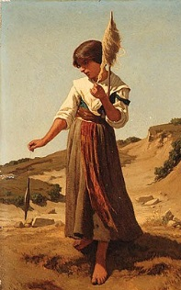
TASK: using the images as prompts2-62 and the internet, summarise the events of the abduction of Virginia.




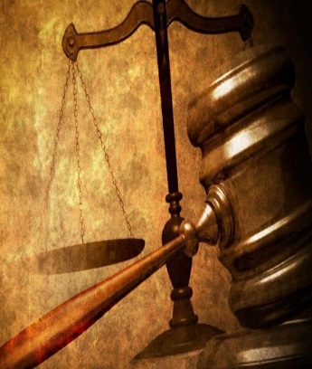


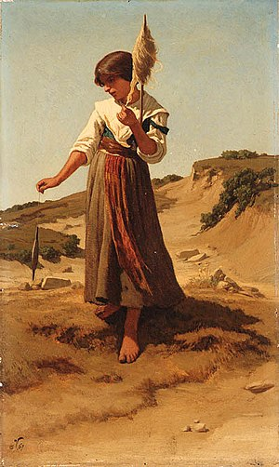


The Second Secession from Rome
The events of the abduction of Virginia, and the role of her father in the Roman army, encouraged the Plebeians to leave Rome for a second time.
TASK: using p.64-65, and the internet, explain the events of the Second Secession and the impact the secession had for Rome/ the Second Decemvirate.
Events of the Second Secession and role of Verginius

Consequences for Rome and the Second Decemvirate

The Valerio-Horatian Laws
Valerius and Horatius were key in negotiating peace in Rome and the end of the Second Secession. Once the Secession had ended, 10 new tribunes were elected, and Valerius and Horatius were elected as the new Consuls. Their first move as Consuls was to cement a new range of laws for Rome, to help avoid a Secession having to happen ever again. These became known as the Valerio-Horatian laws, and they were there to protect the Plebeians.
There was a promise not to seek revenge against the tyrannical second Decemvirate, however the decision WAS made to indict Crassus, who then killed himself rather than be put on trial.
TASK: using p.65 and the internet, summarise the 3 most important features of the new Valerio-Horatian laws. – focus your ideas on importance on how much they helped protect the Plebeians!

The Twelve Tables
Th final act that Valerius and Horatius undertook, before heading off to defeat the Sabine and Aequi threat that had been bubbling along since the Second Secession, was to create the Twelve Tables of Rome. These were 12 cleer laws, avaialbe for all to see, written in simple language that everyone in Rome could understand. They gave each Roman citizen basic civil rights, although they didn’t make everyone EQUAL under the law!
TASK: using p.65-66 and the internet, create a spider diagram summarising a range of key laws from the Twelve Tables. For each one, you MUST have a note about HOW that would help the Plebeians live a more secure life.
The Twelve Tables

