King’s College London Department of Classics

Classical Civilisation Summer School

A Level Greek Religion Activity – Methods of Divination

It is clear that a range of methods of divination were used by Greeks and Romans in both public and private circumstances. But we have surprisingly little evidence about how oracles and other forms of divination worked.

This activity has two elements.

- In your group look at one of the three images, and the accompanying text. See what they can tell you about what a divination session might actually have involved. Do bring in any other information you have about the particular example – but bear in mind that not everything said about divination is reliable. It is worth noting that there is no scholarly agreement about how things worked in any of the three cases.

- Once you think you know what the process involved, consider how far you would find the outcome of the divination trustworthy. Famously, the anthropologist E.E. Evans-Pritchard said about the ‘poison oracle’ used by the Azande in Southern Sudan in the 1920s, ‘I found it as satisfactory a way of running my home and affairs any other I know.’

1. Oracle of Apollo at Delphi

Evidence: Red-figure Attic kylix depicting the Pythia and a consultant (440-430 BC). The figures are named Themis and Aigeus. This is a prescribed source at A level.

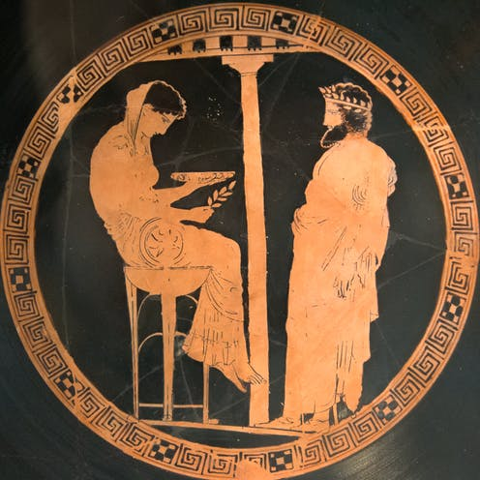

Responses recorded in inscriptions:

Apollo prophesied that these things were in a[ccordance with custom for the Praxiergidae:] they should put on the peplos [of the goddess and make sacrifices to the Fa]tes, Zeus Moiragetês, Gê[... (c. 460-450 BC)

The god told the demos of the Athenians to dedicate the house of Demon, and the garden attached to it, to Asclepius, and that Demon himself should be his priest. (mid fourth century BC)

The god said that it was better and more profitable for the demos of the Acharnians and the demos of the Athenians to build altars to Ares and Athena Areia, that the Acharnians and Athenians might act properly towards the gods. (mid fourth century BC)

and to as[k the g]od whether it is more profitable and better for the demos of the Athenians [to make the sacred adornments] of Arte[mis bigge]r and more beautiful than they now are. (335/4 BC)

2. Oracle of Zeus and Dione at Dodona

Evidence. Documents written on lead. These are discussed on pp. 30-2 of the A-level textbook.

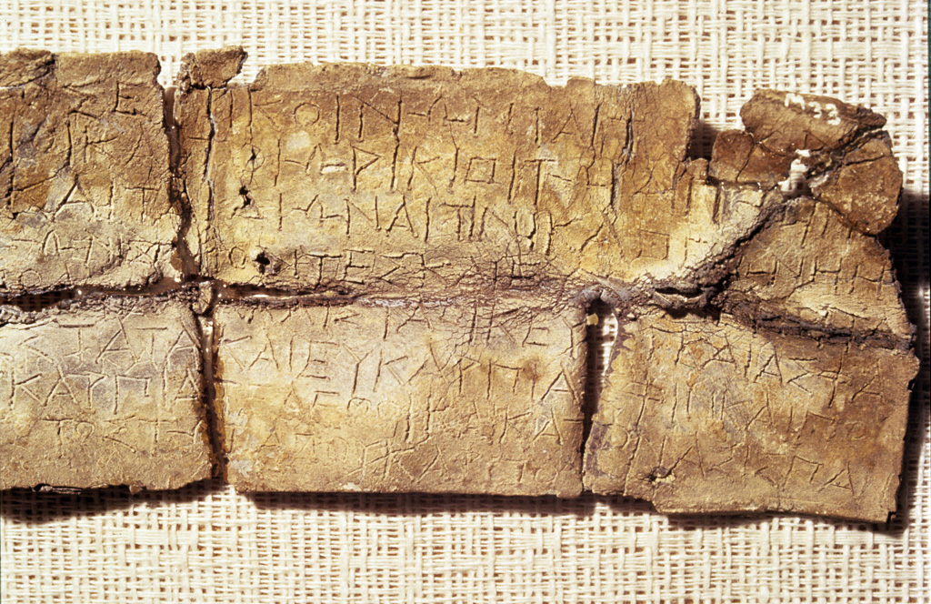

Sample texts:

219b. [God]. Iphiates (?) [(asks Zeus?)] to which god to address prayers [— concerning] his household and safety.

268a. [God. The city of the — (asks)] Zeus Naios and Dione concerning the sign which happened, what would be more advantageous and better [—] nothing [—]

272a. If not, (I ask) whether the shipowner has had evil worked against him by means of poison/potion, and if it will no longer be possible for him to transact any other business; and, without business, (I ask) if Aristobia [keeps ready what] this rogue Onasiphoros will get?

1077b. ΕΣΣΤΙ (Is it? or It is.)

2432. Set apart (or: uproot) the wild olive-tree; and to the hero offer pure pounded flour by way of seasonal fruit-offerings.

3. Etruscan Haruspicy

Evidence. Bronze Liver from Piacenza (c. 100 BC). This is referred to on p. 60 of the GCSE textbook.

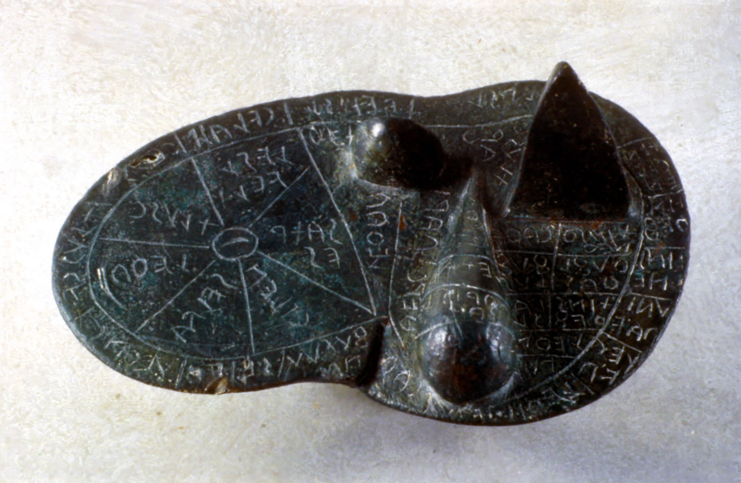
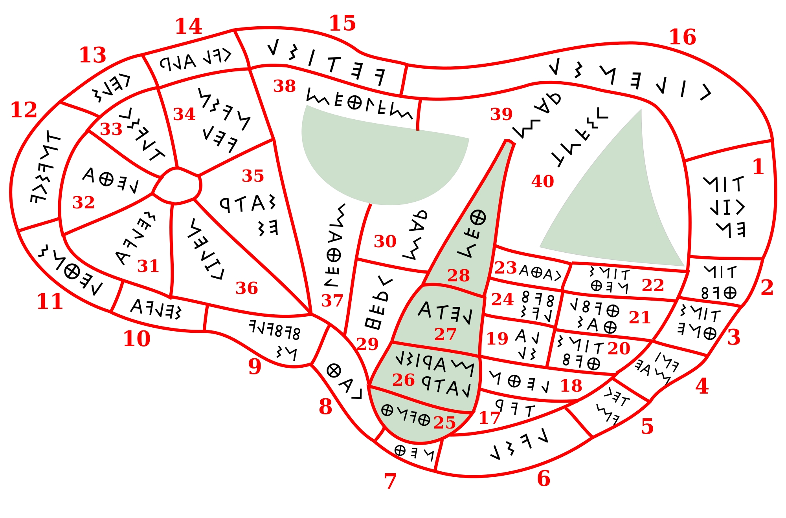

But those methods of divination which are dependent on conjecture, or on deductions from events previously observed and recorded, are, as I have said before, not natural, but artificial, and include the inspection of entrails, augury, and the interpretation of dreams. These are disapproved of by the Peripatetics and defended by the Stoics. Some are based upon records and usage, as is evident from the Etruscan books on divination by means of inspection of entrails and by means of thunder and lightning, and as is also evident from the books of your College of Augurs.

But the Etruscans, being in their nature of a very ardent religious temperament and accustomed to the frequent sacrifice of victims, have given their chief attention to the study of entrails. And as on account of the density of the atmosphere signs from heaven were common among them, and furthermore since that atmospheric condition caused many phenomena both of earth and sky and also certain prodigies that occur in the conception and birth of men and cattle — for these reasons the Etruscans have become very proficient in the interpretation of portents. (Cicero, On Divination 1.33, 43)

