The Mycenaean World (Homeric World)

Resources:

1) Bloomsbury site: https://www.bloomsbury.com/cw/OCR-GCSE-Classical-Civilisation/literature-culture/the-homeric-world/culture-resources/
The Bloomsbury book and site contain links to online resources that it considers authoritative.

2) Lecture series: https://www.dartmouth.edu/~prehistory/aegean/?page_id=104
For undergraduate level, so very thorough. But extremely useful (has lecture outline, images, bibliography etc, set out in clear lessons).

3) Image commentaries sheet
For some guidance in approaching image commentaries, as expected for culture questions.

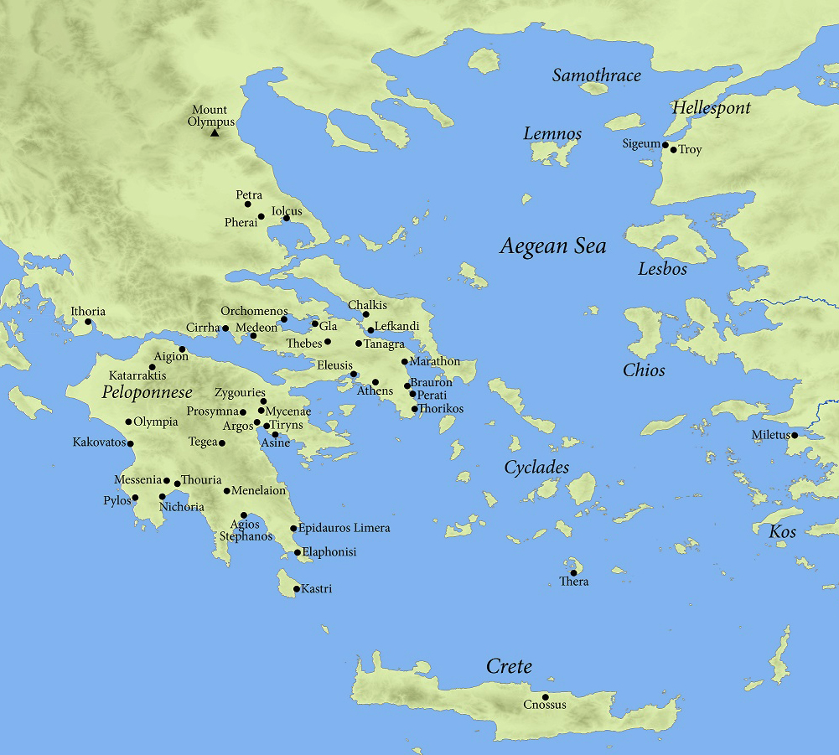

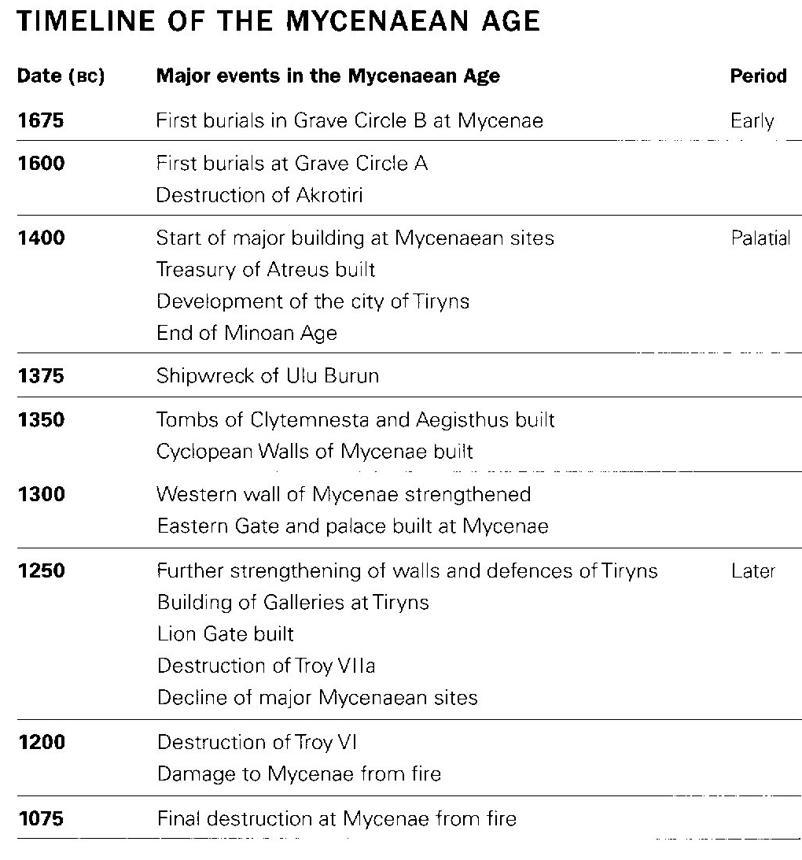
Homer – composing late 8th century BC – ‘possibly written down in the 7th century BC’

