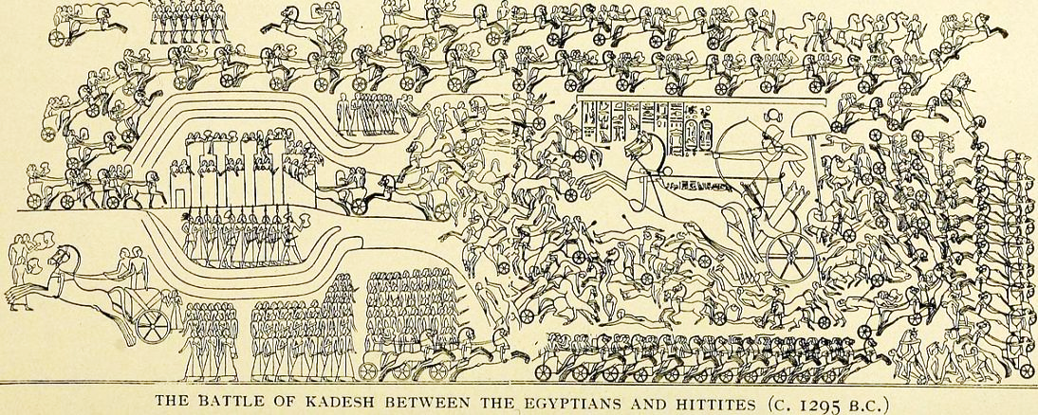
Think about;
How Rameses is presented
Where the city of Qadesh is shown
How the Hittites are presented
Drawing from the Temple of Luxor, showing the Egyptian version of the Battle of Qadesh
Extract from the Hittite version of the peace treaty that followed the battle, written in Akkadian. – each side’s version makes THEM look like the victor…
"Reamasesa, the great king, the king of the country of Egypt, shall never attack the country of Hatti to take possession of a part (of this country). And the king of the country of Hatti, shall never attack the country of Egypt to take possession of a part (of that country).
If Reamasesa and the children of the country of Egypt don't observe this treaty, then the gods and the goddesses of the country of Egypt and the gods and goddesses of the country of Hatti shall exterminate the descendants of Reamasesa.
If Reamasesa and the children of the country of Egypt observe this treaty, then the gods of the oath shall protect them.
They who do not observe the words that are in this silver tablet, the great gods of the country of Egypt as well as the great gods of the country of Hatti will exterminate their houses, their country and their servants. "

A statement from Rameses II, carved into the wall at the Temple of Luxor to go with the relief. – He appears to be angry with his nobles/ soldiers…
"None of you were there...None lent me his hand in the fight...None of you came back and said how well you fought!....Since ancient times a man was honored for his fighting abilities, but I will not reward any of you, as you have abandoned me when I was alone fighting my enemies."

