Verus vs Priscus
By Martial

Verus and Priscus were well-known gladiators during the reigns of the Emperors Vespasian and Titus in the latter part of the 1st century. Verus vs Priscus was the highlight of the opening day of the games conducted by Titus to inaugurate the Flavian Amphitheatre (later the Colosseum) in AD 80, and was recorded in a poem by Martial — the only detailed description of a gladiatorial fight that has survived to the present day. Both gladiators were declared victors of the combat, and were awarded their freedom by the Emperor in a unique outcome.

As Priscus and Verus each lengthened the contest,
And for a long time the battle was equal on each side,
Repeatedly loud shouts petitioned for the men to be released;
But Caesar followed his own law; —
It was the law to fight without shield until a finger was raised: —
He did what was allowed, often gave dishes and gifts.
But an end was found to the equal division:
Equals to fight, equals to yield.
Caesar sent wooden swords to both and palms to both:
Thus skillful courage received its prize.
This took place under no prince except you, Caesar:
When two fought, both were the victor.

For a clip on this fight, view:
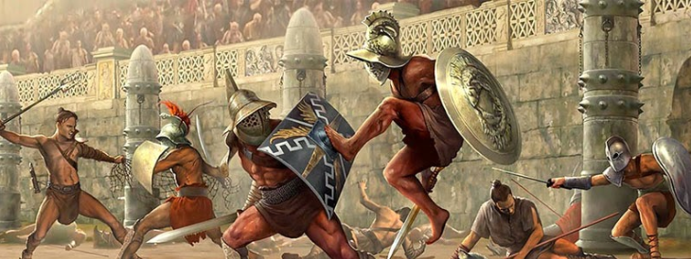
https://www.youtube.com/watch?v=ns-Dlg4TFRc

