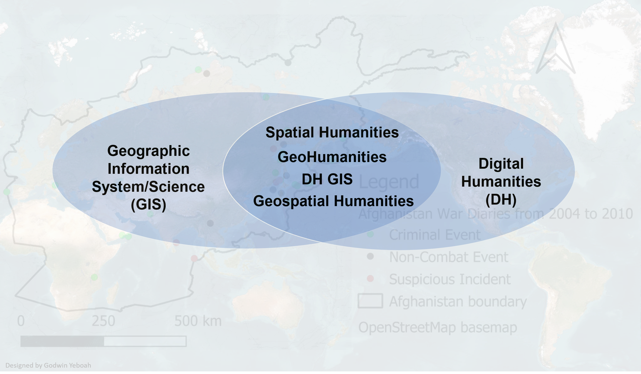
This article was written by Godwin Yeboah who is a member of the Information and Digital Group (IDG) Technology for Research team at Warwick. The article provides a short overview on the use of Geographic Information System (GIS) in Digital Humanities (DH). The content here is drawn from a thirty-minute DHAL (Digital Arts and Humanities LAB) “Shorts” presentation which touches on some basic definitions and concepts as well as some exemplars of GIS uses in the Digital Humanities including the provision of some resources on GIS tools, spatial data sources, and training materials. The team can provide advice on potential GIS tools and techniques in the advancement of research by academics and postgraduate research students in Warwick.
There is a long tradition of “spatial turn” in the Humanities where spatial data, theory and methods as well as the analysis of geographical space and place have been used in examining human activities of the past (particularly in archaeology which dates back several decades). Recently, there is an emerging (if not already established) field called Spatial Humanities which sits at the intersection of DH and GIS. Other scholars tend to also use different names for Spatial Humanities such as DH GIS, GeoHumanities, and Geospatial Humanities (see header image). While DH covers scholarly activity situated at the intersection of digital technologies or computing and the disciplines of the humanities, GIS consists of integrated computer hardware and software that store, manage, edit, analyze, output, visualize geographic data and broadly includes people and methods (Figure 1).
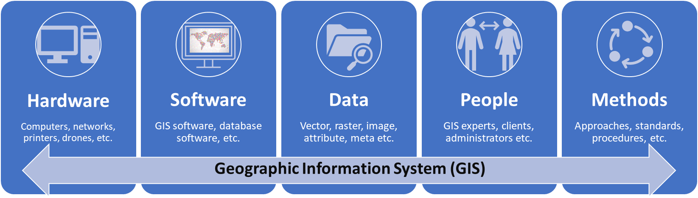
Figure 1: Components of a Geographic Information System
Spatial data (or GIS data or Geographic data) is the type of data that represents (or references) directly or indirectly a specific geographical area or location. There are two main types of spatial data which are (1) vector data, and (2) raster data. The presentation will provide further details to better understand these two types of spatial data. The two spatial processes (georeferencing and geocoding) considered to be commonly used in DH will be presented. Furthermore, terms like “map” and “cartographic process” will be presented including some critical questions to ask when planning to map with spatial data and GIS. Examples of GIS use cases will be provided (Figure 2) including some GIS tools (Figure 3) and spatial data sources (Figure 4) as well as training materials as a follow-on study or “go-to” resource.
GIS uses cases in DH
Mapping the English Lake District: a literary GIS (2011): used GIS to create static maps of two accounts of actual journeys through the Lake using ArcGIS, Google Earth, etc.
The Atlas of Early Printing (2019): mapped and visualised early printing via fairs, trade routes, etc. using Google maps API, ArcGIS software, Leaflet, etc.
Developing Geographically Oriented NLP Approaches to Sixteenth – Century Historical Documents: Digging into Early Colonial Mexico [DECM] (2020): used GIS to auto-link text analysis results to spatial data.
Static and interactive maps from the “Anti-Eviction Mapping Project (AEMP)”: used GIS tools for static/ interactive map visualisations and storytelling. Won 2016 ASA Garfinkel Prize in Digital Humanities.
Find more GIS use cases here: https://geohumanities.org/?page_id=125
A Digital Botanical Garden: Using Interactive 3D Models for Visitor Experience Enhancement and Collection Management (2023): created an interactive 3D web map using ArcGIS and 3D City Modelling tools.
Foodscapes of bread in sixteenth-century New Spain using a historical gazetteer (2022): mapped types of bread with a DECM historical gazetteer using ArcGIS and QGIS
Crossing the Mediterranean Sea by Boat (2019): mapped and documented migrants’ journeys and experiences using Leaflet library for interactive maps.

Figure 2: Some examples of GIS use cases in DH

GIS tools
Programming (analysis / mapping / visualisation libraries):
- JavaScript libraries (Leaflet, OpenLayers, CesiumJS, Turf, etc.)
- R programming (for geocoding, mapping, etc.)
- Python programming (GeoPy, PySAL, Rasterio, etc.)
- php programming (Geotools, etc.)
- APIs (ArcGIS APIs/SDKs, etc.)
Publish / Share / WebGIS:
- ArcGIS Online
- GeoServer
- MapServer
- QGIS Server
- ArcGIS Enterprise
- Mapping module (Omeka S)
- Carto
- QGIS2Web plugin + Github Pages
- GeoNode - a geospatial content management system
Desktop GIS software:
- ESRI’s ArcGIS Pro (21 day trial)
- QGIS | GeoDa
- GRASS | SAGA
- uDig | gvSIG
- Microsoft Excel (Map Chat, Power Map, etc)
- MapInfo (30 day trial)
Geocode /Georeference:
- ESRI’s ArcGIS Pro, LocateXT
- QGIS
- Map Warper
- Edinburgh Geoparser
- IPUMS GeoMarker
- DECM Place name search
- Allmaps Editor
3D GIS software:
- ArcGIS Pro, Earth, etc.
- Google Earth
- QGIS 3D MapView
- Power 3D Map for Excel
Database software:
- PostGIS (and PostgreSQL)
- MySQL/ MariaDB
- SpatiaLite (and SQLite)
- MongoDB
- Oracle Spatial

Figure 3: Some GIS tools in DH
Gazetteers:
- Gazetteer of British place names
- World Historical Gazetteer
- Pleiades - community-built gazetteer of ancient places
- GeoNames - geographical database of place names
- DECM Historical Gazetteer*
- Digital Gazetteer of Song Dynasty China
GIS data sources
Base maps:
- OpenStreetMap – free editable world map
- OpenMapTiles – vector maps for self-hosting
- Google maps
- Bing maps
Some other data:
- Public libraries in England
- UK ONS historical data search
- Free maps from the Ancient World Mapping Center *
- UK Ordnance Survey Historical maps of Great Britain
- US National Historical Geographic Information System
- ARCHI UK MAPS - Find old maps of Britain
- Free GIS Data (over 500 sites providing freely available geographic datasets)
- Harvard dataverse for Arts and Humanities
Searchable (spatial) data sources:
- Harvard Geospatial Library (hgl.harvard.edu)
- Georeferenced Maps – Find/upload old georeferenced maps
- OpenStreetMap (OSM.org) – free editable world map
- Google maps
- Bing maps
- Google Dataset Search
- Earth Explorer (Historical Satellite Images)

Figure 4: Some GIS data sources in DH
The creation of maps may be complex depending on the GIS approach being used but it may also be as simple as creating a basic map using, for example, the Afghan War Diaries data here and ArcGIS online tool called MapViewer without needing to sign-up to ArcGIS online (i.e., go to “Map Modify” -> Add-> Add Layer from Web-> Select “A CSV File”-> Enter war data url -> ADD LAYER button-> OK-> Print Map with Legend).
References and other pointers
- Journal articles
  - Mapping the English Lake District: a literary GIS
  - Where Are We? The Method of Mapping with GIS in Digital Humanities
  - Digital Spatial Infrastructures and Worldviews in Pre-Modern Societies
  - The Spatial Humanities : GIS and the Future of Humanities Scholarship (Warwick library access)
  - The Visualization of Spatial Data in the Humanities
- Other research project websites or conference
  - Analysing 18-Century Tourism in the English Lake District
  - Crossing the Mediterranean Sea by Boat
  - DH GIS Projects
  - The Spatial Humanities: GIS and the future of humanities scholarship (book review)
  - The geospatial humanities: past, present and future
  - GeoHumanities Project and Resource Listings
  - The Historical GIS Research Network Resources
  - A tutorial on Datums
  - Awesome Digital Humanities - a curated list of tools, resources, and services supporting the Digital Humanities
  - Spatial Humanities 2022 Conference Programme
- Tools
  - ArcGIS StoryMaps – A digital platform to create inspiring, immersive stories by combining text, interactive maps, and other multimedia content. You can publish and share your story with your organization or everyone around the world. An ArcGIS StoryMaps cheat sheet.
  - QGIS - A Free and Open-Source Geographic Information System.
  - ArcGIS Online - Build interactive web maps with ArcGIS Online, Esri's web-based mapping software.
  - StoryMap JS - a free tool to help you tell stories on the web that highlight the locations of a series of events.
  - Mapping is a module for Omeka S - allows you to geolocate Omeka S items and add interactive maps to Site Pages.
  - DARIAH-DE Geo-Browser Geo-Browser – Create visualizations with geotagged data.
  - Map Warper - open-source georeferencing service (upload scanned maps and georeferenced them against OpenStreetMap)
  - PLATIN - HTML5-based tool for presentation and analysis of spatial and temporal data, with a focus on historical data.
  - Other list of tools
  - GeoDa – a free desktop GIS software.
  - ArcGIS Pro - a commercial desktop GIS software.
  - R programming (geocoding, mapping, tutorials, etc)
  - Edinburgh Geoparser
- Training materials
  - Georeferencing in QGIS 2.0
  - Create a map using ArcGIS ( ~ 20 mins)
  - Getting started with ArcGIS StoryMaps
  - Nine steps to great storytelling
  - How to create a basic map for print and web using QGIS
  - QGIS Training Manual
  - GIS and Humanities lecture
  - Finding Places in Text with the World Historical Gazetteer
  - GIS for Humanities
  - Getting started with GIS
  - Introduction to Map Warper
  - Geocoding Historical Data using QGIS
  - Repository of ArcGIS lessons/tutorials
  - ArcGIS Tutorials – gallery of tutorials about using ArcGIS tools.
  - Lecture with GIS
- Spatial data sources
  - The GeoNames - geographical database covers all countries and contains over eleven million placenames that are available for download free of charge.
  - HARVARD Geospatial Library
  - OpenStreetMap – free crowd-sourced editable/downloadable map of the world made up GLAM items such as Museum/Library locations etc.
  - Rectified Maps - Find old maps and other imagery or upload a map and rectify against a real map.
  - Other list of data sources
  - World Historical Gazetteer
  - Gazetteer of British Place Names
  - Harvard dataverse for Arts and Humanities
  - Google Dataset Search (Spatial Humanities)
  - Earth Explorer (Historical Satellite Images)

