Primary texts to purchase/borrow from the library
(anything else on the syllabus, but not listed here, will be provided)
- Please try and get recommended editions where possible. I recommend using this price comparison site to keep costs down. Based on the recommended editions, you are looking at between £30-50 for all of them (inc. Jekyll/Hyde and TOTS), depending on whether you go used or new.
- I have tried to ensure copies of the specified editions are in the library or available as e-books, but in some cases other editions already in the library’s possession will suffice.

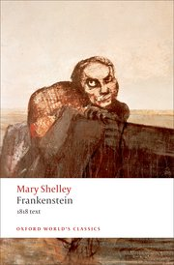
Mary Shelley, Frankenstein
recommended edition is the Oxford University Press, 1998 or 2008.
[we will be reading the 1818 not the 1831 edn.]
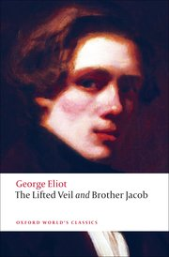
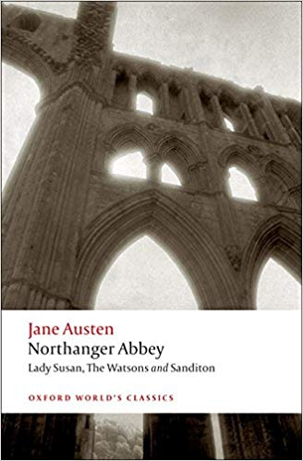
Jane Austen, Northanger Abbey
recommended edition is the Oxford University Press, 2008 or Penguin 1998.
[I own a copy of Penguin edition which I am happy to lend for the semester
– first come, first served]
Sweeney Todd: The Demon Barber of Fleet Street
recommended edition is the Oxford University Press, 2008, ed. Robert Mack.
The text called Sweeney Todd: The String of Pearls, is, as far as I can tell, the same,
but has different footnotes/introductory material, and the pagination is different,
so try and get the recommended if possible.

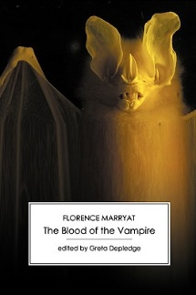
George Eliot, "The Lifted Veil"
Recommended Oxford University Press, 2009 edn (earlier edition in library)
Florence Marryat, The Blood of the Vampire
Recommend the Victorian Secrets edition
H.G. Wells, The War of the Worlds
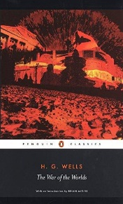
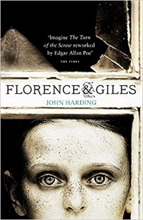
Recommended edn. is Oxford 2017, or Penguin, 2005
[I own a copy of Penguin edition and an old non-academic press version
which I am happy to lend for the semester – first come, first served]
John Harding, Florence and Giles (2010)
The Borough Press, 2011
RE: Robert Louis Stevenson, The Strange Case of Dr Jekyll and Mr Hyde – if you own a Norton Anthology (vol.E The Victorian Age) the text is reproduced in there. If not, an academic press (OUP, Penguin, Norton) is preferable.
RE: Henry James, “The Turn of the Screw” there are LOTS of editions in the library, lots of e-versions [and I own another copy which I am happy to lend for the semester – first come, first served]. If you want to purchase, again an academic press (OUP, Penguin, Norton) is preferable.

