Week 1: What is Gothic?

As well as my general brief introduction to, and overview of, the course, in week one, we will be considering, as a group, the elusive nature of “Gothic” (and, indeed, whether it should be capitalised, and whether that even matters). You need to do some preparatory work:
1.a) Read the following “primary sources” (this is a bit of a contentious term…but let’s go with it) to get a sense of how contemporary authors framed the character and functions of terror and horror, how critics of the nineteenth century received and criticised what we would call (broadly) “Gothic” literature and its readers.
- Anon. ‘Terrorist Novel Writing’ (1797) [reproduced below]
- Anon. “Novel-Reading: A Cause of Female Depravity” (1817) [reproduced below]
- Ann Radcliffe, ‘On the Supernatural in Poetry’ (1826) https://www.saylor.org/site/wp-content/uploads/2011/01/On-the-Supernatural-in-Poetry.pdf
- Wilkie Collins, “The Unknown Public” (1858) [reproduced below]
1.b) Get a sense of reception by reading the chapter “Literary Rubbish” by Franz. J. Potter from The History of Gothic Publishing, 1800–1835. London: Palgrave Macmillan, (2005).
https://link.springer.com/content/pdf/10.1057%2F9780230512726_1.pdf

2. Ensure to get some sense of context and – in particular the origins of Gothic literature – by reading and making notes on the early chapters, introductions, and overview chapters on Gothic origins found in Gothic companions such as**:
- The Cambridge companion to gothic fiction / ed. by Jerrold E. Hogle (2002)
- A New Companion to the Gothic / ed.by David Punter (2012) [electronic resource]
- Romantic gothic: an Edinburgh companion / ed. Angela Wright and Dale Townshend (2016) [electronic resource]
- See also texts such as The Gothic: A Very Short Introduction by Nick Groom, [electronic resource]
**Note I don’t expect you to read all of these, nor limit yourself to these suggestions. But just one chapter would not be enough!
3. Ensure to get some sense of the key tropes and themes and of the critical concepts at play in Gothic Studies. Keep track of who says what, in which text, arguments for and against. The following are suggested texts, but you should read beyond these:
- Key Concepts in the Gothic by William Hughes (2018) [electronic resource]
- Gothic literature (2014) / Andrew Smith [print and electronic resource]
- Gothic / Fred Botting (2014) [electronic resource]
- Gothic: critical concepts in literary and cultural studies / edited by Fred Botting and Dale Townshend [only print version available but there are 4 copies] (2004)
- Gothic literature: a Gale critical companion / foreword by Jerrold E. Hogle; Jessica Bomarito (2006) [electronic resource]
**Note, again, I don’t expect you to read all of these, nor limit yourself to these suggestions. But just one chapter would not be enough!
4. Using overviews and introductory chapters, start to have a read of how different critics characterise early-nineteenth and Victorian Gothic (but this is something we will be building on in more detail across the course, so concentrate on the previous three tasks if short of time).

Spirit of the Public Journals for 1797, London: R.Phillips, 1798. pp.223-5. © British Library Newspapers
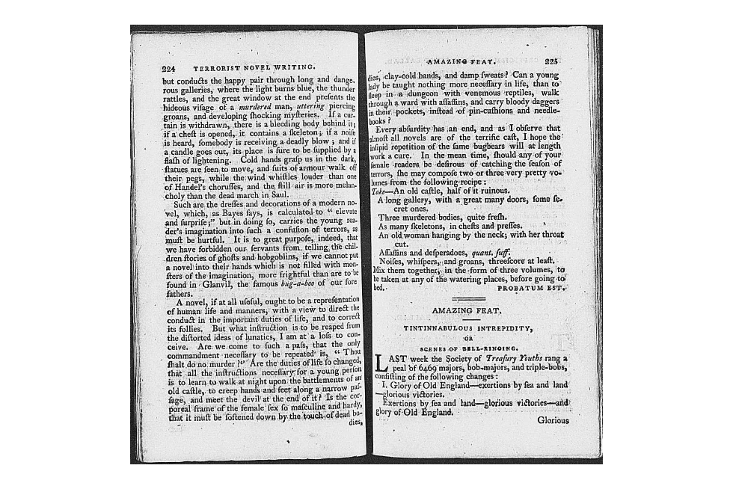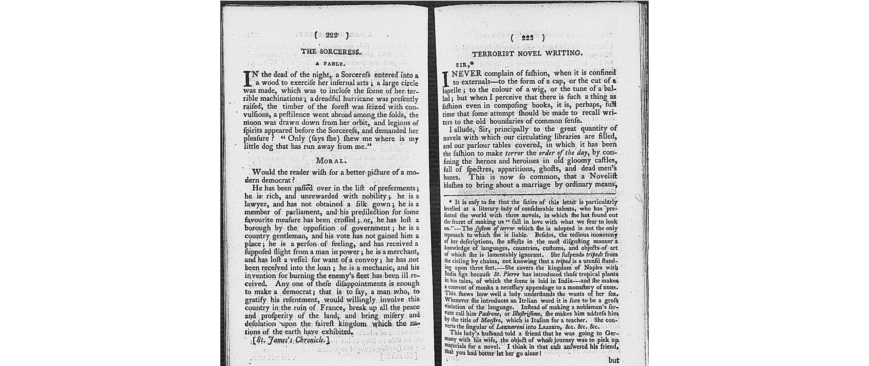

La Belle assemble: or Court and fashionable magazine; May 1817; British Periodicals pg. 219-220

