Q300 English Literature Degree

See online version of this handout for access to all links referred to in this handout.

You will take all of these Core modules:
- EN101 (30 CATS) Epic into Novel
- EN121 (30 CATS) Medieval and Early Modern Literature
- EN122 (30 CATS) Modes of Reading
Optional:
- Either the optional core EN123 (30 CATS) Modern World Literatures
- Or an alternative Language option from the Language Centre or in the School for Modern Languages – this will be your responsibility to liaise with the other department to sign up for this module and arrange to be allocated to the required classes. See further information at the end of this document regarding Language modules.
Additional compulsory module:
- Academic Enrichment Programme
You will also participate in the Academic Enrichment (AE) Programme – you will have been allocated to a session with any AE tutor. Please note, there is no timetabled Academic Enrichment session in week 1, rather you will need to attend the “Hidden Curriculum” talk that week, which will appear on your timetable.
This will take place on Monday 2nd October at 9:00 – 11:00am.
Academic Writing Support
Please see Academic Writing support via Moodle.

Lectures
Lectures for all of the core modules start in week 1 – you should attend these in preparation for your studies, the lectures for core modules will show on your timetable however, if you are still deciding if you wish to take this Modern World Literatures or a language module, you can attend the lecture for Modern World Literatures as below:
- EN123 (30 CATS) Modern World Literatures – Tuesday – 2:00 – 3:00pm – Room FAB0.08

Seminars
There are introductory meet and greet seminars in week 1, but don’t worry if you miss that. Seminars officially start in week 2, so you need to select a seminar as follows via Tabula:
- Core modules – you will already be registered for your three core modules, so you just need to select a seminar group via Tabula – if do not do this by Friday of week 1, we will allocate one for you. The lectures will automatically be displayed on your Tabula Timetable.

- Optional Core module – you need to decide which module to take, either Modern World Literatures (see lecture details above) or a language module – see details overleaf. You will then need to register, via eVision, by Thursday of week 1, the system then updates overnight, and you can then sign up for a seminar on Tabula – You must do this by Friday of week 1 at the very latest – if it is not done and you leave this until week 2, then there may not be spaces on your first choice of module.

Once you have registered for all modules and selected seminars as per the attached note, double-check your timetable carefully for any issues/clashes. Please note that you can swap groups if required to accommodate a class from another department. However, you must do this by the end of week 1.
If you have any queries regarding your English literature modules, please contact UGEnglish@warwick.ac.uk or you can call into the student office – room FAB5.42 – 5th floor of the Faculty of Arts Building - see the departmental webpage for up to date contact details and times. Please refer any other queries regarding optional modules to the School of Modern Languages on 4th Floor of the Faculty of Arts Building or via SMLoffice@warwick.ac.uk or the Language Centre via academic.language@warwick.ac.uk
Plus, do not forget to attend the Welcome Week induction meetings and events - See online version of this handout for access to all links.
Tuesday 26th September
10:00 – 12:00 Induction 1 – Room FAB0.03
1:00 – 2:00 – If your surname starts with A – L, collect books for your core reading for Epic into Novel, Medieval to Early Modern Literature, Modes of Reading and Modern World Literatures, if required, from the student office - room FAB5.42 – 5th floor of the Faculty of Arts Building. Bring a bag!
Wednesday 27th September
9:30 – 11:00 – Induction 2 – Room FAB0.03
11:00 – 12:00 - If your surname starts with M - Z, collect books for your core reading for Epic into Novel, Medieval to Early Modern Literature, Modes of Reading and Modern World Literatures, if required, from the student office - room FAB5.42 – 5th floor of the Faculty of Arts Building.
17:00 - All ECLS students - Welcome Social with staff – FAB5.01/2/3
Thursday 28th September
9:30 – 11:00 – Induction 3 – L3, Chemistry building 2nd floor
13.00 – 14.00 – Induction for Visiting International Students only – Room FAB5.03

Arts Faculty Student Pre-Arrival Module
Please also be aware of the Arts Faculty Student Pre-Arrival Moodle Module! This module can be accessed via this link: http://warwick.ac.uk/artsfacultystudentinduction
If any of you seem to be finding it difficult to settle in, adjust to University life or familarise yourselves with academic structures, processes and terminology it might be worth accessing this resource. The resource contains useful information about assessment, wellbeing, personal tutoring, the library and various extra curricula activities and will be available to you throughout your first year.

ACTIVE BYSTANDER INFORMATION
You can attend an online session on Thursday 28th September at 2:00 – 3:00 – Click here to join the meeting.
For more information – see here - Active Bystander Intervention Course (warwick.ac.uk)

Would you like to add a language to your degree?

The Language Centre (http://warwick.ac.uk/languagecentre) offers a wide range of modules and the facilities, resources and programmes to support your acquiring a new foreign language or brushing up your language skills:

i. Modules for credit on our academic programme

These can be taken as part of an undergraduate degree course but must be agreed with your home department before enrolling. There are a range of levels available, as well as accelerated options for those who want to develop their language skills at a faster pace. More information is available from: http://warwick.ac.uk/languagecentre/academic/

ii. Modules not for credit on our academic programme

The same modules as those available for academic credit are also available to take in addition to degree studies. A fee applies to these modules. More information is available from: http://warwick.ac.uk/languagecentre/academic/fees/

iii. Courses not for credit on our Lifelong Language Learning (LLL) programme

A programme of language courses available to students and staff from beginner through to advanced level. More information is available from: http://warwick.ac.uk/languagecentre/lifelonglearning/.

Enrolment

Enrolment takes place online for all programmes, from late September.

Academic modules: Please consult Language Centre - Academic Enrolment (warwick.ac.uk) for further information on the enrolment process. The Language Centre can also be contacted by email at academic.language@warwick.ac.uk for more information on these modules.

Lifelong Language Learning courses: Please consult Language Centre - Enrolment for Lifelong Language Learning (LLL) Courses (warwick.ac.uk) The Language Centre can also be contacted by email at language.enquiries@warwick.ac.uk for more information on these courses.

How do I select a Seminar Group?

PLEASE ENSURE YOU REGISTER FOR MODULES VIA THE MODULE REGISTRATION
To select your Seminar Groups you will need to:
- Go to Tabula http://tabula.warwick.ac.uk
- Log in
- Click on Small Group Teaching on the front menu page
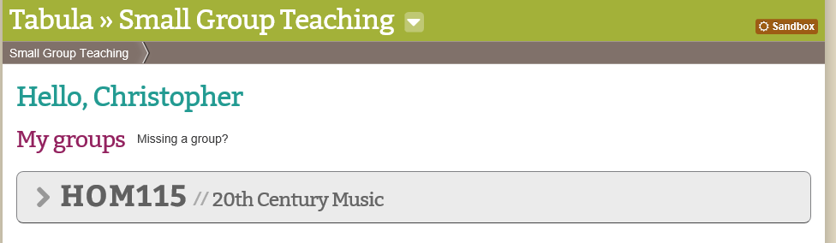
- You should now see a list of all your Modules that have available seminar groups to sign up for. Click on the > sign to expand a module so you can see what Groups are available.
- You should now see a page similar to below.
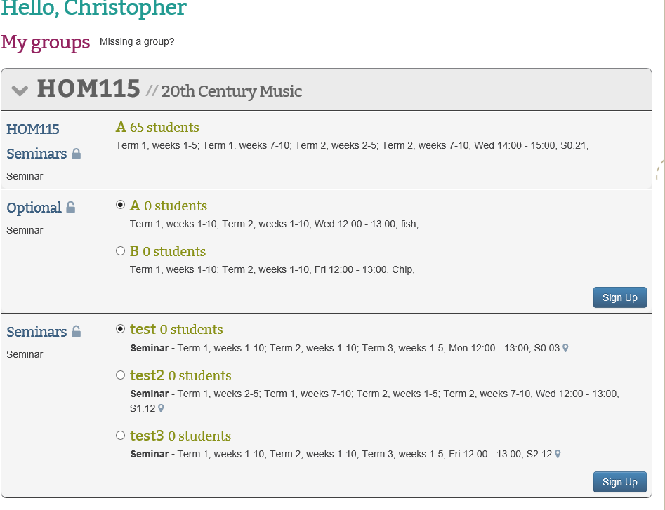
- For each event you have a choice of groups for you should:
- Check the details of the event listed (it lists Term, Weeks, Day, Time and room beneath each group)
- Tick the radio button for the group you want to be in
- Click on the Sign-Up button
Please note you must do this for each module and event that you need to register for.
Please note that groups will have set sizes and once a group is full it will not be possible to register for it.

Can I change groups?
To select your Seminar Groups, you will need to:
- Go to Tabula http://tabula.warwick.ac.uk
- Log in
- Click on Small Group Teaching on the front menu page
- You should now see a list of all your Modules that have available seminar groups to sign up for. Click on the > sign to expand a module so you can see what Groups are available.
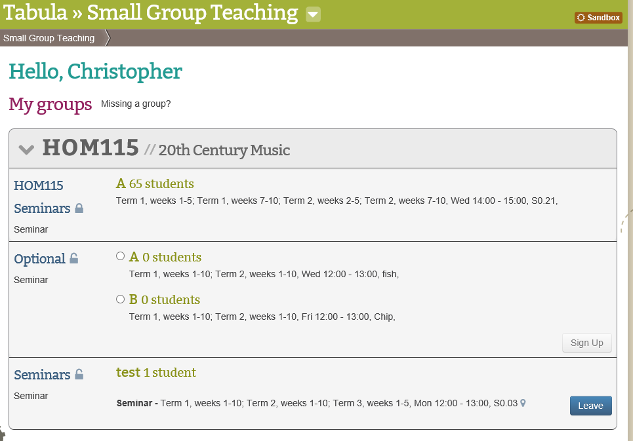
- You should now see a page similar to below.
- As you can see that the Sign-Up button has changed to a Leave button

- If you wish to change groups, you must first leave the one you are registered for by clicking the Leave button

- You will then be able to select a new Seminar group from a list of the available groups which still have space available by following the Selecting a Seminar Group instructions.

Please note that groups will have set sizes and once a group is full it will not be possible to register for it.

