How do I select a Seminar Group?

PLEASE ENSURE YOU REGISTER FOR MODULES VIA THE MODULE REGISTRATION SYSTEM – SEE OTHER NOTE
To select your Seminar Groups you will need to:
- Go to Tabula http://tabula.warwick.ac.uk
- Log in
- Click on Small Group Teaching on the front menu page
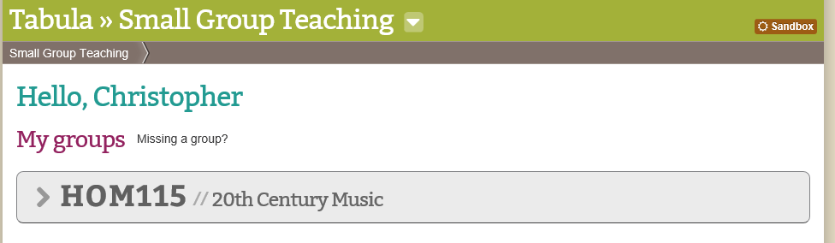
- You should now see a list of all your Modules that have available seminar groups to sign up for. Click on the > sign to expand a module so you can see what Groups are available.
- You should now see a page similar to below.
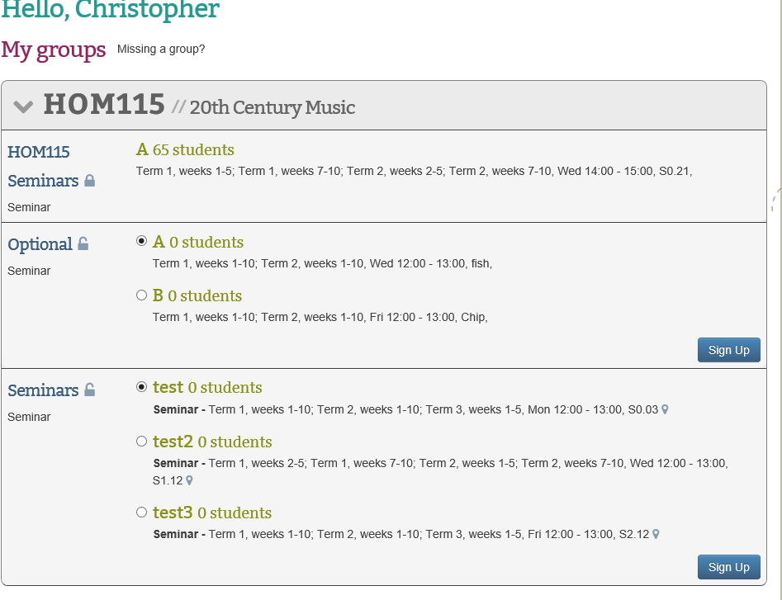
- For each event you have a choice of groups for you should:
- Check the details of the event listed (it lists Term, Weeks, Day, Time and room beneath each group)
- Tick the radio button for the group you want to be in
- Click on the Sign Up button
Please note you must do this for each module and event that you need to register for.
Please note that groups will have set sizes and once a group is full it will not be possible to register for it.

Can I change groups?
To select your Seminar Groups you will need to:
- Go to Tabula http://tabula.warwick.ac.uk
- Log in
- Click on Small Group Teaching on the front menu page
- You should now see a list of all your Modules that have available seminar groups to sign up for. Click on the > sign to expand a module so you can see what Groups are available.
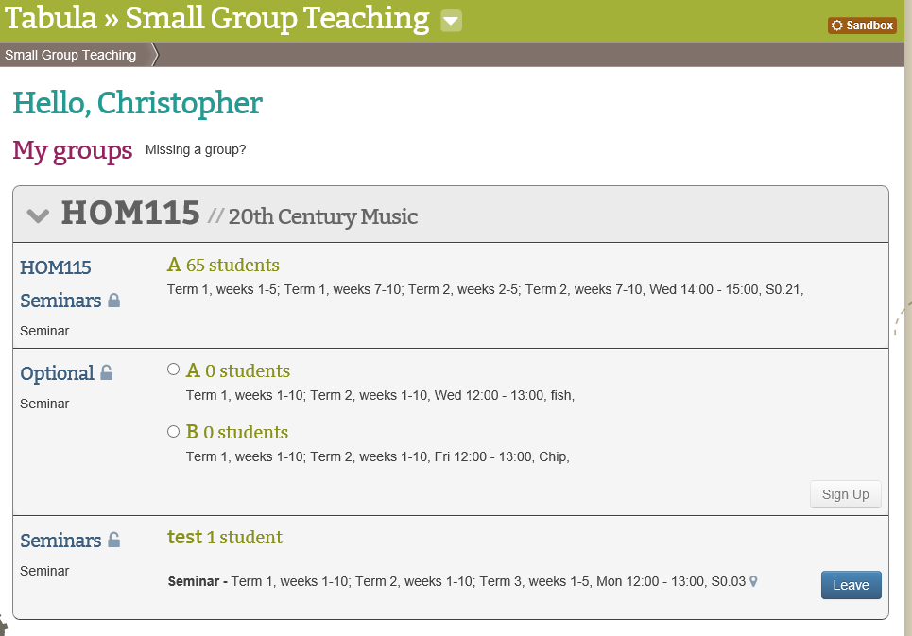
- You should now see a page similar to below.
- As you can see that the Sign Up button has changed to a Leave button

- If you wish to change groups you must first leave the one you are registered for by clicking the Leave button

- You will then be able to select a new Seminar group from a list of the available groups which still have space available by following the Selecting a Seminar Group instructions.

Please note that groups will have set sizes and once a group is full it will not be possible to register for it.

