EN2C2/3C2
The English Nineteenth-Century Novel
(2021-22)

The following list details which editions of our primary novels to buy, borrow, or access online. In many cases it is very important that you obtain the right edition.
For the full weekly reading schedule (including serial instalments and required critical readings) see here and ensure to click on the Reading Guidance for each text to help you take more effective and focused notes.
Places to obtain physical copies of texts:
The library has many of our texts in print or online and the correct editions are listed below. Remember that not every edition in the library will be the one we need – ensure you read any notes below about which edition to get.
Amazon isn’t the only place to get cheaper second-hand books. You can try second-hand book stores/charity shops or online book sellers, such as:
World of Books https://www.worldofbooks.com/en-gb
Oxfam Books https://onlineshop.oxfam.org.uk/books/category/books
BetterWorldBooks https://www.betterworldbooks.com/
You can also compare prices on this website: http://www.booksprice.co.uk/

- The Novel of Manners - Maria Edgeworth, Belinda (1801/2)
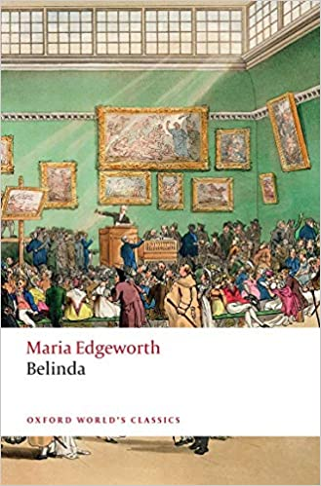
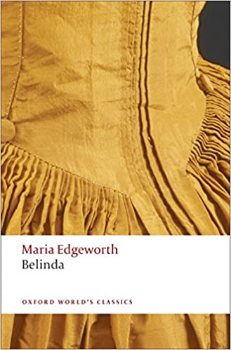
IT IS VERY IMPORTANT that you do not purchase or use online versions of later editions from 1810 onwards because those versions substantially revised the text. We will be discussing these revisions in class, but you need to read an 1801/2 edition. This includes the e-version in library catalogue and the apparent (but not) kindle versions of those pictured below.

The versions pictured above are both published by Oxford World’s Classics (left is 1994 reissued 2008, right is 2020) and introduced by either Kathryn Kirkpatrick or Linda Bree. The text used for these is based on the 1801/2 edition and this is the one you need for class.
The library holds copies of an earlier version 1994/1999 Oxford WC (edited and introduced by Kirkpatrick) which is fine too.
If you want to use a free e-version then please use try this one – you need to sign up for free and “borrow” the book (you can borrow for 1 or 14 days and can re-borrow later) https://archive.org/details/belinda0000edge
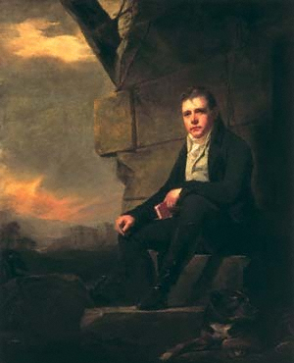
2. Historical Fictions - Walter Scott, Ivanhoe (1819/1830)
For this novel it is very important that you read the correct edition. We are using the 1830 Magnum Opus text originally published in 2 vols (although you will only buy one book) rather than the original 1819/20 edn which was originally published in 3 volumes.
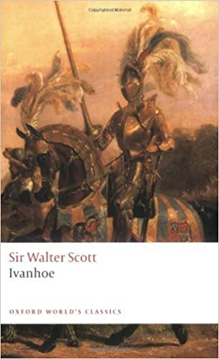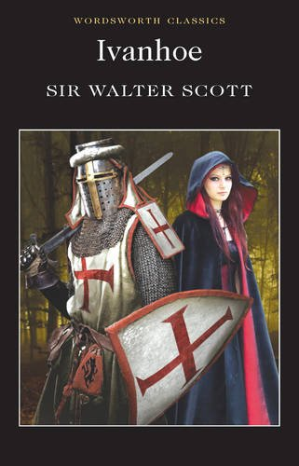
Recommended for Purchase:
I recommend the Oxford World’s Classics edition with an introduction by Ian Duncan (2008/2010) pictured above left. If you can’t get that one then the Wordsworth Classics (1995/2000) version edited and introduced by David Blair (right) is also acceptable.
The Library – does not, as far as I can tell, have the version we need in print, but I have requested that some of the Oxford editions are purchased for September if possible.
If you want to use a free e-copy, please use the following: Ivanhoe. A Romance (archive.org) (you are reading Vol 16 and 17)

3. The Industrial Novel – Elizabeth Gaskell, Mary Barton (1848)
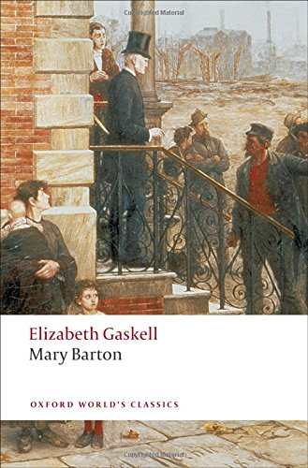 OR 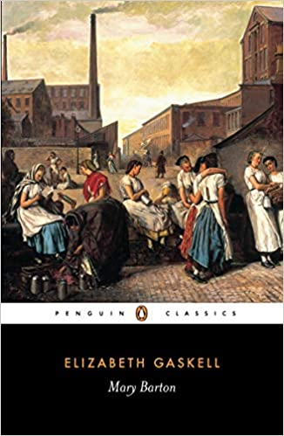 OR 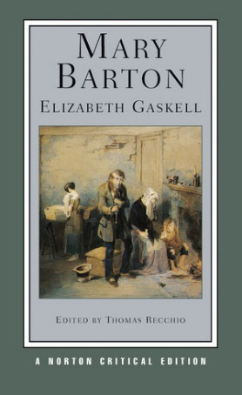
Recommended for Purchase:
For ease of us all being on the same page, and because of their critical insights, the Oxford World’s Classics or Norton Critical Edition (pictured above) are recommended. They base their text on the 1854 edition. This was the fifth edition and the last one Gaskell saw through the press with her own revisions.
The Library has print copies of an older version of the recommended Oxford Mary Barton which you can use.
There are differences from the original 1848 edition that some other texts use (such as Penguin classics), but it is not essential for this novel that you read one edition over the other (we can always raise any differences as a point of interest in class).
Free E-versions:
The Library also has some e-versions but they are plain text (so the editing is dubious) and without critical notes. I therefore recommend one of these versions from Internet Archive if you want a free online edition – you need to sign up for free and “borrow” the book (you can borrow for 1 or 14 days and can re-borrow later). https://archive.org/details/marybarton0000gask_o3v1/mode/2up
https://archive.org/details/marybarton0000gask

4. Hybrid Sensations - Charlotte Brontë’s Villette (1853)

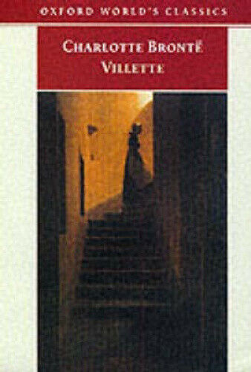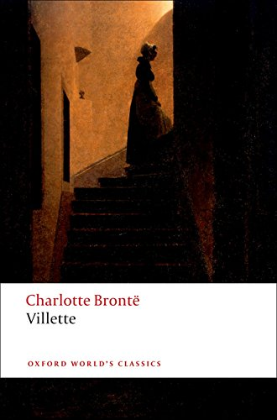 OR 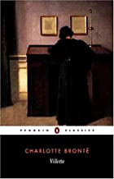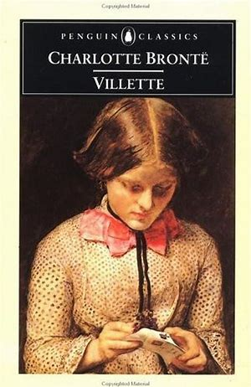
Recommended for Purchase:
For this novel, there is not really any issue with which edition you get (as long as it’s not abridged!) but I will be using the Oxford World’s Classics version. Oxford and Penguin are generally more reliable. Everyman and Wordsworth are fine too.
Library/Free E-versions:
The Library has print copies (3 Day loan) and online copies of the Oxford version:
Villette [electronic resource] / Charlotte Brontë ; edited by Margaret Smith and Herbert Rosengarten ; with an introduction and notes by Tim Dolin

5. Children’s Literature – Charles Kingsley, The Water-Babies (1863)
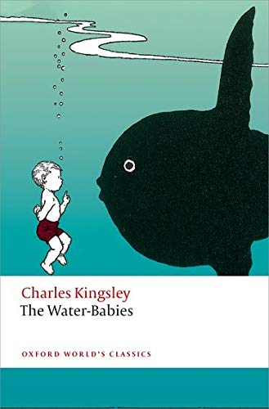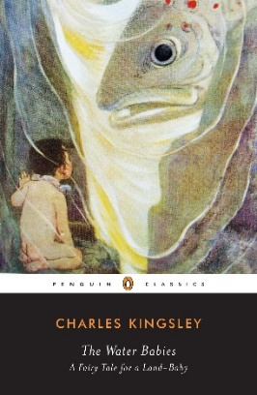
If you already own an unabridged edition then that is fine, but if you would like to purchase a copy, then I am suggesting foremost Oxford or Penguin as they contain some early illustrations, but any unabridged version is acceptable, and lots of versions have different fabulous illustrations we can compare.
The Library doesn’t currently have any copies we can use but I have requested some.
Free e-version: There are lots of versions, but this is an 1894 version with illustrations https://archive.org/details/waterbabiesfairy00king2/page/6/mode/thumb

6. The Pastoral Novel – Thomas Hardy’s Far from the Madding Crowd
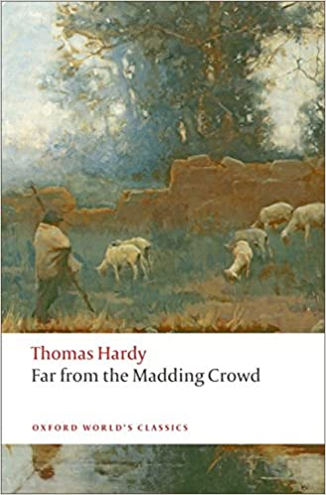
It is fairly important we use the same or similar edition to this novel (1874), if possible, as in 1895 and then 1912 Hardy substantially revised passages. The one I recommend if you want to purchase – the Oxford World’s Classics edition – collates some of the revisions.
The Penguin editions are based on the 1912 “New” Wessex Edition, and we are using the early versions – but it does also include some of the revised passages so if you already own a Penguin then we can make do. As beautiful as the Norton Critical edition is, it’s not appropriate for our needs here.
I have requested the library purchases some of the Oxford editions.
The Library has two e-books - Open Road Integrated Media that uses the 1912 edn and Floating Press which uses the 1895) so my recommendation is this e-version: https://archive.org/details/farfrommaddingc00hardgoog/page/n42/mode/thumb

7. Imperial Romance – H. Rider Haggard’s She: A History of Adventure
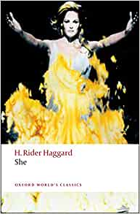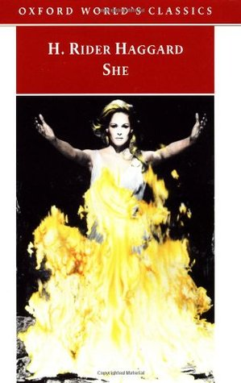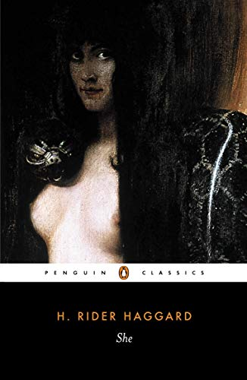
I will be using, and therefore, recommend one of the Oxford World’s Classics editions (1991 or 2008). But there is no issue with the Penguin or most other unabridged versions (but try to get one with some sort of critical introduction).
The Library has two print copies of the 1991 Oxford edn (middle – that’s the one I have) and also some Pulp Fictions versions with very interesting covers
Free e-version (via library catalogue):
She [electronic resource] : a history of adventure / by H. Rider Haggard

8. Realism and the Literary Profession/Market-place – George Gissing’s New Grub Street (1891)
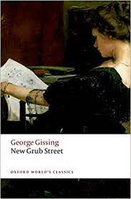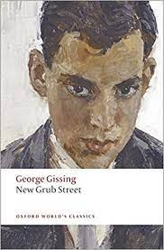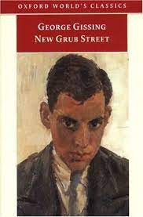
I recommend any of the Oxford World Classics versions pictured above (these reproduce the text in the single-volume format), but you can also use/obtain the Penguin editions (the indicate the separate volumes but that is not an issue).
If you want to spend a bit more money the Broadview Press critical edition might entice.
The Library has hard copies of the Oxford and the Penguin versions.
Free e-versions:
Link to a facsimile of the Oxford edition at archive.org (for this one you need to sign-up for free to borrow the book – borrowing is renewable)
Link to a facsimile of the Penguin edition at archive.org

9. Science Fiction – The War of the Worlds
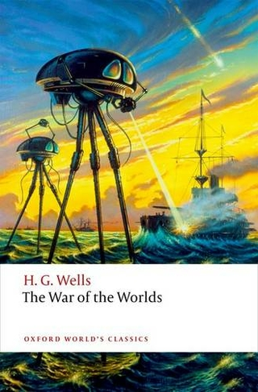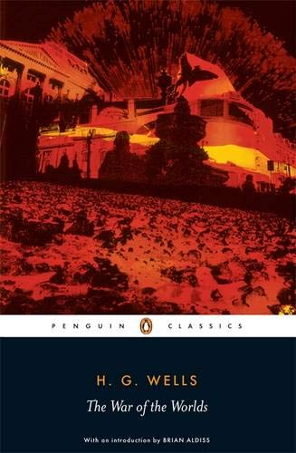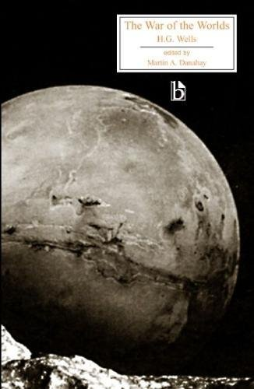
For this text, you can use any unabridged edition, but as per, I recommend the Oxford or the Penguin. If you want one with lots more critical material in, then try the (more expensive) Broadview.
The Library as a few print copies of the Penguin and this free e-text:
The war of the worlds / by H. G. Wells

