QR34 English & Hispanic Degree

Scan for further information and links:


Modules from the English Department:
Lectures for all our first-year modules start in week 1.
Core module:
- EN122 (30 CATS) Modes of Reading – Thursday 10:00 – 11:00am – room L3
You must choose one of these Optional Cores:
- EN101 (30 CATS) Epic into Novel - Thursday – 12:00-1:00pm – room L3
- EN121 (30 CATS) Medieval to Early Modern Literature – Tuesday – 12:00 – 1:00pm – room L3
- EN123 (30 CATS) Modern World Literatures – Tuesday – 2:00 – 3:00pm – Room Woods-Scawen, Arts Centre.
There is an introductory meet and greet seminar in week 1, but don’t worry if you miss that. Seminars officially start in week 2, so you need to select a seminar as follows via Tabula:
- Core module – you will already be registered for Modes of Reading, so you just need to select a seminar group via Tabula – if do not do this by Friday of week 1, we will allocate one for you. The lecture will automatically be displayed on your Tabula Timetable.
- Optional Core modules – you need to decide which module to take – if you are still undecided, you can attend the lectures for the optional cores in week 1 – see lecture details above. You will then need to register, via eVision – see your Home Department about this - by Thursday of week 1, the system then updates overnight, and you can then sign up for a seminar on Tabula – You must do this by Friday of week 1 at the very latest – if it is not done and you leave this until week 2, then there may not be spaces on your first choice of module. Lectures will not appear on your timetable until you register for your optional module.

Once you have registered for all modules and selected seminars as per the attached note, double-check your timetable carefully for any issues/clashes. Please note that you can swap groups if required to accommodate a class from another department. However, you must do this by the end of week 1.

If you have any queries regarding your English literature modules, please contact UGEnglish@warwick.ac.uk or you can call into the student office – room FAB5.42 – 5th floor of the Faculty of Arts Building - see the departmental website up to date contact details and times. Please refer any other queries to your home department.

How do I select a Seminar Group?

PLEASE ENSURE YOU REGISTER FOR MODULES VIA THE MODULE REGISTRATION SYSTEM
To select your Seminar Groups, you will need to:
- Go to Tabula http://tabula.warwick.ac.uk
- Log in
- Click on Small Group Teaching on the front menu page
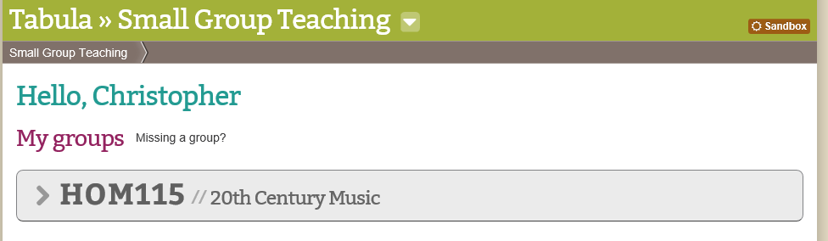
- You should now see a list of all your Modules that have available seminar groups to sign up for. Click on the > sign to expand a module so you can see what Groups are available.
- You should now see a page similar to below.
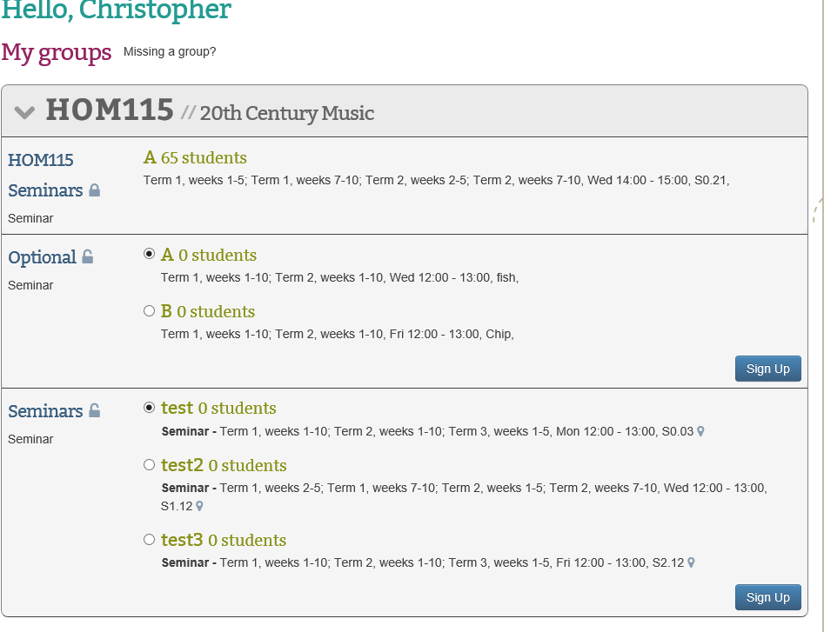
- For each event you have a choice of groups for you should:
- Check the details of the event listed (it lists Term, Weeks, Day, Time and room beneath each group)
- Tick the radio button for the group you want to be in
- Click on the Sign-Up button
Please note you must do this for each module and event that you need to register for.
Please note that groups will have set sizes and once a group is full it will not be possible to register for it.

Can I change groups?
To select your Seminar Groups, you will need to:
- Go to Tabula http://tabula.warwick.ac.uk
- Log in
- Click on Small Group Teaching on the front menu page
- You should now see a list of all your Modules that have available seminar groups to sign up for. Click on the > sign to expand a module so you can see what Groups are available.
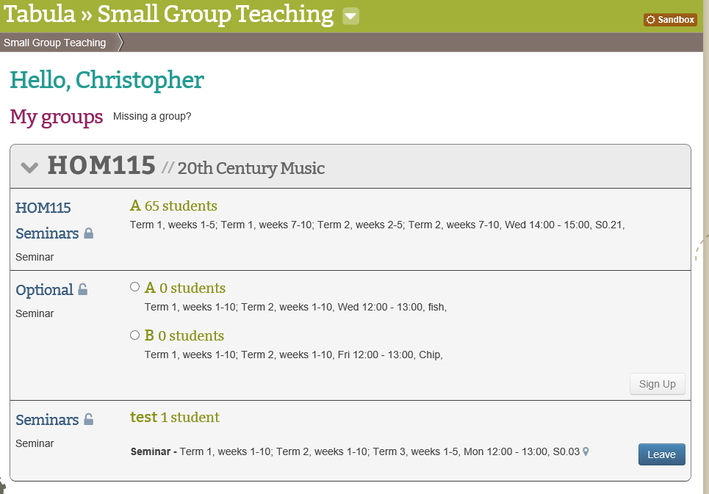
- You should now see a page similar to below.
- As you can see that the Sign-Up button has changed to a Leave button

- If you wish to change groups, you must first leave the one you are registered for by clicking the Leave button

- You will then be able to select a new Seminar group from a list of the available groups which still have space available by following the Selecting a Seminar Group instructions.

Please note that groups will have set sizes and once a group is full it will not be possible to register for it.

