Modes of Reading – Seminar Handout
Week 7 – Allen Ginsberg, Howl (1956)
Points of general relevance
- Use of semi-colons
- Use of weak claims – ‘seem’, etc. Avoiding automatically strengthens argument and programmatically encourages use of evidence.
- Task
- Elucidation
- Quotations/page numbers
- Rhetoric/questions (use sparingly)
- Thesis – stick to it and argue it! Spend time working out what you want to argue for.
Howl (1956)
Ginsberg reading (- http://www.youtube.com/watch?v=2p_kKhRmRkM
Time
Mescaline - http://www.youtube.com/watch?v=Hd4rgyZzseY
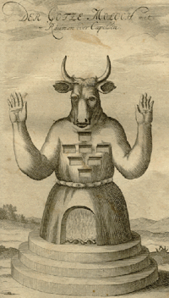 (Moloch)
Questions
(1) How do the structure and form of Howl reflect its content?
(2) Consider Ginsberg's view of Capitalist society and discuss how this view is presented in the poem.
(3) The poem begins: "I saw the best minds of my generation destroyed by madness" and ends: "Holy the supernatural extra brilliant intelligent kindness of the soul!" How does the mood of the poem change as it progresses?
(4) Discuss the role of Moloch in Part II of Howl.
(5) What effect does the language create in Footnote to Howl?

