Modes of Reading – Seminar Handout
Week 9 – Shklovsky and Ginsberg
What does literature do?
- ‘Art exists that one may recover the sensation of life’
- Does this always work politically/anti-ideologically? Think about what we said last week about whether the art that makes you feel happy/comfortable vs. angry/sad/indignant, etc.
- ‘…the author's purpose is to create the vision which results from that deautomatized perception’ / ‘…defamiliarization is found almost everywhere form is found’ – absolutism – do people agree?
Theoretical elaboration of this…?
- Marx on ideology – ‘false consciousness’
- Habitus: ‘…embodied history, internalized as a second nature and so forgotten as history […] It is just that we don't directly feel the influence of these past selves precisely because they are so deeply rooted within us. They constitute the unconscious part of ourselves. Consequently we have a strong tendency not to recognize their existence and to ignore their legitimate demands’ (Pierre Bourdieu, The Logic of Practice, 1990).
Avant-Garde/conceptual art

DISORDER – ‘It is obvious that the systematization will not work, for in reality the problem is not one of complicating the rhythm but of disordering the rhythm - a disordering which cannot be predicted.’
http://www.ubu.com/sound/bok.html

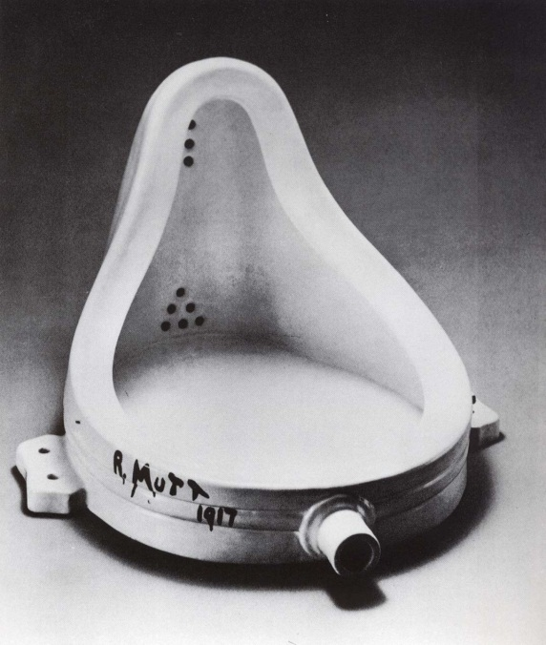

‘Cognitive estrangement’ and Sci-fi
- Ursula K. Le Guin – Left Hand of Darkness (1969) – classic example of cognitive estrangement – a world in which the inhabitants are ‘gendered’ only once a month. This has the effect of forcing us to question the nature of our own permanently gendered social organisation.
- Charles R. Saunders - ‘Why blacks don’t read sci-fi?’ Windhaven no.5 (1977)
- Tolstoy and Kholstomer – cf. http://video.google.com/videoplay?docid=5437261131639475009 – 5:00 ff
Questions
1. “Images change little from century to century… from poet to poet.” In relation to this statement, does ‘Howl’ use/not use predictable imagery, and what is the effect of this?
2. How does ‘Howl’ use poetic imagery to create “the strongest possible impression”? Can you give examples?
3. Is there any accepted perception, whether ideological or social, which has become “unconsciously automatic” in the eyes of the poem, and which Howl actively questions?
4. “The technique of art is to make objects ‘unfamiliar’.” How can this statement be applied to the language and ideas in Howl, and what is the effect, if any, of this unfamiliarity?
5. How can the text be seen as responding to Shklovsky’s idea that “the purpose of art is to impart the sensation of things as they are perceived and not as they are known”?

