Modes of Reading – Seminar Handout
Week 4 – Selvon and Buell - Place and Belonging – Can literature save the world?

Housekeeping

- Next essay due Term 3, Week 2, 30th April, 2013
- Lit theory component lecture – H051
- Office hour room H528

FUUUUCCCCCKKKK!!!!!!!!!!!!!!

“I think the economic logic behind dumping a load of toxic waste in the lowest-wage country is impeccable and we should face up to that. . . . I’ve always thought that countries in Africa are vastly under polluted; their air quality is probably vastly inefficiently low compared to Los Angeles. . . . Just between you and me, shouldn’t the World Bank be encouraging more migration of the dirty industries to the Least Developed Countries?” (Lawrence Summers, confidential World Bank memo, December 12, 1991)

Petrofiction - http://www.youtube.com/watch?v=XbVuEHtJGQU

Manufactured Landscapes - http://www.youtube.com/watch?v=FEOe27xXhVU
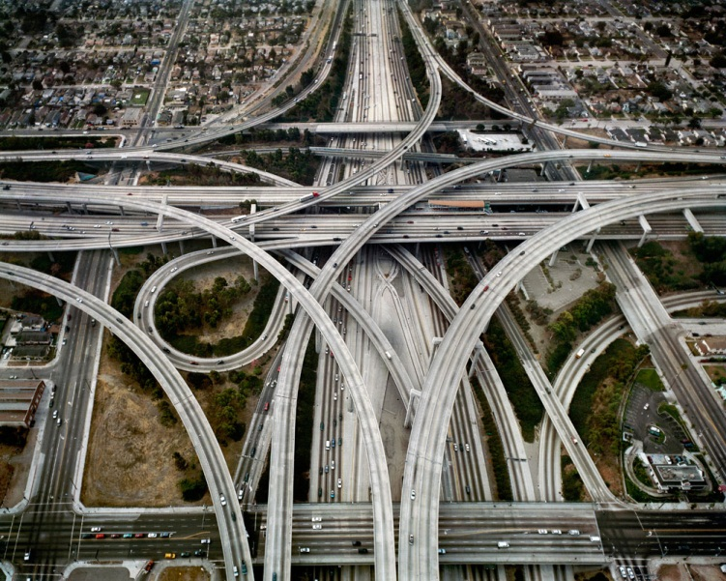

Lawrence Buell

- “Without a complex knowledge of one’s place, and without a faithfulness to one’s place on which such knowledge depends … it is inevitable that the place will be used carelessly and eventually destroyed” (Wendell Berry) (667)
- ‘…an awakened place-awareness that is also mindful of its limitations and respectful that place molds us and vice versa’ (668)
- ‘Environmental literature launches itself from the presumption that we do not think about our surroundings, and our relation to them, as much as we ought to’ (673)
- “Restorationism” (Aldo Leopold, Thoreau, Berry, etc.) (677)
- “Now, environmental writing does not literally repair the biosphere, does not literally do anything directly to the environment. But in the ways I have described it tries to practice a conceptual restoration in reorienting the partially denaturized reader not to a primordial nature, which we cannot recover either in fact or in fantasy but to an artificial version of environment designed to evoke place –sense … “to make scars grow grass”’ (677)
- ‘Places are by definition bounded…’ (678)
- ‘In the betweenness of map making and place-bonding environmental writing locates itself. Both official and intuitive knowledge are ultimately directed towards expressing its topophilia, its commitment to rendering a textual equivalent of an actual or virtual place’ (685)

Selvon

- ‘Tolroy and his family live off the Harrow Road, and the people in that area call the Working Class. Wherever in London that it have Working Class, there you will find a lot of spades. … The houses around here old and grey and weather beaten, the walls cracking like the last days of Pompeii, it ain’t have no hot water, and … none of the houses have bath … playing in the road because they have no other place to play … Them people who have car …don’t know nothing about hussling two pound brussel sprout … or queuing up for fish and chip in the smog … they come to kind of accept that so the world is, that it bound to have rich and poor…’(59 ff).’
- ‘Jesus Christ, when he say “Charing cross”, when he realise that he, sir Galahad, who going there ’ that place that everybody in the world know about (it even have the name in the dictionary) he feel like a new man. It didn't matter about woman he going to meet, just to say he was going there made him feel big and important, and even if he was just going to coast a lime, to stand up and watch the white people, still, it would have been something’ (72; 74)
- ‘“Ah you just like Daniel and Five Past Twelve and them other fellar … I go and live Paradise … All day long sit down in the grass in the sun”’ (125)

Others

- Darwin has directed attention to the history of natural technology, i.e. the formation of the organs of plants and animals, which serve as the instruments of production for sustaining their life. Does not the history of the productive organs of man in society; of organs that are the material basis of every particular organization of society, deserve equal attention? And would not such a history be easier to compile, since, as Vico says; human history differs from natural history in that we have made the former, but not the latter? Technology reveals the active relation of man to nature, the direct process of the production of his life, and thereby it also lays bare the process of the production of the social relations of his life, and of the mental conceptions that flow from those relations. Even a history of religion that is written in abstraction from this material basis is uncritical. It is, in reality, much easier to discover by analysis the earthly kernel of the misty creations of religion than to do the opposite, i.e. to develop from the actual, given relations of life the forms in which these have been apotheosized. The latter method is the only materialist, and therefore the only scientific one. The weaknesses of the abstract materialism of natural science, a materialism which excludes the historical process, are immediately evident from the abstract and ideological conceptions expressed by its spokesmen whenever they venture beyond the bounds of their own speciality (Marx).
- Labour is, first of all, a process between man and nature, a process by which man, through his own actions, mediates, regulates and controls the metabolism between himself and nature. He confronts the materials of nature as a force of nature. He sets in motion the natural forces which belong to his own body, his arms, legs, head and hands, in order to appropriate the materials of nature in a form adapted to his own needs. Through this movement he acts upon external nature and changes it, and in this way he simultaneously changes his own nature (Marx).
- “It is space not time that hides consequences from us” (John Berger).
- “What Harvey calls ‘historical-geographical materialism’, I name ‘eco-materialist aesthetics’ […] But since I have understood ‘environment’ as being the symbiotic network of the entire human and non-human fields of existence, I have collapsed the potentially distinct terms ‘history’ and ‘geography’ into ‘eco-’” (Pablo Mukherjee).
- ‘…a further reimagining of space that acknowledges the impossibility and of course the undesirability of partitioning space along the lines demanded by colonial power and therefore reconceptualises space as a means of interaction and dialogue, even of connection and recognition’ (Robert Spencer)
Definitions of ‘Ecocriticism’

- ‘Simply put, ecocriticism is the study of the relationship between literature and the physical environment’ (Cheryll Glotfelty).
- ‘If [ecocriticism] is to lead to a serious rethinking of the relations between humankind and the environment, it has got to operate within the language of intellectual enquiry as well as the practical ... All revolutions need an intellectual arm as well as the people out there on the ground, taking the risks’ (Jonathan Bate).
- ‘The study of the relation between literature and the environment conducted in a spirit of environmentalist praxis’ (Buell).
- ‘…the search for the stories and images of a new kind of eco-cosmopolitan environmentalism that might be able effectively to engage with steadily increasing patterns of global connectivity, including those created by broadening risk scenarios. This book understands itself as a part of the same search’ (Ursula Heise).
Question

"Without a complex knowledge of one's place, and without the faithfulness to one's place on which such knowledge depends, it is inevitable that the place will be used carelessly, and eventually destroyed." In light of this statement and Lawrence's Buell's article on envoronmental perspective, to what extent do you think the protagonists of Lonely Londoners are environmental sensitive?

Food and the global system: http://warwickfoodcoop.wordpress.com/2013/01/28/we-need-to-talk-about-quinoa/

