Unit III (1914-1945): Modernisms and World War
Week 3: ‘Zone’ (1913) Guillaume Apollinaire; ‘The Wasteland’ (1922) T.S. Eliot

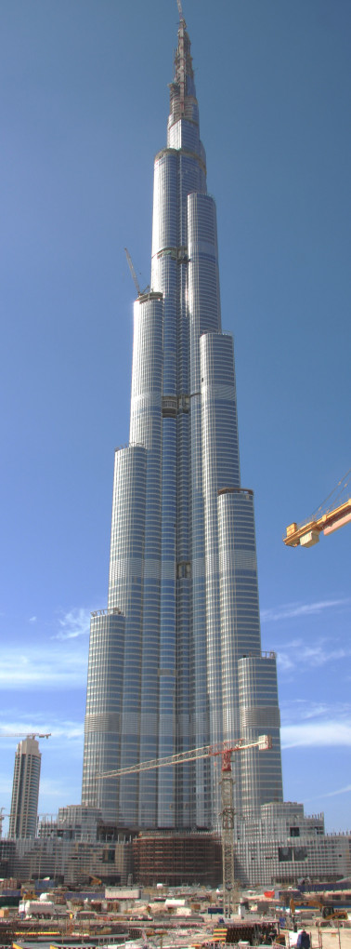
Biblical References in ‘Zone’
- Tower of Babel
- Holy Spirit comes at Pentecost
- The Resurrection
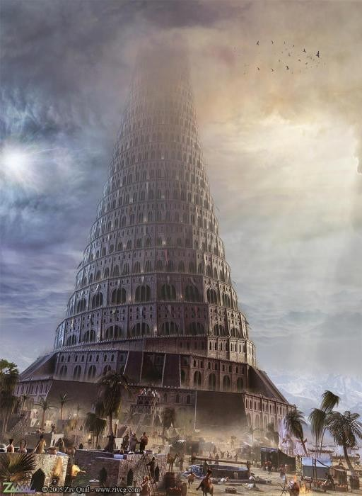
- Simon Magnus: sorcerer who proclaimed through magic arts to be the “great power of God”, tried to ‘buy’ ability to transmit Holy Spirit from the apostles. Regarded as the first heretic.
- Enoch – great grandfather of Noah
- Elijah – prophet that raised the dead
- Apollonius of Tyana: not strictly biblical, greek philosopher compared to Jesus
- Feeding the five thousand: ‘in the seaweed, fishes swim emblems of the Saviour’ (p.115)
Artistic rendering of Tower of Babel
- Saint Vitus
Burj Khalifa skyscraper in Dubai
- Lazarus
The Tower of Babel

1 Now the whole world had one language and a common speech.
2 As people moved eastward,[a] they found a plain in Shinar and settled there.
3 They said to each other, “Come, let’s make bricks and bake them thoroughly.” They used brick instead of stone, and tar for mortar.
4 Then they said, “Come, let us build ourselves a city, with a tower that reaches to the heavens, so that we may make a name for ourselves; otherwise we will be scattered over the face of the whole earth.”
5 But the Lord came down to see the city and the tower the people were building.
6 The Lord said, “If as one people speaking the same language they have begun to do this, then nothing they plan to do will be impossible for them.
7 Come, let us go down and confuse their language so they will not understand each other.”
8 So the Lord scattered them from there over all the earth, and they stopped building the city.
9 That is why it was called Babel—because there the Lord confused the language of the whole world. From there the Lord scattered them over the face of the whole earth.

--- Genesis 11:1-9, The Holy Bible, New International Version

NB. This is likely a play on words owing to the similarity between the pronunciation of “babel” and “balal” which is Hebrew for “to confuse”

‘It is Christ who better than airmen wings his flight/Holding the record of the world for height.
Pupil Christ of the eye/Twentieth pupil of the centuries it is no novice/And changed into a bird this century soars like Jesus’ (p.111)

The Modern Landscape: Technology, Mass Reproduction, Commerce

The initial verses of ‘Zone’ immediately proclaim, in a solemn gesture far from all elegiac farewell, the renunciation of the Old World of the entire Western past: is Greek and Roman antiquity not more antique than ever when even the recently invented automobile can already appear "old"? The bucolic spirit of antiquity, ironically cited by addressing the Eiffel tower as a shepherdess amidst a herd of bellowing bridges, announces what will subsequently […] be elevated as the very essence of a modern avant-garde lyric: the city as aesthetic landscape, as the production site of a poetry which renews itself daily in "loudly singing" hand- bills, catalogues, and posters, and has its prosaic counterpart in the newspapers, penny-pamphlets, pin-ups, and in a "thousand different headlines".

It is not enough provocatively to discover Beauty amid the working masses at day’s end, in the “grace” of a new street in the industrial district. The euphoric affirmation of the world escalates into a phastamagoria of the modern, in which the opening verse, “La religion seule est renée toute neuve,” is realised by means of a vision of the twentieth century ascending like an airplane. The Christ of this modernity, at first praised in a litany recalling the features of traditional worship, now breaks all altitude records in his new ascension and opens the horizon of a new heaven: here, as in the sermon of Saint Francis, birds from all over the earth and from the oldest myths fraternise with the flying machine.
--- Hans-Robert Jauss and Roger Blood, ‘1912: Threshold to an Epoch. Apollinaire’s Zone and Lundi Rue Christine’, Yale French Studies 74(1988) pp.39-66 (p.40)

[1900] marked the advent of the supremacy of the scientist in the history of human progress, not the pure scientist who dealt with the abstract, but the man who applied the principles of science and produced…[he had] concrete intelligence…an inventive spirit […] The development of technical imagination seemed, however, to have no immediate parallel in artistic activities. Art suddenly appeared a weak sister. Since the end of the nineteenth century a rift had taken place between science and art which was growing wider and wider. Art […] had soon protested, revolted, taken refuge in the dream, unsuspecting that soon science was to claim the dream itself as one of its legitimate domains of investigation. Science seemed to be the destroyer of the marvellous and the mysterious.

--- Anna Balakian, ‘Apollinaire and the Modern Mind’ Yale French Studies 4(1949) pp.79-90 (p.79)

New Art Forms: Surrealism, Cubism

[Apollinaire] believed that the power of the artist, like the scientist, to create was directly dependent upon his ability to imagine. It was the task of the imagination to invent new realms to explore, realms leading to the development of new forms and concepts.

Protesting bourgeois values in art and life, effecting a tabula rasa on all that had
preceded it, Dada both destroyed and reconstructed reality utilizing the "scandalous." In their efforts to implement this program, the Dadaists - like the Surrealists – abolished the distinction between art and life.

--- Willard Bohn, ‘From Surrealism to Surrealism: Apollinaire and Breton’ The Journal of Aesthetics and Art Criticism 36(1977)2 pp.197-210.

In the course of really exploring with a modern spirit what was going on, [Apollinaire] got to be friends with all of the early (20th) Century French painters, who were initiating a whole theory, or a whole practice of relativism in their paintings, breaking things up, so, literally, you could see the table, if you were doing a still life, from various angles at one time, (they were) interested in taking (Paul) Cézanne's theory of hot colors […] hot colors advance, cool colors recede […] the spaciousness Cézanne created (in) his little sensation of space, not by perspective lines but by optical arrangements on the flat canvas that would deceive the eye into seeing space […] this was a specific perception which Apollinaire understood. […] I don't know if you see the parallelism of the painter's approach to simultaneous views of space and his approach to the simultaneous appearance of imagery in the mind's eye, one image set next to the other, without connective, in a sense, without the connectives of perspective lines. Perspective lines in painting might be equivalent to the syntactical connectives of "and"'s, "but"'s, "if"'s, "or"'s in language, or punctuation. In a sense, without perspective lines in the poetry, he created both space and a sense of passing time.

--- Allen Ginsberg, ‘History of Poetry: Apollinaire’, transcription from Ginsberg’s 1975 NAROPA class

The Artist; Baudelaire’s ‘Flâneur’

‘Multitude, solitude: identical terms, and interchangeable by the active and fertile poet. The man who is unable to people his solitude is equally unable to be alone in a bustling crowd […] the poet enjoys the incomparable privilege of being able to be himself or someone else, as he chooses. Like those wandering souls who go looking for a body, he enters as he likes into each man’s personality.’
--- Charles Baudelaire, The Painter of the Modern Life

Points to Consider

- How might we read ‘Zone’ in relation to Baudelaire’s Flâneur?
- What is the significance of Biblical allusion?
- What do the poets think about modernity? How do they comment on modern life?
- What is the effect of the temporal and geographical translocations?
- How does form contribute to a sense of fragmentation, discontinuity and incoherence?
- How does modernist poetry acknowledge, incorporate or compete with other ways of registering the modern? (i.e. film, music, art)
- How do these poems ‘collaborate with the past’?
- How do the poems tackle the tension between alienation and unification? What is the significance of the many voices of The Wasteland?

Although [The Wasteland] deals with the ills of a society, it is also the expression of a single protagonist, various facets of whose character are represented by the different men and women of the poem. This necessity for interpreting simultaneously in two modes makes an unusual demand on readers accustomed to look for a single "meaning" in a poem, but it is familiar enough to those acquainted with Jung's distinction between the objective and subjective modes of interpreting dreams.

--- Genevieve W. Foster, ‘The Archetypal Imagery of T. S. Eliot’ Modern Language Association 60(1945)2 pp.567-585. (p.569)

The Grail Quest

‘In Eliot’s wasteland the grail offers spiritual salvation and an escape from the meaningless worldly existence […] the grail supports Eliot’s desire for a religious transcendence beyond the modern wasteland to a “still point” of eternity.’
--- Linda Ray Pratt, ‘The Holy Grail: Subversion and Revival of a Tradition in Tennyson and T. S. Eliot’ Victorian Poetry 11(1973)4 pp.307-321. (p.308)
‘The waste land to which the Grail knight must travel symbolises [the] condition both of single individual and of the civilisation in which he lives […] the poem is the record of a quest for the essential vision […] earth stands for material reality, or conscious life; water for […] the imagination […] the two psychological realms coexist, but they do not interpenetrate.’
--- Genevieve W. Foster, ‘The Archetypal Imagery of T. S. Eliot’ Modern Language Association 60(1945)2 pp.567-585. (p.570)

Heteroglossia | “many-voicedness” cf. polyphony

The Wasteland – original title: ‘He Do the Police in Different Voices’

‘All language, Bakhtin observes, comes to us contaminated by previous usage, saturated with ideology, class association and history.’
- Social element to heteroglossia; includes regional dialects and registers related to profession or age with competing social and political implications, ‘the social diversity of speech types’; social tensions inherent in language. Local versus National. Standardised versus Alternative.

Further Reading:
Anna Balakian, ‘Apollinaire and the Modern Mind’ Yale French Studies 4(1949) pp.79-90.
Benjamin Bailey. ‘Heteroglossia’ The Routledge Handbook of Multilingualism eds. Martin-Jones, Blackledge and Creese. (London: Routledge, 2012) pp.499-507. Available at: http://works.bepress.com/benjamin_bailey/74
Allen Ginsberg Project: http://www.allenginsberg.org/index.php?page=history-of-poetry-apollinaire-1975
Genevieve W. Foster, ‘The Archetypal Imagery of T. S. Eliot’ Modern Language Association 60(1945)2 pp.567-585.
Linda Ray Pratt, ‘The Holy Grail: Subversion and Revival of a Tradition in Tennyson and T. S. Eliot’ Victorian Poetry 11(1973)4 pp.307-321.
Hans-Robert Jauss and Roger Blood, ‘1912: Threshold to an Epoch. Apollinaire’s Zone and Lundi Rue Christine’, Yale French Studies 74(1988) pp.39-66.
Keith Tester, ‘Introduction’ The Flâneur ed. Keith Tester (London: Routledge, 1994) pp.1-21.
Marianne W. Martin, ‘Futurism, Unanimism and Apollinaire’ Art Journal 28(1969)3 pp.258-268.
Willard Bohn, ‘From Surrealism to Surrealism: Apollinaire and Breton’ The Journal of Aesthetics and Art Criticism 36(1977)2 pp.197-210.

