Unit I (1789-1848): Enlightenment, Revolution, Romanticism
Week 3: The Life of Olaudah Equiano or Gustavus Vassa, the African (1789)

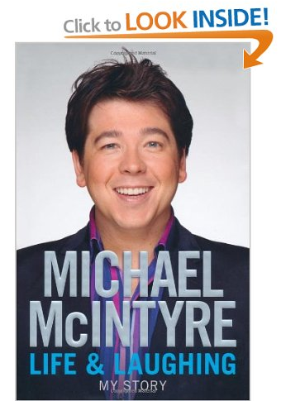
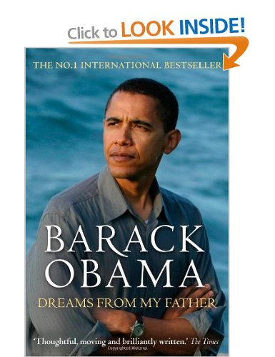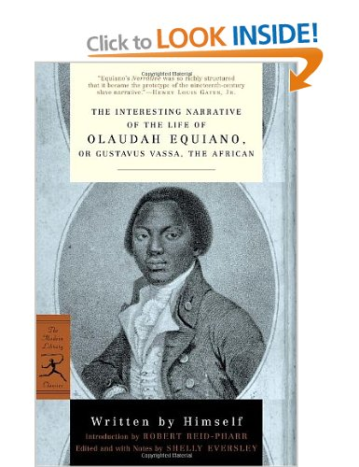

‘…the teller of his or her own story becomes, in the act of narration, both the observing subject and the object of investigation, remembrance, and contemplation. We might best approach life narrative, then, as a moving target, a set of shifting self-referential practices, that in engaging the past, reflect on the identity of the present.’

---Sidonie Smith and Julia Watson, Reading Autobiography: a guide for interpreting life narratives 2nd Edition. (Minneapolis: University of Minnesota Press, 2010) p1.

‘Autobiography, like History, claims to tell true stories about past events. Like history, autobiography is usually presented in the form of a chronological narrative. To be sure, there are many differences between history and autobiography. History deals with collective time and collective experience, and posits a separation between the historian/author and his or her subject matter. Autobiography adopts the arbitrary time frame of the individual life and the perspective of the individual, is inherently subjective, and derives its claim to authority from an assumed identity between author and subject.’

--- Jeremy D. Popkin, ‘History and Autobiography’ History, Historians & Autobiography (Chicago: University of Chicago Press, 2005) p11.

Classic Three-Part structure of Slave Narratives:
- Slavery
- Escape
- Freedom

‘Life writing and the novel share features we ascribe to fictional writing: plot, dialogue, setting, characterisation and so on. But they are distinguished by their relationship to and claims about a referential world. We might helpfully think of what fiction represents as “a world” and what life writing refers to as “the world”.’

--- Sidonie Smith and Julia Watson, Reading Autobiography: a guide for interpreting life narratives 2nd Edition. (Minneapolis: University of Minnesota Press, 2010) p10.
Points to Consider:
- How is language used for the creation of Equiano as a character?
- His narration is saturated with the emotion of experience; how is this problematic as a narrative pertaining to be a ‘true story’?
- Is the author’s intention significant?
(‘Permit me […] to lay at your feet the following genuine narrative; the chief design of which is to excite in your august assemblies a sense of compassion for the miseries which the Slave-Trade has entailed on my unfortunate countrymen.’)
- How does the narrative relate to the notion of modernity as a movement of liberation and progress?
- What is the purpose of Christian/biblical allusion? (e.g. p20)
- How is race presented in relation to rights and/or civilisation?
- How are slaves commodified? And how does this relate to the ideology behind the Communist Manifesto?

‘Marxist criticism analyses literature in terms of the historical conditions which produce it […] Marxism is a scientific theory of human societies and of the practice of transforming them; and what that means rather more concretely is that the narrative Marxism has to deliver is the story of the struggles of men and women to free themselves from certain forms of exploitation and oppression.’

--- Terry Eagleton, ‘Preface’ Marxism and Literary Criticism (London: Methuen & Co, 1976) ppvi-vii.

‘Marked by an internationally identifiable and translatable literariness, not to mention cuddly-bear politics, the global novel threatens to render obsolete, according to Parks, “the kind of work that revels in the subtle nuances of its own language and literary culture” […] But the homogenising and depoliticising effects of the “global novel” can also be exaggerated, to the point where every writer of non-western origin seems to be vending a consumable – rather than a challenging – cultural otherness.’

--- Pankaj Mishra, ‘Beyond the Global Novel’ Financial Times (27th September 2013) <http://www.ft.com/cms/s/2/6e00ad86-26a2-11e3-9dc0-00144feab7de.html#axzz2hjMVcVEB> [accessed Oct 2013]

Further Reading/Resources:
‘Legacy of British slave-owners’ site from UCL – aims to track the £20m paid to slave owners after abolition of slavery in 1833: http://www.ucl.ac.uk/lbs/
Trans-Atlantic Slave Trade Database: http://www.slavevoyages.org/tast/index.faces
Vincent Carretta, ‘Olaudah Equiano or Gustavus Vassa? New light on an eighteenth‐century question of identity’ Slavery and Abolition 20(1999)3 pp96-105.
Wilfred D. Samuels, ‘Disguised Voice in The Interesting Narrative of Olaudah Equiano, or Gustavus Vassa, the African’ Black American Literature Forum 19(1985)2 pp64-69.
Adam Potkey, ‘Olaudah Equiano and the Arts of Spiritual Autobiography’ Eighteenth Century Studies 27(1994)4 pp677-692.
Map by historical geographer, Miles Ogborn, and cartographer, Edward Oliver, depicting Equiano’s sea travels.
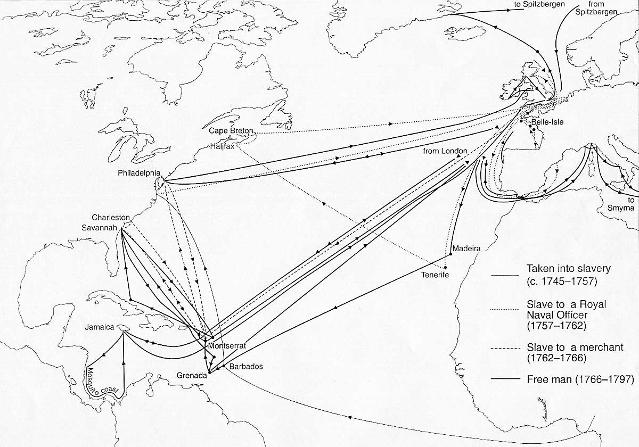

In 1999, Historian Vincent Carretta suggested, from analysis of material evidence (a baptismal record and a muster roll), that Equiano was infact born as a slave in South Carolina, not Africa.
How does this impact on our understanding of the text?
Why might Equiano lie about his birth place?
Check out the competing arguments and cases for and against here: http://www.brycchancarey.com/equiano/nativity.htm

