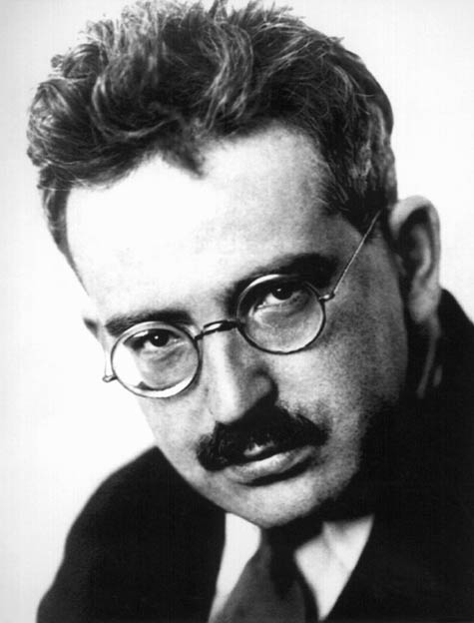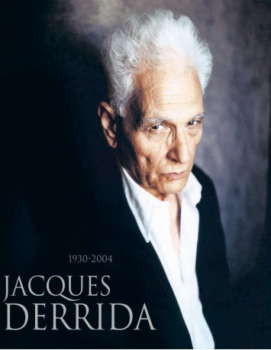
Week 10: J. M. Coetzee’s Foe, Walter Benjamin “On the Concept of History” and
Jacques Derrida “Racism’s Last Word”
- Walter Benjamin was concerned with history and the articulation of its significance in the present. What does he believe is the danger that threatens history?

- From which perspective does Benjamin believe we should explore history?

- How would you describe Benjamin’s approach to “historical materialism”?

- How is Benjamin different from Karl Marx?

- In XI Benjamin refers to Klee’s Angelus Novus as “The Angel of History”, what does this represent?

- How can you relate Benjamin’s theory “On the Concept of History” to Coetzee’s Foe?

- For Derrida what is the danger in speaking the other’s language?

- Derrida points out that the word apartheid remains the same no matter what language is being used, it is embedded within it. He observes that it was “as if all tongues were refusing to give an equivalent, refusing to let themselves be contaminated through contagious hospitality of the word-for-word”. Why is this significant?

- Derrida contends “there’s no racism without a language. The point is not that acts of racial violence are only words but rather that they have to have a word”. How would you interpret this quote? Can you relate it to Foe?

- Derrida has faced criticism from those who argue that he should focus his analysis on the concrete nature of material conditions rather than the play of language, do you agree?

- Anne McClintock and Rob Nixon critique Derrida in their essay, ‘‘No Names Apart: The Separation of Word and History in Derrida’s ‘Le dernier mot du racisme,’ ’’, reminding Derrida that a word’s meaning is not separate from its history, and this relationship gives us the word’s politics. Do you agree with this criticism?

