Week 8: J.M. Coetzee & Edward Said
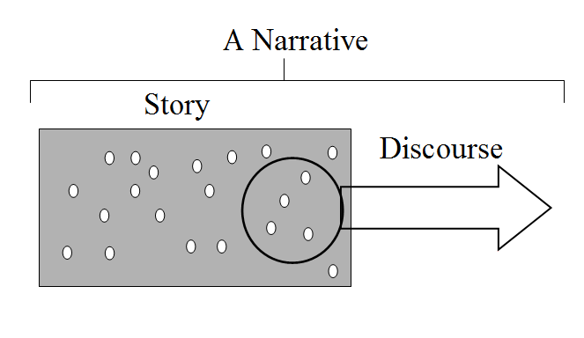
Discourse and Orientalism: The term ‘discourse’, which derives its current meaning from the work of Foucault and other poststructuralist writers, is used to describe the complex web of underlying mechanisms and structures that informs the functioning of a society, be they semiological, mythological or ideological. In this week’s reading, Edward Said refers to the way that certain types of knowledge can give rise to traditions ‘or what Foucault calls a discourse’. In time, these new discourses are reproduced, even if it is only the ‘material weight, not the originality of a given author that is really responsible for the texts produced out of it.’ Said explains that the Western perception of the East or what used to be called The Orient, has been informed by scores of texts written by European scholars in what Said refers to as ‘the tradition of Orientalism’. Consequently, the voice of the Orient is replaced by the voice of the European who may or may not have their own imperial designs. In other words, ‘Orientalism overrode the orient.’ As modern scholars we can say that these texts teach us more about the dominant European discourses than they do about the Orient, in much the same way that postcolonial literature tells us more about the experience of postcolonialism than it does about colonialism.
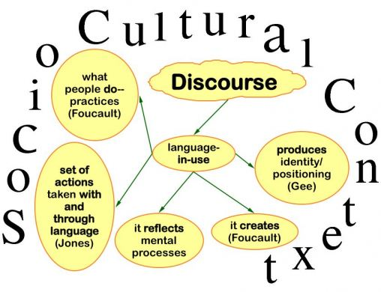

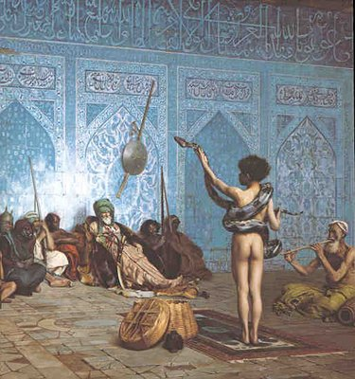
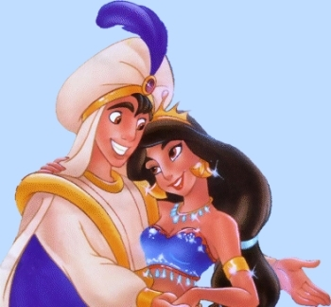
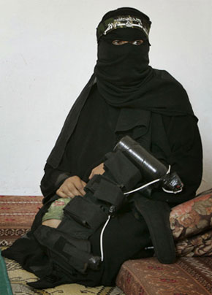

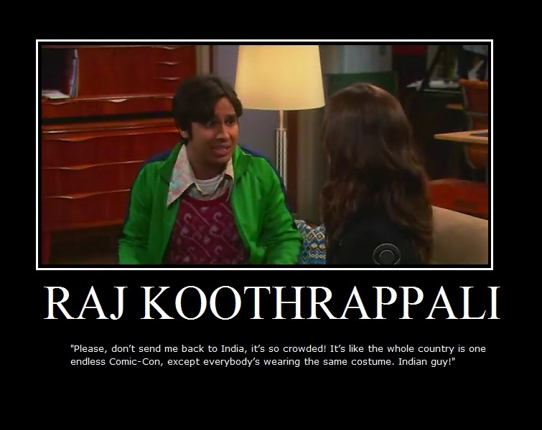


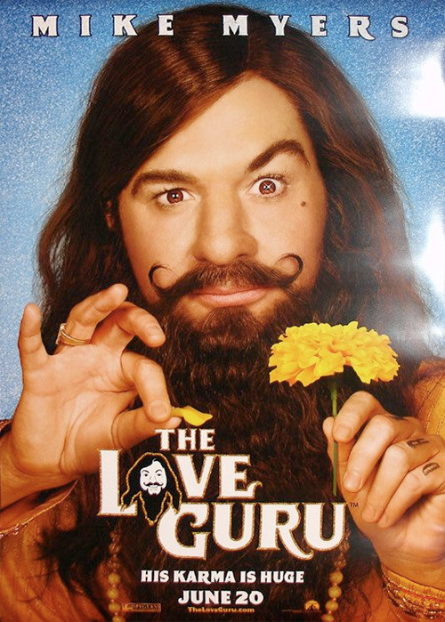
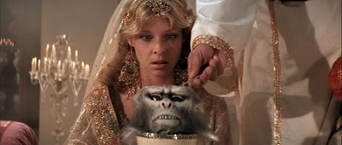
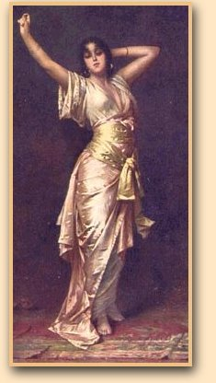

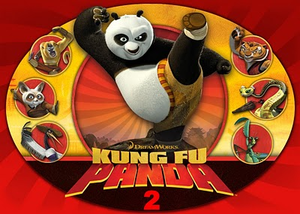
Discussion Questions:

- What is Orientalism?

- Can you think of any examples of Orientalist views within the novel?

- Do any of the characters represent Orientalist views?

- To what extent does Foe challenge an Orientalist view?

- Said discusses the impact of scholars contributing to dehumanisation of society - does Coetzee respond to this?

- What discourses can we identify in the novel? E.g. Exclusion

- How does Coetzee explore different cultural assumptions about gender and identity?

- Consider the images in relation to the novel. Is Orientalism still a contemporary concern?

- Who has the right to represent the ‘other’?

- How can we interpret Friday’s silence in the novel in light of this theory?

- What are the dominant discourses of British/Western society concerning the Middle East, Africa, Asia etc? What does popular film, literature and TV tell us?

- What do we learn about European discourses from the novel?

- Does Coetzee succeed in demythologizing history?

