Week 9: Stuart Hall and J.M. Coetzee
Hall: difference and ethnicity
Hall begins by examining the history of the term ‘black’, which he describes as a ‘politically and culturally constructed category’ and how it became a way of ‘referencing the common experience of racism and marginalisation in Britain.’ According to Hall, in historical as well as (cultural) theoretical terms, the term ‘black’ has provided ‘an organising category of a new politics of resistance among groups and communities with [...] very different histories, traditions and ethnic identities.’ He argues that over time this new politics carved out new cultural spaces that formed the ‘conditions of existence of a cultural politics designed to challenge, resist and, where possible, to transform the dominant regimes of representation.’ In other words ‘black’ becomes a rallying call to resist the dominant cultural discourse that sought to marginalise the Other. In this sense, the word ‘black’ has been used interchangeably with the Other.
Hall identifies two critical questions that focus on the role of representation: (1) who has the right of access to representation and (2) how can social and cultural marginality be successfully challenged? Finally, Hall suggests that since the post-war years a political shift has occurred in this debate, a change from a ‘struggle over the relations of representation to a politics of representation itself’, or put simply, a shift from seeking representation to decoding what such representation means.
He also argues that it is extremely difficult to consider the ‘essential black subject’ since, as we have already discussed, essentialism doesn’t sit very well with postmodernist critical theory that in very broad terms challenges notions of authenticity and logocentrism. However, Hall asks what the political cost might be if ‘black’ can no longer be considered a fixed or essentialized term, although he admits that deconstructing this term does bring into play the ‘recognition of the immense diversity and differentiation of the historical and cultural experience of black subjects.’ This is extremely problematic because it is no longer possible to just assume that because a film deals with the black experience it is a good and worthy film. Hall writes:
Once you enter the politics of the end of the essential black subject you are plunged headlong into the maelstrom of a continuously contingent, unguaranteed, political argument and debate: a critical politics, a politics of criticism. You can no longer conduct black politics through the strategy of a simply set of reversals, putting in the place of the bad old essential white subject, the new essentially good black subject.
This represents the ‘new phase’ that Hall refers to throughout his essay, a shifting away from the oppositional cultural resistance of the ‘black’ experience. Hall notes that racism always seeks to fix and categorise people and groups, constructing ‘impassable symbolic boundaries between racially constituted categories’. Any form of inverted essentialism runs the risk of becoming equally impassable and can take into itself the ‘epistemic violence’ inherent in colonialism, Orientalism, the exotic Other etc. In light of this problem Hall asks what is it that currently informs the term ‘black’ within the context of the new politics, and he responds by suggesting the term ‘ethnicity’, which ‘acknowledges the place of history, language and culture in the construction of subjectivity and identity.’ More importantly, this term, like the term ‘black’ has to be shorn of its negative associations before it can reused. This term needs to engage with, rather than suppress difference. Historically it may have been necessary to demand fair representation, but now it is necessary to articulate difference in representation. Hall puts it like this:
This marks a real shift in the point of contestation, since it is no longer only between anti-racism and multi- culturalism but inside the notion of ethnicity itself. [...] That is to say, a recognition that we all speak from a particular place, out of a particular history, out of a particular experience, a particular culture, without being contained by that position as ‘ethnic artists’ or filmmakers.
Hall identifies this as approaching ‘the end of a certain critical innocence in black cultural politics’ but also the beginning of new critical discourses that engage with the term ‘ethnicity’ and what it holds.

Gramsci and Hegemony
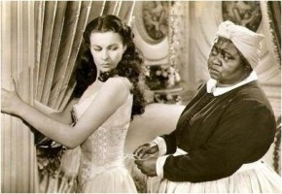

Gramsci’s theory of hegemony suggests that we should pay special attention to everyday routine structures and common sense values in trying to locate mechanisms of domination and discourses of power. Gramsci’s theory is useful here when considering racial representations in literature, film and television. One of ways to begin this analysis is to consider the far from subtle racial stereotypes that have been used in film. Hall has identified three key structures in what he calls the ‘grammar of race’ typically employed in old TV and film. For example, Hall gives us the slave figure, the faithful fieldhand, the Native and the clown or entertainer. Each of these stereotypes can be broken down in further sub-categories, but Hall makes the point that in each case the master-slave dichotomy is asserted and maintained with servile black characters assimilating themselves into the hegemonic (dominant culture) world view. Gramsci would argue that constitutes what he referred to as ‘consensual control’ or ‘spontaneous consent’ with individuals basically assimilating the hegemonic view even if it is especially harmful to them.
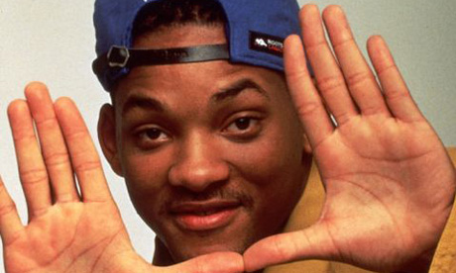
More recently, debates have arisen about how hegemonic racism has found expression in comedy. For example, there is a general view that the major television broadcasting companies regulate content and maintain a open dialogue with the public so that offense can be reported. Comics and sit-coms often use irony to mock racist views and the people and institutions that seem to support them such as the The Daily Mail. But is there an element of inferential racism at work here? When the comedian Frankie Boyle, appearing on Mock The Week and improvising in response to the question ‘unlikely things to hear on sports commentary’ joked: ‘there’s a white man in the 100 metres. Good luck with that!’ he is tapping into deep rooted racial stereotypes relating to black athletic ability and physical strength, which has been used historically as a means of dehumanising black subjects. Boyle may be using irony, but does that irony points towards a form of hegemonic racism?
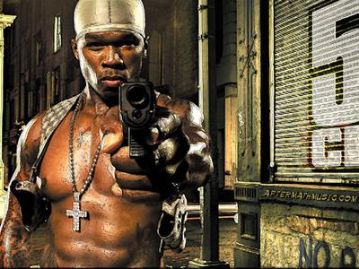

In the 1990s black sitcoms like Fresh Prince of Bel-Air have been said to normalise the threat of a rising black middle class to a white audience, but at the same time perpetuating the stereotype of the black clown and entertainer, played in this instance by the actor Will Smith. On the surface the programme presents a comedic and often critical view of the “problem” of a extremely wealthy black family living in a salubrious district of LA, while still recycling hegemonic tropes. You might also think about how anti-racism films like Malcolm X, The Help, and Schindler’s List and blaxploitation films like Blacular and Shaft present racist hegemonic views even while attempting to challenge such views. Old stereotypes are repacked and recycled, the clown remains along with new stereotypes like the angry black man/woman, the revolutionist and of course tokenism. In the UK, television shows aimed at minority and ethnic groups tend to presume that the lives of these people is entirely focused on their racial identity, a trend which is often repeated in documentaries. The existence of separate ethnic programming also raises the issue of whether it is further entrenching a hegemonic view of the Other.
There is also the issue of hegemonic cultural appropriation meaning the assimilation or appropriation of cultural practices belonging to a distinct cultural group by a dominant hegemonic system. This can easily be seen in the world of fashion where ethnicity is traded and performed on the catwalk suggesting there is a cultural depth behind the aesthetic that places Otherness within the hegemonic view. A similar case could also be made for The Fresh Prince of Bel-Air and another of Will Smith’s films, Men in Black, where Smith teams up with Tommy Lee Jones to fight the threat of illegal aliens in a very literal sense.
Connecting Theory to the Text and Text to the Theory

- How does Coetzee construct and deconstruct race in the novel?
- Does Foe present any kind of dominant hegemonic world view? Discuss.
- How does the novel engage with racial stereotypes?
- Does Foe raise questions in relation to hegemonic racism?
- How can we read the novel through the lens of Hall’s ethnicity?
- Is Foe aimed at a particular readership?
- To what extend does Friday resist the label of the Other and exotic Other? Does he succeed?
- To what extent does the novel engage with the new politics alluded to in the Stuart Hall chapter?

