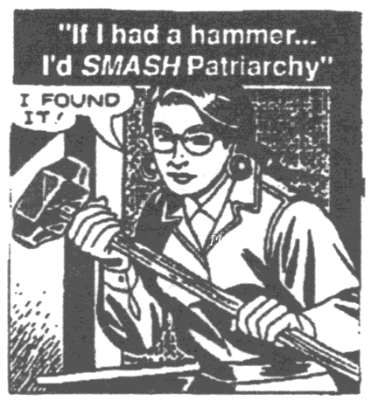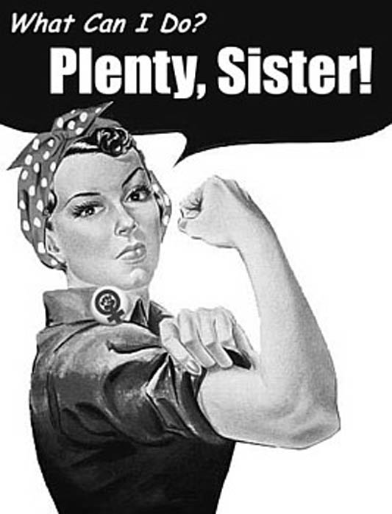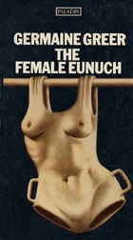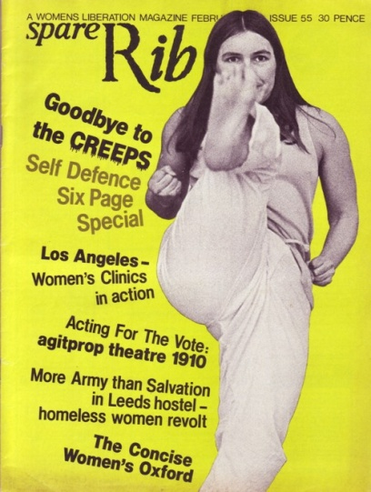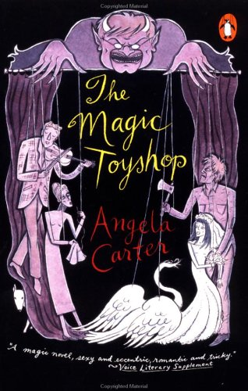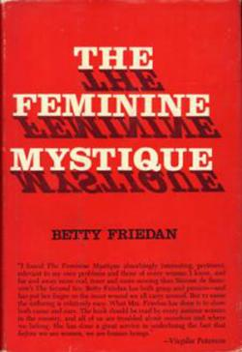
Term 2: Week 1: The Magic Toyshop By Angela Carter
- Consider the images. Think about how the language of dominance/inequality permeates culture at all levels. What is considered normative can often hide systemic inequalities.
- What cultural questions or issues are established in The Magic Toyshop?
- How does The Magic Toyshop engage with feminist concerns or issues?
- To what extent does The Magic Toyshop challenge/ subvert/ reinforce conventions of patriarchy and dominance?

EXTRA QUESTIONS:
Discuss how Carter represents the destructive effects of patriarchal culture on both women and men.

Some critics have argued that Melanie seeks refuge from one man in the arms of another, by running away with Finn she is continuing the power of patriarchy. Discuss.

Rape is the basic trope of our Western cultural heritage. Discuss how Carter presents the theme of rape.

Discuss the alternative forms of masculinity, and revised notions of femininity Carter presents.

The metaphor of the puppet master and the marionette is central to the story. What do you think Carter is trying to suggest through this metaphor?

What view of human sexuality, male and female, is portrayed in the novel?

