Raymond Williams and Sam Selvon
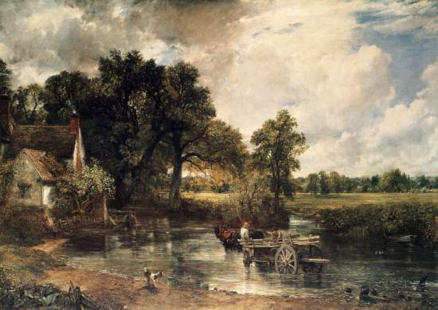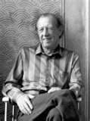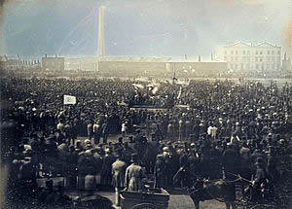

In his book The Country and the City, Raymond Williams argues that English literature has a longstanding historical fascination with ideas of city and country. He is particularly interested in how geographical space itself can contour ideas of social structure and artistic achievement. Accordingly, space becomes political and problematic, and being a Marxist, Williams wants us to think about what representations and readings of the city and country can teach us about ideology and social structure.
- Outline the visual images and metaphorical associations Williams makes of the country and city. Explain how we perceive these two spaces and how they are opposed to one another.
- If we read the landscape of London presented in Selvon’s novel, what do we find? Is it a happy pastoral scene, a vibrant metropolis, or something else entirely?
- Perceptions of space are filtered through an individual - consider how Selvon influences the perception of London that is presented in the novel.
- Having been schooled on a diet of English literature and stories of the Mother Country, what preconceptions do you think Selvon’s lonely Londoners have about London and the big city? Why is this significant?
- Throughout the text Selvon reinforces binaries. How does Selvon deploy the binaries of city (London) and country (colonies), and English and West Indian? Find some examples from the text.
- Is the division between the city and the country problematic?
- According to Williams we need to interrogate the text, discuss how the following impacts on our reading of the novel:
  - the place it is written in
  - the expectations of the writer
  - the writer's background and upbringing
  - his relationship to the material
- Williams posits that the creative voice of the artist comes into being only as that voice is heard critically by the artist himself in the context of the other, different voices and individuals, rather than offering a single universal language. Each work of art forms an interior community, how does Selvon’s voice come into being, and does it create a sense of community?
- Williams argues the problem is not the division between the city and the country, but the fact that this division has been constituted in such a way that the city chattels the country, assimilating and transforming it to the requisites of the city. In order to capture the uniqueness of two individual voices, both voices must be included to convey how different they are from one another. How does Selvon represent the divide between the country and city? Are there two voices in Selvon’s novel?

