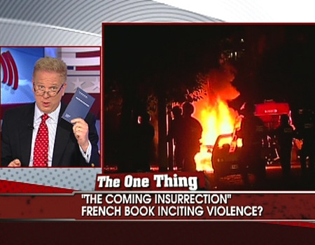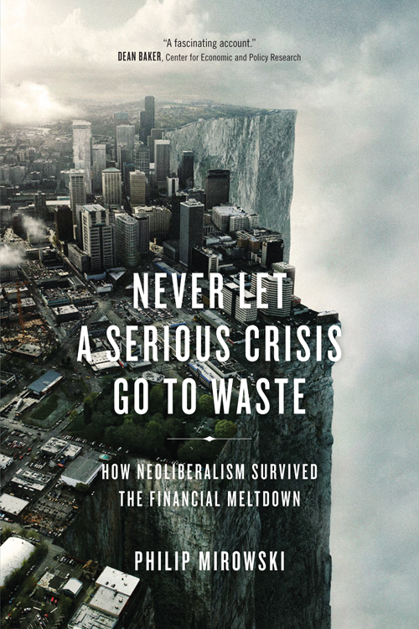

Week 10: Kushner: The Coming Insurrection: The Flamethrowers as a contemporary novel

The Coming Insurrection "A Point of Clarification"

- Why are the authors of The Coming Insurrection invisible?

- Does their anonymity change the way we read the text?

- Does their anonymity serve as a form of resistance to capitalism and commodification?

- Is Reno somewhat anonymous in The Flamethrowers? Why do you think this is? Does she become a commodity?

- “Everyone finds himself forced to take sides, to choose between anarchy and the fear of anarchy.” Does Reno ever take sides? Does she remain disenchanted?

- “Deserting classical politics means facing up to war, which is taking up arms and maintaining an “armed presence” than it is about armed struggle.” How do we read the use of violence and force in the novel? How does Reno react to the violence she witnesses?

- “If one puts so much effort into imprisoning as terrorists a few communists who are supposed to have participated in publishing The Coming Insurrection, it is not because of a “thought crime”, but rather because they might embody certain consistency between acts and thought.” What is the connection between “acts and thought” in Flamethrowers? How culpable are we if we incite violence in writing? What is more effective in inspiring change, words or the sword?

- “There is no ideal form of action. What’s essential is that action assume a certain form, that it give rise to a form instead of having one imposed on it.” Is Kushner suggesting there is a need for action? Is she juxtaposing Reno’s indifference with the movements that surround her? What effect does this contrast have on the reader?

Philip Mirowski Never Let a Crisis Go to Waste "One More Red Nightmare"

- “After the crisis, professional explainers from all over the map were throwing up their hands and pleading that the economy was just too complex to understand. Better to treat the Great Recession like an Act of God, and simply move on. This is a cultural debility that predated the crisis but has worked wonders in immobilizing responses to the debacle” (12). Is Reno an example of “immobilizing responses”?

- “[T]o deploy ignorance as a political tool will go some distance in dispelling the onus of having been transparently duped.” What is the role of ignorance in the novel? Does it serve as a political tool?

- “[T]he problem seems to be, rather, that no one cares enough anymore to expend the effort”. Is The Flamethrowers a novel about this very problem, of not caring, or the juxtaposition between those that care and are aware, and those that are content to remain ignorant?

