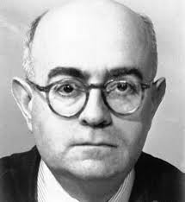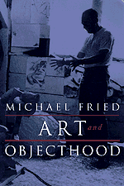

Week 8: The Role of Art in the Age of Finance: The Flamethrowers as a Novel about Art

Adorno “Commitment”

- What does “commitment” mean for Adorno?

- To understand Adorno’s essay we need to understand Satre’s essay. What is Satre’s thesis in “What is Literature?”?

- What is the difference between committed and autonomous art according to Adorno?

- What is the difference between Satre and Adorno’s argument?

- Could you sum up Adorno’s thesis in a few sentences or find one quote which clarifies his argument?

- What are the problems with autonomous art according to Adorno?

- What kind of art is promoted in Flamethrowers?

- Is Flamethrowers a form of committed or autonomous art?

Brown “The work of art in the age of its real subsumption under capital”

- Is art a commodity in Flamethrowers?

- If art is created for financial gain, can it have any meaning beyond this purpose?

- What is the difference between autonomous art and art as a commodity?

Fried “Art and Objecthood”

- What are literalists according to Fried?

- How does “art” and “objecthood” differ according to Fried?

- Do you consider art in Flamethrowers to be literalist?

