Modern World Literatures – Seminar Handout
Fridays 15:00-17:00 – Room H501
Session 2 (17/10/14) – Olaudah Equiano – The Life of Olaudah Equiano or Gustavus Vassa, the African (1789)
Course information
- Chris Maughan
- Email: c.j.maughan@warwick.ac.uk,
- Office hour: Fridays 17:00-18:00 (T1-3 H501)
- Assessment reminder - a short response (500 words maximum) to one of the 'Discourses of Modernity' at the Modernity Clinic is due in class in Week 5 of Term 1.
Estrangement, Alienation, and Modernity

Destination Earth (1956)
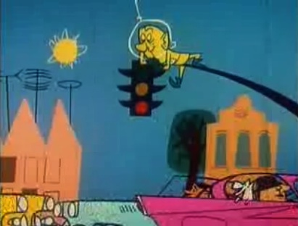
Estrangement
The truth of interpretation lies in its intellectual structure of contrasts, and its reality is inherently self-critical. So, although this work focuses on the cultural reactions of peasants to industrial capitalism and attempts to interpret those reactions, it is, inevitably, also an esoteric attempt to critically illuminate the ways by which those of us who are long accustomed to capitalist culture have arrived at the point at which this familiarity persuades us that our cultural form is not historical, not social, not human, but natural—"thing-like" and physical. In other words, it is an attempt forced upon us by confrontation with precapitalist cultures to account for the phantom objectivity with which capitalist culture enshrouds its social creations. (Michael Taussig)
And art exists that one may recover the sensation of life; it exists to make one feel things, to make the stone stony. The purpose of art is to impart the sensation of things as they are perceived and not as they are known. The technique of art is to make objects "unfamiliar," to make forms difficult, to increase the difficulty and length of perception because the process of perception is an aesthetic end in itself and must be prolonged. (Victor Shklovsky)
Discussion questions

- What is the relevance of this piece of literature in today's world?

- According to Marshall Berman, 'To be modern is to find ourselves in an environment that promises us adventure, power, joy, growth, transformation of ourselves and the world – and, at the same time, that threatens to destroy everything we have, everything we know, everything we are.' With this in mind, to what extent is Equiano a subject of modernity?

- Does this text support Baudrillard's idea of modernity 'irradiating from the occident'? [in Baudrillard, Jean (1987) "Modernity," Canadian Journal of Political and Social Theory Vol. 11]

- How does Equiano present the theme of freedom/emancipation?

