Introduction: Modernity, Manifestos and the Module

Some OED Definitions

Modern, adj. and n. ‘Of or relating to the present time and recent times, as opposed to the remote past; of, relating to, or originating in the current age or period.’
‘Of, relating to, or designating a current or recent movement or trend in art, architecture, etc., characterized by a departure from or a repudiation of accepted or traditional styles and values.’

Modernity, n. ‘The quality or condition of being modern; modernness of character and style.’

‘An intellectual tendency or social perspective characterized by departure from or repudiation of traditional ideas, doctrines, and cultural values in favour of contemporary or radical values and beliefs (chiefly those of scientific rationalism and liberalism).’

Modernism, n. ‘A usage, mode of expression, peculiarity of style, etc., characteristic of modern times. Later more generally: an innovative or distinctively modern feature.’

‘Any of various movements in art, architecture, literature, etc., generally characterized by a deliberate break with classical and traditional forms or methods of expression; the work or ideas of the adherents of such a movement.’

‘Some 50 years ago, "modern" had two clear connotations. One was positive and forward-looking. "Modern" signified the most advanced technology. The term was situated in a conceptual framework of the presumed endlessness of technological progress, and therefore of constant innovation. This modernity was in consequence a fleeting modernity - what is modern today will be outdated tomorrow. This modernity was quite material in form: airplanes, air-conditioning, television, computers […] There was in addition, however, a second major connotation to the concept of modern […] To be modern signified to be anti-medieval, in an antinomy in which the concept "medieval" incarnated narrow-mindedness, dogmatism, and above all the constraints of authority […] It was in short the presumptive triumph of human freedom against the forces of evil and ignorance […]. But it was not a triumph of humanity over nature; it was rather a triumph of humanity over itself […] it was the modernity of liberation, of substantive democracy […] This modernity of liberation was not a fleeting modernity, but an eternal modernity.’

--- Immanuel Wallerstein, ‘The End of What Modernity?’ Theory and Society 24(1995)4 pp471-488.
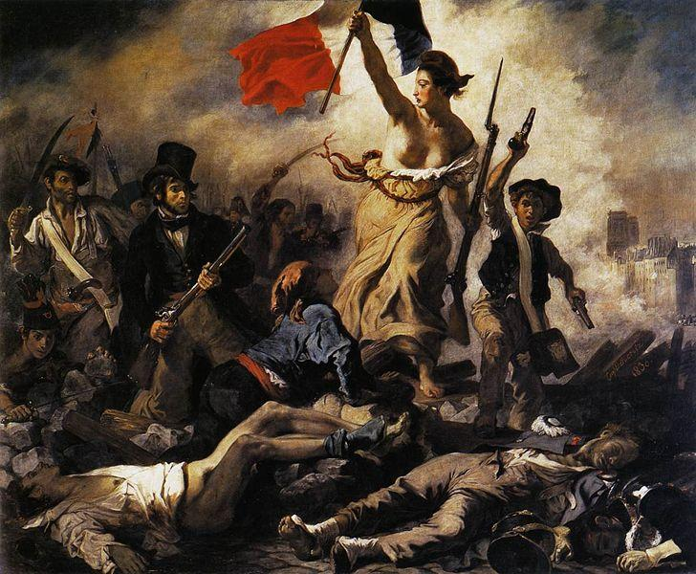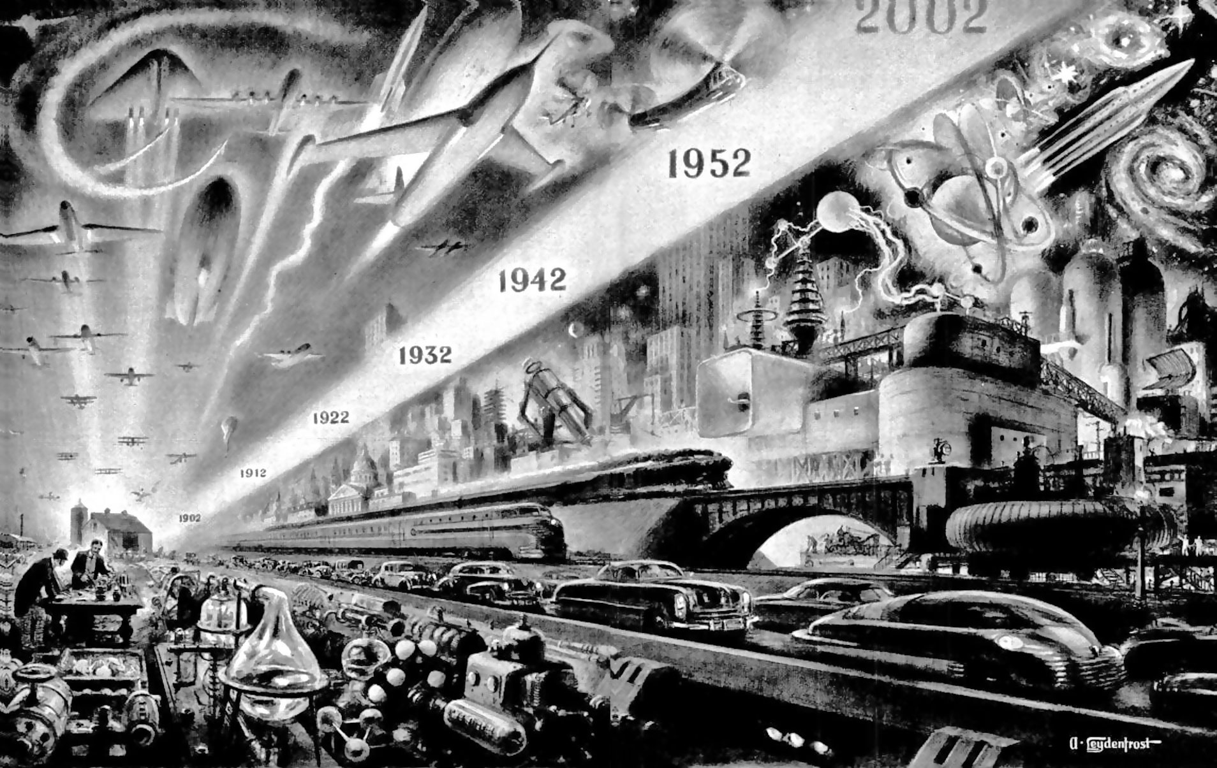
French Revolution 1789-1799 Science on the March (1952) by Alexander Leydenfrost

Rise of Modernity characterised by:
- Scientific Advancement & Technological Progress
- Secularism
- Urbanisation
- Democracy and Revolution

Manifestos: Points to Consider
- What are the key issues being raised in each manifesto and how do they relate to this notion of modernity?
- How is language being used and to what effect?
- What kind of imagery/metaphor is being employed and why?
Use of Nature? Of Military Power? Of Science/Technology? Of Imperialism? Of disease? Of Material Culture?
- What is the motivation of the author(s)? Is this problematic?
- Who is the intended audience?

‘The laws respecting woman […] make an absurd unit of a man and his wife; and then, by the easy transition of only considering him as responsible, she is reduced to a mere cypher […] Women thus infallibly become only the wanton solace of men, when they are so weak in mind and body, that they cannot exert themselves, unless to pursue some frothy pleasure, or to invent some frivolous fashion […] If this be the fiat of fate, if they will make themselves insignificant and contemptible, sweetly to waste 'life away' let them not expect to be valued when their beauty fades, for it is the fate of the fairest flowers to be admired and pulled to pieces by the careless hand that plucked them.’

--- Mary Wollstonecraft, A Vindication on the Rights of Women (1792)

‘The bourgeoisie cannot exist without constantly revolutionising the instruments of production, and thereby the relations of production, and with them the whole relations of society […] All fixed, fast-frozen relations, with their train of ancient and venerable prejudices and opinions, are swept away, all new-formed ones become antiquated before they can ossify. All that is solid melts into air, all that is holy is profaned, and man is at last compelled to face with sober senses his real conditions of life, and his relations with his kind. The need of a constantly expanding market for its products chases the bourgeoisie over the entire surface of the globe. It must nestle everywhere, settle everywhere, establish connexions everywhere.’

--- Karl Marx and Friedrich Engels, Communist Manifesto (1848)

We have been up all night, my friends and I, beneath mosque lamps whose brass cupolas are bright as our souls, because like them they were illuminated by the internal glow of electric hearts. And trampling underfoot our native sloth on opulent Persian carpets, we have been discussing right up to the limits of logic and scrawling the paper with demented writing […] We must break down the gates of life to test the bolts and the padlocks! Let us go! Here is the very first sunrise on earth! Nothing equals the splendor of its red sword which strikes for the first time in our millennial darkness […] And yet we had no ideal Mistress stretching her form up to the clouds, nor yet a cruel Queen to whom to offer our corpses twisted into the shape of Byzantine rings! No reason to die unless it is the desire to be rid of the too great weight of our courage!’

--- Filippo Marinetti, The Futurist Manifesto (1909)

‘I'm writing this manifesto to show that you can perform contrary actions at the same time, in one single, fresh breath; I am against action; as for continual contradiction, and affirmation too, I am neither for nor against them, and I won't explain myself because I hate common sense […] DADA - this is a word that throws up ideas so that they can be shot down; every bourgeois is a little playwright, who invents different subjects and who, instead of situating suitable characters on the level of his own intelligence, like chrysalises on chairs, tries to find causes or objects (according to whichever psychoanalytic method he practices) to give weight to his plot, a talking and self-defining story […] Even if logic were confined by the senses it would still be an organic disease […] I hate slimy objectivity, and harmony, the science that considers that everything is always in order.’

--- Tristan Tzara, Dada Manifesto (1918)

‘The signers of this manifesto have, under the battle cry DADA! assembled together to put forward a new art, from which they expect the realization of new ideals. What then is DADAISM? The word Dada symbolizes the most primitive relation to the surrounding reality; with Dadaism a new reality comes into its own. Life appears as a simultaneous whirl of noises, colors, and spiritual rhythms, which Dada takes unflinchingly into its art, with all the spectacular screams and fevers of its feisty pragmatic attitude and with all its brutal reality.’

--- Richard Huelsenbeck, Dada Manifesto [Berlin] (1918)

‘Tupi or not Tupi, that is the question.’
‘The struggle between what we might call the Uncreated and the Created – illustrated by the permanent contradiction of man and his taboo. Daily love and the capitalist modus vivendi. Cannibalism. Absorption of the sacred enemy. To transform him into a totem.’

--- Oswald de Andrade, Cannibal Manifesto (1928)

