Ends and Beginnings:
Late 19th & Early 20th Century Literature & Culture

Week 1: Introduction

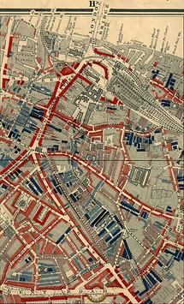
Unit 1: London And/As the Global City

Significant fin de siècle themes:

- Aestheticism
- Cultural, Social, Biological Degeneration
- Urban Poor/City Expansion
- Public Health
- Expansion of the British Empire
- “New” Women
- Advent of Microbiology
- Institutionalisation/Specialisation of Science
- Technological innovation
- Globalisation
- Medico-Legal theories of Sexual Perversion
- the “Criminal” Classes
- Spiritualism/Mesmerism
- Temperance Movement
- Consumer Culture

Points to Consider for Next week:

How does The Diary of a Nobody present the
lower middleclass household?

What is the relationship between the City and the suburbs?
A Section of Charles Booth’s Poverty Map (1889)
In what ways does the diary format impact the narrative?

Consider the generational differences between the Pooters and their friends, and Lupin and his friends.

Useful Resources
https://archive.org
http://www.victorianlondon.org/index-2012.htm
http://www.history.ac.uk/ihr/Focus/Victorians/www.html
http://www.victorianweb.org
http://www.bbk.ac.uk/deviance/

Close Reading Exercise

India

HERE from my lonely watchtower of the East
An ancient race outworn I see—
With dread, my own dear distant Country, lest
The same fate fall on thee.

Lo here the iron winter of curst caste
Has made men into things that creep;
The leprous beggars totter trembling past;
The baser sultans sleep.

Not for a thousand years has Freedom’s cry
The stillness of this horror cleaved,
But as of old the hopeless millions die,
That yet have never lived.

Man has no leisure, but to snatch and eat;
Who should have been a god on earth;
The lean ones cry; the fat ones curse and beat,
And wealth but weakens worth.

O Heaven, shall man rebelling never take
From Fate what she denies, his bliss?
Cannot that mind that made the engine make
A nobler life than this?

Madras, 1881.

