Ends and Beginnings:
Late 19th & Early 20th Century Literature & Culture

Week 10: H.G. Wells – The War of the Worlds (1898)

Keywords: Evolution; Degeneration; Industrialisation; Communication; Bio-warfare; Technological Advancement; Imperialism; Religion; Micro-organisms; Space Travel.
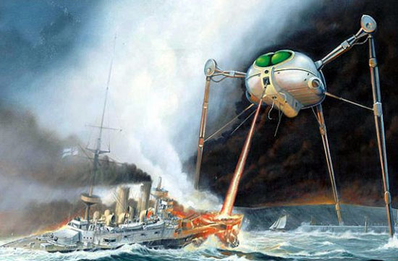
- George Thomkyns Chesney published The Battle of Dorking: Reminiscences of a Volunteer (1871), which describes a successful invasion of Britain by an unnamed power with “fatal-engines” weapon.

- The Challenger Deep Sea Expeditions
(1872-1876) proved life on the bottom of the ocean and discovered 4,700 species new to science! HMS Challenger report published in 1880.

- Italian astronomer Schiaparelli observed ‘canali’ on Mars (1877)

- Camille Flammarion: L’astronomie populaire (1879) and La Planete Mars (1892); Percival Lowell: Mars (1895) both argued for intelligent life on Mars.

- Wells: “Zoological Retrogression” (1891) “The Extinction of Man”; “On Extinction” (1893-4)

In the case of every other predominant animals the world has ever seen […] the hour of its complete ascendency has been the eve of its entire overthrow

--- Wells, H.G. “The Extinction of Man” The Pall Mall Gazette, 25 Sept 1894. Print.

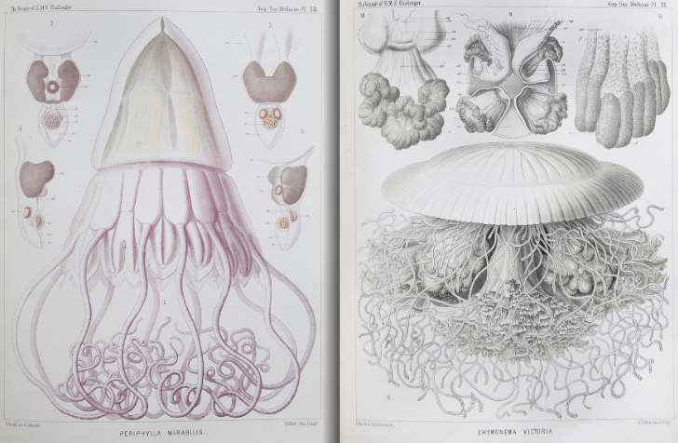
“Two large dark-coloured eyes were regarding me steadfastly […] there was a mouth under the eyes, the lipless brim of which quivered and panted, and dropped saliva. The whole creature heaved and pulsated convulsively. A lank tentacular appendage gripped the edge of the cylinder, another swayed in the air.” (21)

[Wells writes about] the special threat to homo sapiens arising from the fact that dominant species invariably fall to some humble creature that Nature Is quietly preparing in the abyss. (9)

--- Philmus, Robert M. and David Y. Hughes “Introduction” H. G. Wells: Early Writings in Science and Science Fiction eds. Robert M. Philmus and David Y. Hughes. Berkley: University of California Press, 1975. Print.
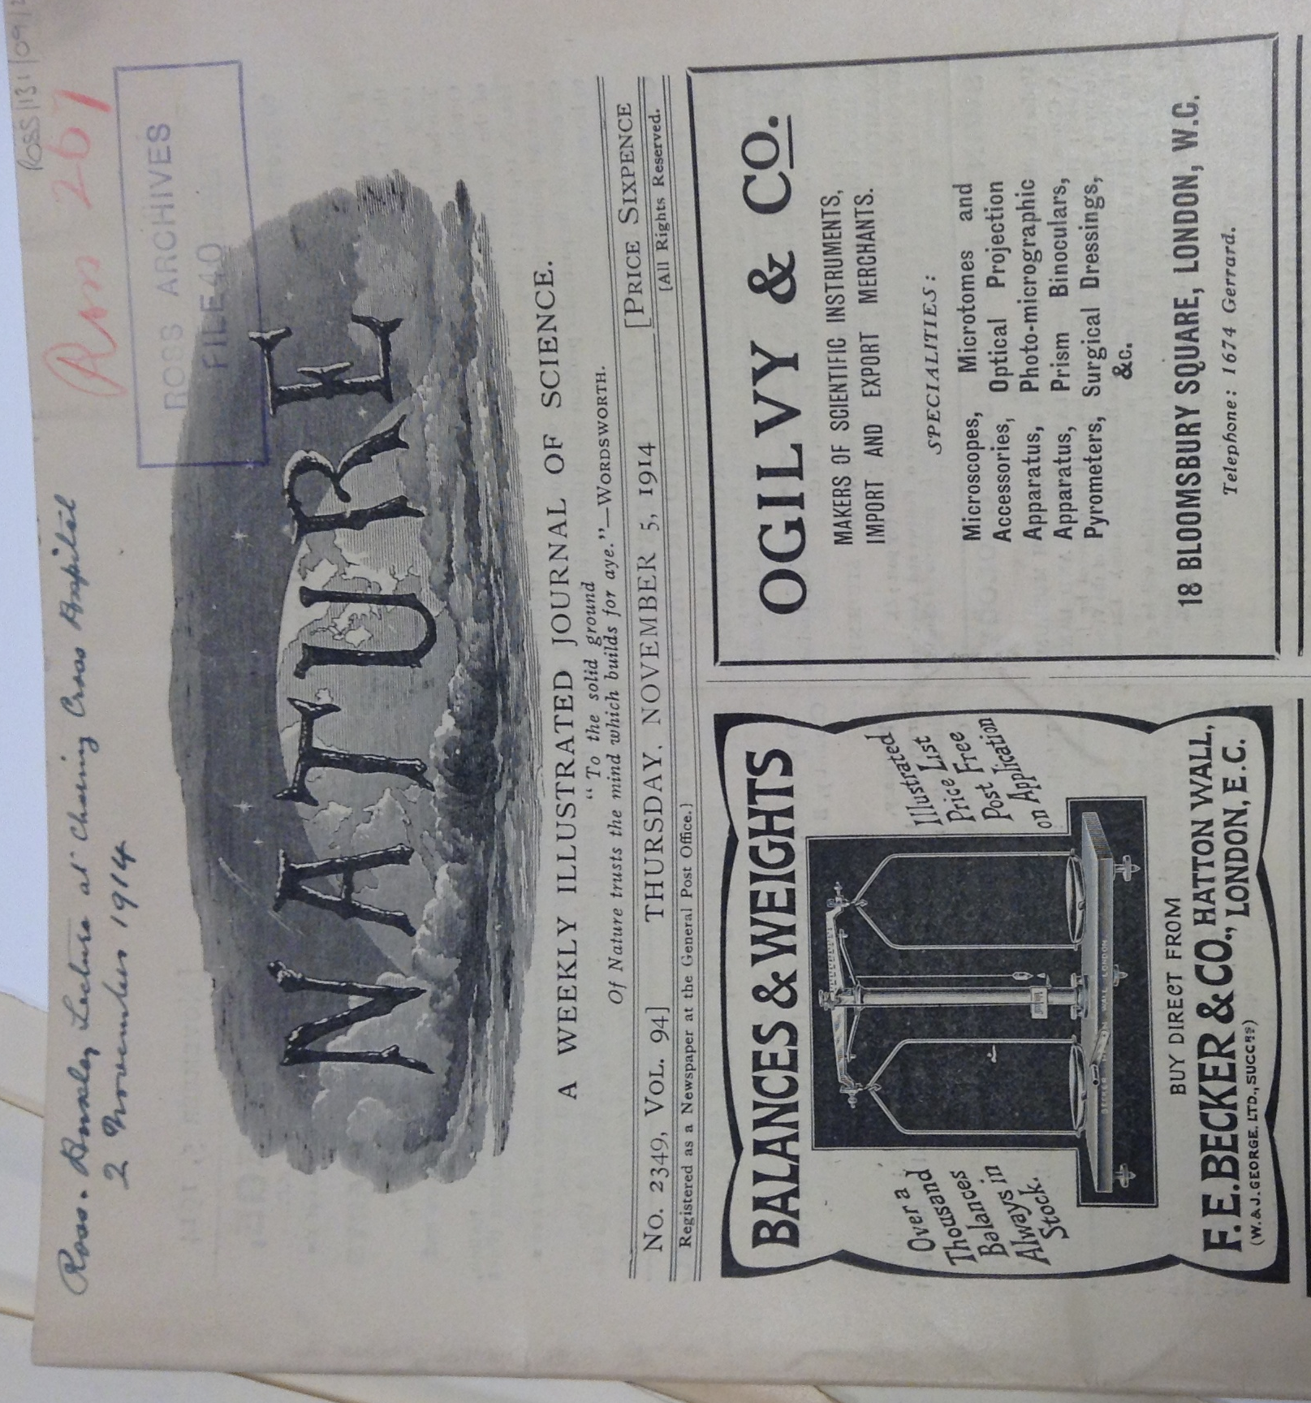
- 1820/30s - Christian Ehrenberg discovers highly complex organisation of infusorians under the microscope.

- 1846 – Discovery of Neptune, thought to push at the boundaries of the known universe (before the discovery of Pluto in 1930)

- 1862 – Sir William Thomson (Lord Kelvin) On the Age of the Sun’s Heat

The air, the earth, and the waters teem with numberless myriads of creatures, which are as unknown and as unapproachable to the great mass of mankind, as are the inhabitants of another planet. (7)

That there should be more species of intelligent creatures above us, than there are of sensible and material beings below us, is probable to me […] that the species of creatures should by gentle degrees ascend upwards from us towards Infinite Perfection, as we see they gradually do from us downwards. (5)

--- Mantell, Gideon Algernon. Thoughts on Animalcules, or, a Glimpse of the Invisible World Revealed by the Microscope. London: John Murrary, 1846.

Points to Consider

How does Wells set up a parallel between microscopic and telescopic worlds?
How does the Martian invasion transform the English landscape, and why is this a powerful image?
In what ways might the text be read as a critique of British Imperialism?
How does the evolutionary anxiety inherent in the text combine with fears concerning degeneration?
How are the differences between Natural and Artificial selection explored in the text?
Does religion have a place in society for Wells?
Consider the symbolic breakdown of technological communication, as well as technology’s part in Martian domination.
What is the significance of the Martian’s defeat?
Explore the use of symbolism such as blood, consumption and land as body metaphors.

Degeneration

“Octopuses” “Crab” “Thing” “something fungoid in the oily brown skin”

“These creatures, to judge from the shrivelled remains that have fallen into human hands, were bipeds with flimsy, silicious skeletons (almost like those of the silicious sponges) and feeble musculature, standing about six feet high and having round, erect heads and large eyes in flinty sockets.”

Technological Advancement and Mechanisation

Day by day the machines are gaining ground upon us; day by day we are becoming more subservient to them […] Our opinion is that war to the death should be instantly proclaimed against them.
--- Samuel Butler, ‘Darwin Among the Machines’ (1863) published anonymously in a New Zealand colonial newspaper in response to Darwinism and related debates.

“Their organisms did not sleep, any more than the heart of man sleeps. Since they had no muscular mechanism to recuperate, that periodical extinction was unknown to them. They had little or no sense of fatigue, it would seem […] in twenty four hours, they did twenty four hours of work.” (126)

“…the perfection of mechanical appliances must ultimately supersede limbs; the perfection of chemical devices, digestions […] the Martians wore no clothing […] it was in the other artificial additions to their bodily resources that their great superiority over man lay. We men, with our bicycles and road-skates, our Lilienthal soaring-machines, our guns and sticks, and so forth, are just in the beginning of the evolution that the Martians have worked out.” (128-9)

Men as Invertebrates

“Ants in a nest against which [Man’s] foot has kicked”, (63) “little frogs hurrying through the grass from the advances of man” (65), “just…eatable ants” (153)

Colonial Encounters

“Before we judge of them too harshly, we must remember what ruthless and utter destruction our own species has wrought, not only upon animals […] but upon its own inferior races.” (9)

