Unit III (1914-1945): Modernisms and World War
Week 1: ‘Diary of a Madman’ (1918) Lu Xun; ‘The Story of my Dovecote’ (1925) Isaak Babel; ‘The Garden of Forking Paths’ (1941) Jorge Luis Borges
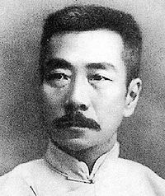
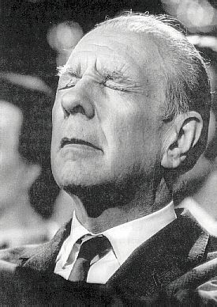
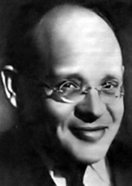
Lu Xun [Zhou Shuren]
(1881-1936)
Jorge Luis Borges (1899-1986)
Isaak Babel (1894-1940)

Important Political Movements:
China – May Fourth Movement New Culture Movement: disillusionment with traditional Chinese culture and enforced social hierarchies like the patriarchal family (Confucianism). Desire for liberation, individual freedom, westernised science and a more democratic state.

Russia – 1905 Odessa pogrom: part of a series of large-scale communal anti-jewish violent riots across the Russian empire. [Previous pogroms – 1821,1859,1871,1881,1900] Anti-Semitism fuelled by increased visibility of Jews, particularly in Odessa, and their perceived wealth, power and influence, particularly in commerce.
1920s Soviet Realism – movement in art and literature that drew attention to the everyday struggles of the working classes in order to further socialist and communist ideologies

Argentina – 1930s Buenos Aires modernism: modernist movements that was characterised by existential questioning and pushing the boundaries of reality; influenced by the writings of Heidegger and Sartre, experimental in form. Characterised by styles like idealism and magic realism.

European modernism as overarching phenomenon must be located at the threshold of a not yet fully modernised world in which old and new were violently knocking against each other, striking the sparks of that astounding eruption of creativity that came to be known only much later as ‘modernism’.

--- Andreas Huyssen, ‘Geographies of Modernism in a Globalising World’ Geographies of Modernism eds. Peter Brooker and Andrew Thacker (New York: Routledge, 2005) p. 7.

Only Cannibalism unites us. Socially. Economically. Philosophically. The unique law of the world. The disguised expression of all individualisms, all collectivisms. Of all religions. Of all peace treaties. Tupi or not tupi that is the question. Against all catechisms. And against the mother of the Gracos. I am only interested in what’s not mine. The law of men. The law of the cannibal.

--- Oswalde de Andrade, Cannibal Manifesto (1928)

Magic Realism: a literary style associated especially with Latin America, which incorporates supernatural or fantastical elements into an otherwise realistic tale in order to access a higher level of understanding. Often associated with the inexplicable or unsayable.

The term [Borgesian] is generally applied to works that play with a reader’s perceptions of conventional reality, usually by destabilizing notions of time and space, blurring the boundaries of fact, fiction, and philosophy, or blending artistic invention with mock criticism and academia.

--- Allen B. Ruch, ‘Borges as an Influence’ (2004) for The Modern Word at: http://www.themodernword.com/borges/borges_influence.html [accessed Jan 2014]

Hypertextuality: ‘Any relationship uniting text B (which I shall call the hypertext) to an earlier text (I shall of course call it hypotext), upon which it is grafted in a manner that is not that of commentary […] it may be of a kind such as text B not speaking of text A at all, but unable to exist, as such, without text A, from which it originates […] and consequently evokes more or less perceptibly without necessary speaking of it, or citing it.’
--- Gerard Genette, Palimpsests: Literature in the Second Degree trans. Channa Newman and Claude Doubinsky (Lincoln: University of Nebraska Press, 1997) p.5.

The Multiverse Hypothesis: idea that there exists an infinite set of possible universes, which comprise everything that can, has or will ever exist (including time, space, matter and energy); coined in 1895 by William James.

Points to Consider:
- How might the narration style of the three texts impact their sense of authenticity?
- In what ways might we see these texts as ‘modern’?
- How does the language evokes a sense of the narrators state of mind?
- How might these texts relate to others on the module?
- What is the significance of time and space to these texts?

Further Reading

Andreas Huyssen, ‘Geographies of Modernism in a Globalising World’ Geographies of Modernism eds. Peter Brooker and Andrew Thacker (New York: Routledge, 2005)
Gerard Genette, Palimpsests: Literature in the Second Degree trans. Channa Newman and Claude Doubinsky (Lincoln: University of Nebraska Press, 1997)
Lois Parkinson Zamora, ‘The Visualising Capacity of Magical Realism: Objects and Expression in the Work of Jorges Luis Borges’ Janus Head (2002)
Robert Weinberg, ‘Workers, Pogroms and the 1905 Revolution in Odessa’, The Russian Review 46(1987) pp.53-75.
Xiaobing Tang, ‘Lu Xun’s “Diary of a Madman” and a Chinese Modernism’ Modern Language Association 107(1992)5 pp.1222-1234.

Other resources: http://www.themodernword.com/

