Ends and Beginnings:
Late 19th & Early 20th Century Literature & Culture

Week 2: George and Weedon Grossmith, The Diary of a Nobody (1888-1889)
- First appeared in Punch, or the London Charivari in May 1888 with the following footnote:
“As everybody who is anybody is publishing Reminiscences, Diaries, Notes, Autobiographies, and Recollections, we are sincerely grateful to “A Nobody” for permitting us to add to the historic collection” – ed.
- Published in book form in 1892 with new chapter 11 and six further chapters added at the end, as well as Pooter’s foreword. Illustrations were added by Weedon Grossmith.
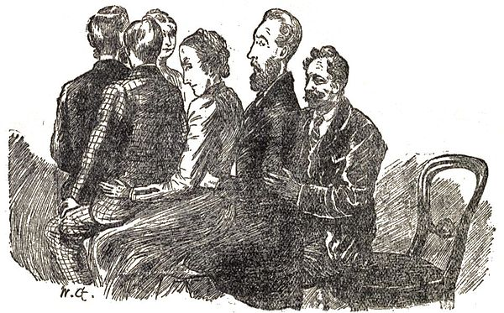
George and Weedon Grossmith’s The Diary of a Nobody (1892) records the daily thoughts of a flummoxed suburbanite, Charles Pooter, bombarded by the forces of middle-class play: parlor tricks, card games, dinner parties, séances, and a theatrically-inclined son embroiled in perpetual self-discovery. Repelled by the ascendant play ethic around him, Pooter nevertheless finds himself drawn to it, desiring the sense of self that it imparts to his friends and family, the sense of being a somebody.
Kaiser, Matthew. “The World in Play: A Portrait of a Victorian Concept” New Literary History 40.1(2009):105-129.

Significant Themes and Cultural Signifiers
- Money, materiality, consumerism
- Class
- Technology: typewriter, telegraph, railway, buses, bicycles
- Fashion and etiquette
- “The modern life”
- Humour (practical jokes, irony, punning)
- Theatricality
- DIY
- Slang
- Spiritualism
Industrialisation, Class Anxiety and the Suburbs
As John Carey has shown, the expanding white-collar suburbs were symbolic for intellectuals of the degradation and cultural mediocrity wrought by mass culture under the influence of universal education. The suburban clerk, bathed in the trivialities of the cheap press and with genteel aspirations far beyond his station, provided the most fruitful target for cutting satire of the entire process.
Hammerton, A. James. “The Perils of Mrs Pooter: Satire, Modernity and Motherhood in the Lower Middle Class in England 1870-1920” Women’s History Review 8.2(1999):261-276.

“I restrained my feelings, and quietly remarked that I thought it possible for a City clerk to be a gentleman.” (Diary, 33).

During the greater part of the nineteenth century the evolving identity of the English gentleman both challenged and defined British social ideals. Coming out of what James Eli Adams calls an “[e]galitarian [. . .] resistance to aristocratic hegemony,” it created a new “norm, that could be realised by deliberate moral striving” (152); as Robin Gilmour explains, the gentlemanly ideal “provided a time-honoured and not too exacting route to social prestige for new social groups [...] a station which aspiring members of the middle classes could hope to penetrate and, to some extent, make over in their own image” (5). Conservative fears about advancing democracy found voice in attendant anxieties over the increasing numbers of would-be gentlemen, dandies, and, later, “gents,” who appropriated (often in exaggerated forms) the trappings of the gentleman without either attaining or exhibiting the moral stature and sensibility which constituted the ideal.

Windholz, Anne. M. “An Emigrant and a Gentleman: Imperial Masculinity, British Magazines, and the Colony That Got Away” Victorian Studies, 42.4 (1999/2000): 631-658.

[Aestheticism and Decadence performed a] shift from the productivist ethos that characterised the industrial revolution to a consumptionist one, in which the display of taste and ownership became a key marker of identity. (39)

Denisoff, Dennis. “Decadence and Asetheticism” The Cambridge Companion to the Fin de Siècle ed. Gail Marshall. Cambridge: Cambridge University Press, 2007.

Points to Consider:
- How does Pooter’s class and social position impact his identity, and in what ways does he perform or act out this identity?
- How does the diary represent suburban life?
- In what ways does Lupin represent the ”modern” man?
- How is the class divide addressed in the diary?

Gender, Masculinity and Sexuality
Young men who came of age in England at the end of the nineteenth century did so as the very nature of masculinity was being contested in social, economic, and sexual arenas. The ideals of British masculinity with which many of these youths grew up, traceable to the “muscular Christianity” of Thomas Arnold and Charles Kingsley decades before, were tested and challenged, redefined or reinforced, against backdrops at least superficially disparate: against the cultural boundaries being extended in a continental bohemia by the Aesthetes and Decadents.
Windholz, Anne. M. “An Emigrant and a Gentleman: Imperial Masculinity, British Magazines, and the Colony That Got Away” Victorian Studies, 42.4 (1999/2000): 631-658.

[Dorian Gray] is the French decadent invested in the commodity culture arising from Britain’s shift toward consumerism and the bourgeois tent of house- and self- beautification. (40)

Denisoff, Dennis. “Decadence and Asetheticism” The Cambridge Companion to the Fin de Siècle ed. Gail Marshall. Cambridge: Cambridge University Press, 2007.

For manual workers the suburban Pooter’s sedentary work and commitment to home represented an effete and degraded manliness. For middle-class writers he failed to measure up to their long-established standards of masculine independence, both in his servile employment and his petty preoccupation with domesticity. If the early Victorian middle class had consolidated an ideal of separate spheres in which women guarded the home as a sanctuary for independent men of the world, a generation later white-collar men had apparently betrayed the arrangement by taking domesticity too seriously in their urge to prove their genteel status.
Hammerton, A. James. “The Perils of Mrs Pooter: Satire, Modernity and Motherhood in the Lower Middle Class in England 1870-1920” Women’s History Review 8.2(1999):261-276.
Points to Consider:

- How does the diary present the matrimonial relationship?
- How does the diary represent women? (Daisy Mutlar, Carrie, Sarah, Mrs. James etc)
- Consider the varying representations of masculinity as embodied by Charles Pooter, Gowing, Cummings, Mr Perkupp, Lupin, Farmerson the Ironmonger, Mr Hardfur Huttle etc
- Are Pooter’s attempts at home improvement successful?
- Consider the ways in which Pooter is exempt from “being a somebody”.
- Consider the generational differences at work in the diary.
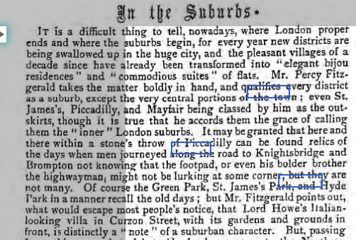

From The Graphic, Saturday 17th June 1893, 4.

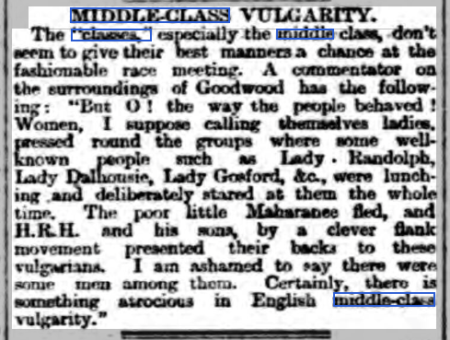

From Edinburgh Evening News, Wednesday 3rd August 1887, 2.

