Unit III (1914-1945): Modernisms and World War
Week 2: The Metamorphosis (1915) Franz Kafka

A Note On Taxonomy

‘Ungeziefer’ | vermin, pest What is Gregor? Cockroach? Beetle?

‘As Gregor Samsa woke one morning from uneasy dreams, he found himself transformed into some kind of monstrous vermin. He lay on his hard armour-like back, and if he lifted his head a little, he could see his curved brown abdomen, divided into arch-shaped ridges, and domed so high that the bedspread, on the brink of slipping off, could hardly stay put. His many legs, miserably thin in comparison to his size otherwise, flickered helplessly before his eyes.’ (p.29.)
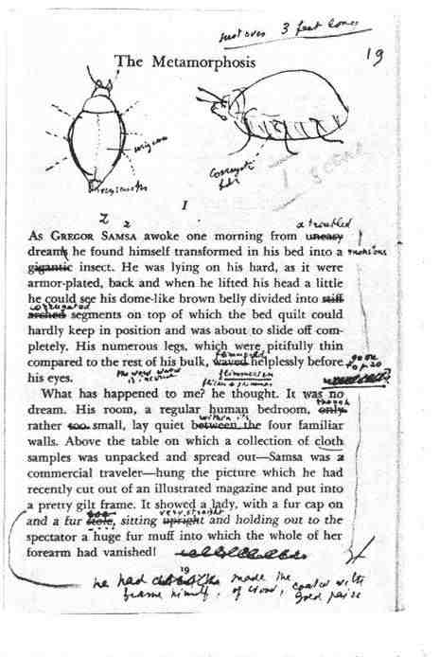
(Left) Vladimir Nabokov’s teaching copy of Kafka’s The Metamorphosis with annotations.

Nabokov, an entomologist as well as a novelist, attempted to define Kafka’s ‘insect’. He suggested some form of beetle was most appropriate from the descriptions, but notes that beetles do not have eyelids and thus Gregor still possesses ‘human eyes’.

‘He has a tremendous convex belly divided into segments and a hard rounded back suggestive of wing cases. In beetles these cases conceal flimsy little wings that can be expanded […] Curiously enough, Gregor the beetle never found out that he had wings under the hard covering of his back. (This is a very nice observation on my part to be treasured all your lives. Some Gregors, some Joes and Janes, do not know that they have wings.)

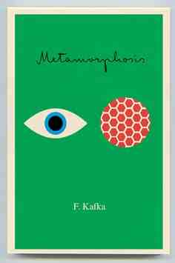
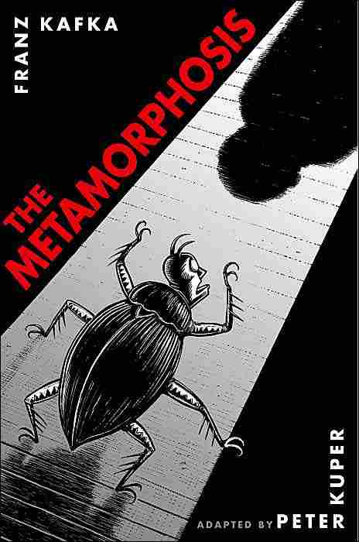
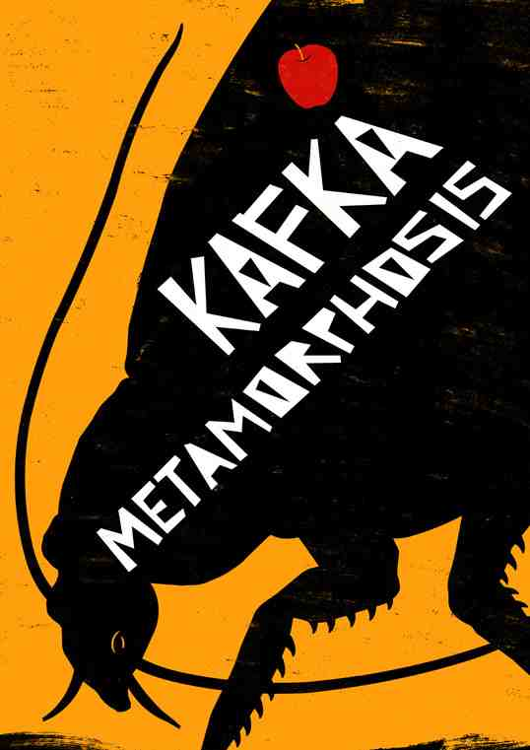
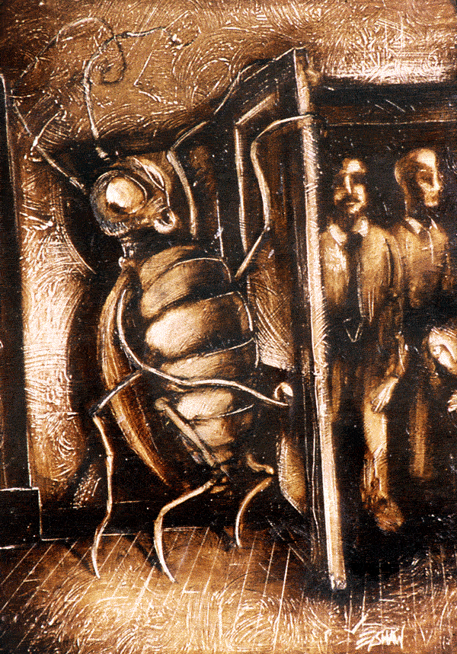

Incongruous descriptions: high domed abdomen, ‘many little legs’, tall enough to reach the door to open with his mouth, however can be crushed by his father’s shoe. Can cover a picture with his body and be interpreted as a ‘brown stain’ on the wall, but large enough for the bedclothes to slip off him and an apple to get stuck in his back. Gets stuck in the doorway, but can wriggle under the sofa.

Modern Life

‘The stresses of making deals […] burdened with the misery of travelling; there’s the worry about train connections, the poor, irregular meals, human contact that is always changing, never lasting, never approaching warmth.’ (p.29.)

‘And he looked across at the alarm clock, which was ticking on the chest. “Father in heaven!” he thought. It was half-past six, and the hands were moving steadily forwards. It was even later than than half-past six; it was already approaching a quarter to seven […] “Seven o’clock already,” he said to himself as the alarm-clock began to ring again, “Seven o’clock already and still so foggy.”[…] But then he said to himself: “Before it rings a quarter-past seven, I absolutely must have got out of bed, all of me.”’ (pp.30-33.)

History of modernity is a history of tension between social existence and its culture. Modern existence forces its culture into opposition to itself. This disharmony is precisely the harmony modernity needs. The history of modernity draws its uncanny dynamism from the speed with which it discards successive versions of harmony, having first discredited as but pale and flawed reflections of it foci imaginarii.
Modernity prides itself on the fragmentation of the world as its foremost achievement. Fragmentation is the prime source of its strength. The world that falls apart into plethora of problems is a manageable world.

--- Zygmunt Bauman, Modernity and Ambivalence (Cambridge: Polity Press, 1991)

What is the significance of time in the text? How is the world ‘fragmented’? Is this an active process? How are the tensions between modern life and Gregor’s experience presented?

The typically modern practice, the substance of modern politics, of modern intellect, of modern life, is the effort to exterminate ambivalence: an effort to define precisely – and to suppress or eliminate everything that could not, or would not be precisely defined.
[…]
Modern existence is both haunted and stirred into restless action by modern consciousness; and modern consciousness is the suspicion or awareness of the inclusiveness of extant order; a consciousness prompted, and moved by, the premonition of inadequacy, nay non-viability, of the order-designing, ambivalence- eliminating project; of the randomness of the world and contingency of identities that constitute it.

--- Zygmunt Bauman, Modernity and Ambivalence (Cambridge: Polity Press, 1991) p.10.

Other Characters

‘He’s got a peculiar way of perching on his desk and talking down to an employee from on high’ (p.30.)

‘Attendant from work […] he was the Boss’s creature, stupid and spineless.’ (p.31.)

‘It was only over his twitching shoulder that he looked back at Gregor, his lips drawn back in a grimace […] he did not stand still, but retreated toward the door without letting Gregor out of his sight – but very gradually […] he drew his leg out of the living room […] stretched his right hand as far as he could toward the stairs […] clinging ludicrously with both hands to the banisters.’ (pp.40-41.)

Gregor’s Changed Perspective

‘He felt drawn back into the sphere of humanity, and had high hopes of impressive and surprising achievements from both, from the doctor and the locksmith, without really distinguishing very clearly between them.’ (p.38.)

‘He really had no more time to examine the good intentions of the two women, whose existence, incidentally, he had almost forgotten, for they were now working in silence.’ (p.55.)
‘He lifted his feet unusually high, and Gregor was amazed at the gigantic size of his boot-soles.’ (p.58.)

Family Dynamics

All parents want to do is drag one down to them, back to the old days from which one longs to free oneself and escape; they do it out of love, of course, and that’s what makes it so horrible.

--- Franz Kafka, Letters to Felice (21st November 1912)

‘None of Gregor’s pleas helped, none of his pleas [were] understood; however submissively he turned his head, his father stamped all the more vigorously with his feet.’ (p.42.)

‘If only there were this intolerable hissing from his father! It made Gregor lose his head entirely […] Being Gregor it no longer sounded like the voice of one single father merely.’ (p.43.)

‘His mother ran to their father […] on the way he layered skirts slipped to the ground one after another […] she stumbled over the skirts to urge herself upon their father, embracing him, in total union with him – Gregor’s sight was already failing – and with her hands circling the back on his father’s head she begged him to spare Gregor’s life.’ (p.59.)

Points to Consider:

- What effect does the ambiguity surrounding Gregor’s transformation cultivate?
- What is the intention of using such a metaphor?
- How does Gregor intitially respond to his transformation?
- How does Gregor’s transformed body’s inconsistent size impact the narrative’s sense of surrealism?
- How does the juxtaposition of the fantastical with the modern mundane create a sense of the absurd? What does this suggest about the dynamics of the modern world in which the narrative is set?
- How are the actions of characters in the narrative amplified and caricatured?
- What does the narrative suggest about the dynamic of the modern nuclear family?
- What is the significance of Gregor’s extreme difficulty getting out of bed?
- Discuss the absurdity of Gregor’s suggestion that he can ‘still make the 8 o’clock train’.
- What is the significance of the family’s (particularly the Father’s) own transformation(s) in response to Gregor’s?

Further Reading
David Constantine, ‘Kafka’s Writing and Our Reading’, The Cambridge Companion to Kafka ed. Julian Preece (Cambridge: Cambridge University Press, 2002) pp.9-24.
J. M. Hawes, Excavating Kafka (London: Quercus, 2008)
Jakob Lothe, Beatrice Sandberg and Ronald Speirs eds. Franza Kafka: Narration, Rhetoric and Reading (Columbus: Ohio State University Press, 2011)
Raymond Armstrong, ‘Descriptions of a Struggle: ‘The Judgement’ and ‘The Metamorphosis’’ Kafka and Pinter; Shadow-Boxing: The Struggle Between Father and Son (Basingstoke: Palgrave Macmillan, 1998) pp.1-36. [particularly: pp.20-36.]
Zygmunt Bauman, Modernity and Ambivalence (Cambridge: Polity Press, 1991)

