Ends and Beginnings:
Late 19th and Early 20th Century Literature and Culture

The Thousand and One Nights/Arabian Nights

Alf Laylah wa Laylah; The Arabian Nights, or A Thousand and One Nights, or The Story of a Thousand Nights and a Night.
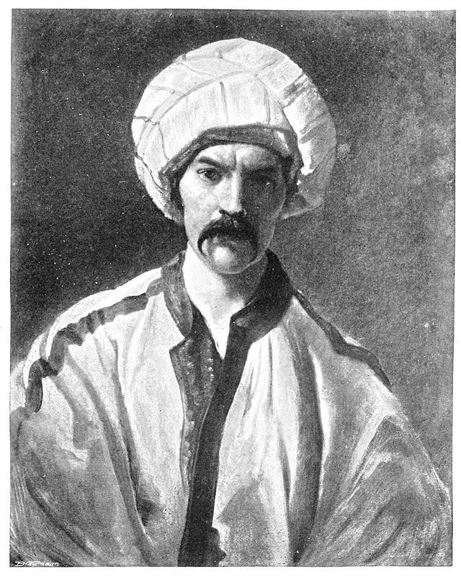
- Collection South Asian and Middle Eastern folktales passed down orally until they were compiled in Arabic during the Islamic Golden Age (c.8th-13^{th)}
- Two Arabic manuscripts: Syrian and Egyptian, from which many different versions have been made.
- Antoine Galland – produced first European edition, translated into French in eighteenth century (1704 -1717) [based on revisions of Syrian manuscript]
- Edward Lane, translated into English from Arabic, (1838 – 1840; rev. edn. 1859) censored much of the sexual content [based on rev. Egyptian MS]
- John Payne produced unabridged version (1882-4). Privately printed. [Egyptian MS]
- Richard Burton produced another unabridged and uncensored version (1885 - 1888); he emphasised the sexual indecency with extensive footnotes and framing essays. Privately printed. [Egyptian MS]

Themes: gender relationships; betrayal; revenge; homosexuality; religion; magic; allegory; infidelity; miscegenation; cross-dressing; deception; power; submission; story-telling; narrative

Explaining Homosexuality

In Burton’s terminal essay he identifies, what he calls the ‘Sotadic zone’ – where pederasty is practiced freely. He gives it specific geographical coordinates: southern France; Iberian peninsular (Spain and Portugal); Italy; Greece; coastal parts of Africa, including Morocco and Egypt; Asia minor (turkey); Mespotamia and Chaldaea (Iraq, Syria and Kuwait); Afghanistan; Sind, the Punjab, and Kashmir (India and Pakistan); China; Japan; Turkestan; South Sea Islands and north and south America.

“…within the Sotadic zone there is a blending of the masculine and feminine temperaments, a crasis which elsewhere occurs only sporadically ” (208)

“Prof. Mantegazza claims to have discovered the cause of this pathological love, this perversion of the erotic sense, one of the marvellous list of amorous vagaries which deserve, not prosecution, but the pitiful care of the physician and the study of the psychologist. According to him the nerves of the rectum and the genitalia, in all cases closely connected, are abnormally so in the pathic who obtains, by intromission, the venereal orgasm which is usually sought through the sexual organs.” (208-9)

“Pederastia had in Greece, I have shown, its noble and ideal side: Rome, however, borrowed her malpractices, like her religion and polity, from those ultra-material Etruscans and debauched with a brazen face.”

“The Sotadic zone covers the whole of Asia Minor and Mespotamia now occupied by the “unspeakable Turk”, a race of born pederasts; and in the former region we first notice a peculiarity of the feminine figure […] whilst the women to the North and South have, with local exceptions, the mammae stantes of the European virgin, those of Turkey, Persia, Afghanistan, and Kashmir lose all the fine curves of the bosom, sometimes even before the first child; and after it the hemispheres take the form of bags.” (232)

“M. Louis Daville describes the infamies of Lahore and Lakhnau where he found me dressed as women, with flowing locks under crowns of flowers, imitating the feminine walk and gestures, voice and fashion of speech, and ogling their admirers with all the coquetry of bayaderes [Indian dancing girls] […] yet the Hindus, I repeat, hold pederasty in abhorrence and are as much scandalised by being called Gand-mara (anus-beater) or Gandu (anuser) as Englishmen would be.” (237)

“Beyond India, I have stated, the Sotadic Zone begins to broaden out embracing all China, Turkistan and Japan. The Chinese, as far as we know them in the great cities, are omnivorous and omnifutuentes: they are the chosen people of debauchery and their systematic bestiality with ducks, goats and other animals is equalled only by their pederasty.” (238)

- In his Terminal Essay, Burton ‘hold(s) [pederasty] to be geographical and climatic, not racial’, however also discusses arguments for the physical basis of so-called ‘pathological love’. What is the significance of these discussions, and how might we situate them in dialogue with nineteenth century British understandings of sexuality?
- How is homosexuality presented in Nights?
- Why does Burton discuss Ancient Greek and Roman sexual practices?

A Question of Translation

From: Lane-Poole, Stanley. “The Arabian Nights” The Edinburgh Review 164.135(1886): 166-199.

“Lane’s ‘Thousand and One Nights’ is, however, something more than a translation. It is a commentary upon Arabian society in the past and present. The translator’s long residence in Egypt gave him not only the scholarship to which the Ulama of Cairo had recourse in their nicest legal disputes, but also an intimate acquaintance with Mohammedan life, which enabled him to annotate his version of the ‘Arabian Nights’ with a wealth of illustration which no other translator has ever approached.” (174)

“Galland had given us a paraphrase of a fragment of the ‘Arabian Nights’, mixed with other tales, to which Von Hammer added an abridged and little known version of the stories not included in the French edition. Then Lane retranslated the ‘Nights’ in a practical spirit, omitting what was objectionable, together with a few tales that were on the whole uninteresting or tautological, and enriching the work with a multitude of valuable notes. We had now a scholarly version of the greater part of the ‘Nights’, imbued with the spirit of the East and rich in illustrative comment; and for forty years no one thought of anything more […] nobody desired to see the objectionable passages […] a mania has now seized upon literary peddlers which incites them to deeds of laborious collation […] the zealous editors and translators of today will spare no pains to retrieve every fragment of an author […] there are surely enough books in the world as it is, of all shades of merit or demerit, without raking up the rubbish heaps of the past.
[…]
What more splendid opportunity for a translator imbued with modern spirit could be found than in this great ‘saga book’, a third of which is locked up in the intricacies of an Oriental tongue, and that third characterised more of less by objectionable qualities which unfortunately only add to the excitement of the new version? Hitherto not one of the translators—Galland, Von Hammer, Torrens, or Lane—had for a moment entertained the idea of reproducing in their editions the coarseness of the original […] but the time has come when all such prudish delicacy must be cast off. The ‘modest Lane’ as Captain Burton styles him, is a being of the past; now we have—well, we have Captain Burton.” (174-6)

“…there is an old and trusty saying that ‘evil communications corrupt ‘good manners’, and it is a well-known fact that the discussion and reading of depraved literature leads infallibly to the depravation of the reader’s mind. The less such things are said and thought about the less they will be enacted in real life. Our standard of delicacy may be wholly conventional, but its infraction is not the less dangerous and reprehensible. As for the argument that the ‘Arabian Nights’ cannot be understood without coarse details, it is one that could only be advanced by those who have wares to sell. Their insertion destroys the enjoyment of cultivated reader, and gives no fresh insight whatever into the character of the tales, except that he finds the Easterns are coarser of speech than he had expected.” (178-9)

“[Burton] gives it his opinion that ‘the student who adds the notes of Lane (“Arabian Society”) to mine will know as much of the Moslem East and more than many Europeans who have spent half their lives in Orient lands.’ When we examine the notes we can readily believe this curiously expressed statement. Probably no European, even if he have live half a century ‘in Orient lands’, has ever gathered together such an appalling collection of degrading customs and statistics of vice as is contained in the notes to Captain Burton’s translation of the ‘Arabian Nights’. It is bad enough in the text of the tales to find that Captain Burton is not content with plainly calling a spade a spade, but will have it styled a dirty shovel; but in his notes he goes beyond this, and the varied collection of abominations which he brings forward with such gusto is a disgrace and a shame to print literature.” (183)

“The different versions, however, each have its proper destination—Galland for the nursery, Lane for the library, Payne for the study, and Burton for the sewers. We have spoken severely with regard to the last, and also in respect of Mr. Payne’s needless literalism, because we can find no adequate justification for flooding the world with an ocean of filth.” (182-3)

- Why does Lane-Poole object to Burton’s translation?
- How is Burton’s translation situated in relation to wider discussions of pornography, morality, and English national character?
- How does Burton defend his translation?

Imaginative Imperialism and Representing the ‘Other’

Despite his claims for scholarship and semantic equivalence, Burton's translation is a creative production that discloses more about English sexual preoccupations than it does about Arab sexuality. His translation demonstrates how his transformation of the Arab text elicited a debate about pornography agitated by English nationalism, by anxiety about English sexual prudery, and by prurient interest in Arab sexuality. Most importantly, it shows how the literary and cultural concept of pornography emerged with the expansion of travel, empire, and globalisation.

--- Colligan, Colette. ““Esoteric Pornography”: Sir Richard Burton’s Arabian Nights and the Origins of Pornography” Victorian Review. 28.2(2002): 31-64. (34)

Orientalism as a discourse [exposes] the enormously systematic discipline by which European culture was able to manage—and even produce—the Orient politically, sociologically, militarily, ideologically, scientifically, and imaginatively during the post-Enlightenment period […] Orientalism was not (and is not) a free subject of thought or action […] European culture gained in strength and identity by setting itself off against the Orient as a sort of surrogate and even underground self. (3)

An Englishman in India or Egypt in the latter nineteenth century, took an interest in those countries that was never far from their status in his mind as British colonies. (11)

The kind of political questions raised by Orientalism, then, are as follows: What other sorts of intellectual, aesthetic, scholarly, and cultural energies went into the making of an imperialist tradition like the Orientalist one? How did philology, lexicography, history, biology, political and economical theory, novel-writing, and lyric poetry come to the service of Orientalism’s broadly imperialist view of the world? (15)

The learned Orientalist’s attitude was that of a scientist who surveyed a series of textual fragments, which he thereafter edited and arranged as a restorer of old sketches might put a series of them together for the cumulative picture they implicitly represent. Consequently, amongst themselves Orientalists treat each other’s work in the same citationary way. Burton, for example, would deal with the Arabian Nights or with Egypt indirectly, through Lane’s work, by citing his predecessor, challenging him even though he was granting him very great authority […] in the system of knowledge about the Orient, the Orient is less a place than a topos, a set of references, a congeries of characteristics, that seems to have its origin in a quotation, or a fragment of a text, or a citation of someone’s work on the Orient, or some bit of previous imagining, or an amalgam of all these. (176-77)

--- Edward Said, Orientalism. London: Penguin, 2003. Print.

[The Nights is] a compound text; on the one hand a medieval popular literature built upon a self-image now alien in European culture, and on the other an integral element and source for Romanticism and European imperial politics. The Nights is not a compound text only because of the uneasy links between the Arabic and English versions. The European texts were accommodating to a confused and compound reception and flexible enough to be convincing in almost contradictory interpretations. The Nights [were] the indulgence of lawless imagination and immorate improbability, the ultimate in flights of fantastic unreality [but were also used] as an accurate picture of the manners and customs of the Other. The two readers , the armchair traveller and the reader in search of exotic and enchanting unreality, existed side by side, even at times as one person. (6)

--- Sallis, Eva. Sheherazade Through the Looking Glass: The Metamorphosis of the ‘Thousand and One Nights’. London: Routledge, 1999. Print.

- How do translations of the Nights embody, resist, or otherwise interact with Said’s concept of Orientalism?
- How does the Nights figure in relation to English national and cultural concerns?
- What significance does the Nights have in relation to wider imperialist concerns?
- What is the relationship between the Nights, translation, and truth?

