Unit III (1914-1945): Modernisms and World War
Week 4: Pale Horse, Pale Rider (1939) Katherine Anne Porter
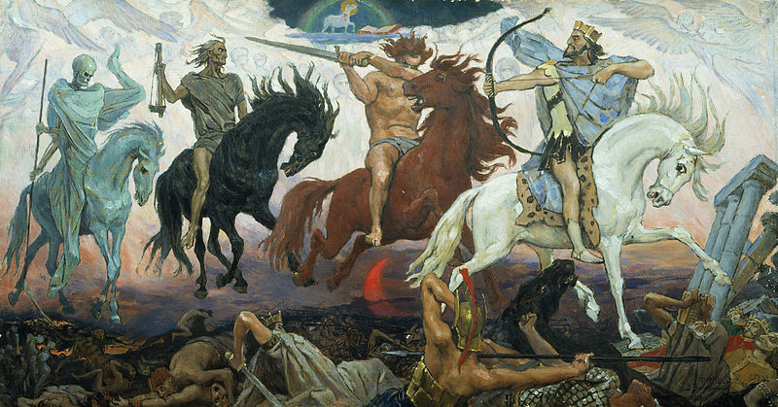

Four Horsemen of Apocalypse by Viktor Vasnetsov (1887)
[Left to Right: Death, Famine, War, Conquest]

In London, nearly 1,500 policemen, a third of the force, reported sick simultaneously. Council office workers took off their suits and ties to dig graves. Coffins that had been stockpiled during the war (a wartime agreement had been made that no bodies would be brought back from the battle lines) were suddenly in short supply. Railway workshops turned to coffin manufacturing and Red Cross ambulances became hearses.
--- Nicolson, Juliet. “The War was Over – but Spanish Flu would Kill Millions More.” The Telegraph 11 Nov 2009. Web. 29 Jan 2014.

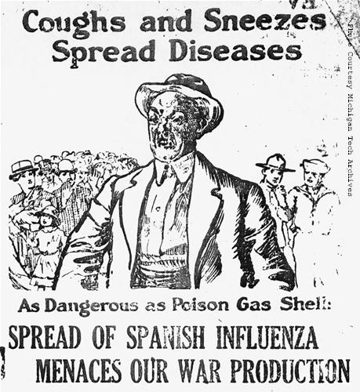
“I had a little bird,
Its name was Enza.
I opened the window,
And in-flu-enza.”

“There was a little girl, and she had a little bird,
And she called it by the pretty name of Enza;
But one day it flew away, but it didn't go to stay,
For when she raised the window, in-flu-Enza.”

Two versions of a playground rhyme, the former sung in 1918, the latter in the 1890s
1918 Spanish Influenza Poster distributed by the US Public Heath Service
Language, Materiality and Expression

In an age defined by the ethos of journalism, both death and language have become as immanent as the daily newspaper. As Ronald Schleifer has argued, the twentieth century has materialized both the fate of the flesh and the work of the word, so that they no longer have meaning in the context of some otherness beyond them.
[…]
The casualties of World War I and of the influenza epidemic in "Pale Horse, Pale Rider" seem completely a matter of the flesh. Constantly attentive to her make-up and clothes, Miranda detects the signs of her own eschaton in her aches and fevers; she glimpses Adam's mortality as a momentary darkening of his typically golden good looks.

--- Ciuba, Gary M. “One Singer Left to Mourn: Death and Discourse in Porter’s ‘Pale Horse, Pale Rider’” South Atlantic Review 61.1 (1996): 55-76. Web.

Stream of consciousness as a method of character depiction is a newly admitted reality. Art has always attempted to express, to objectify the dynamic processes of our inner life. Now that “inner life” is a reality which we recognise as available to any consciousness, and now that techniques, devices and forms have been established for conveying this reality, fictional art has come closer than ever to achieving its purpose.

--- Humphrey, Robert. Stream of Consciousness in the Modern Novel. London: University of California Press, 1954. Print.

Trauma and Memory

In Unclaimed Experience: Trauma, Narrative, and History, Cathy Caruth describes trauma as a "wound of the mind—the breach in the mind's experience of time, self, and the world—[that] is not, like a wound of the body, a simple and healable event, but rather an event that . . . is experienced too soon, too unexpectedly, to be fully known and is therefore not available to consciousness until it imposes itself again, repeatedly, in the nightmares and repetitive actions of the survivor" (4). Most trauma theorists locate trauma's impact in the individual memory, where the unsettling experience disrupts the victim's identity, but when a disruptive event affects a large population simultaneously, a collective trauma occurs. The influenza pandemic of 1918 complicates the distinction between individual trauma and collective trauma. One might stipulate that collective trauma merely consists of numerous individual traumas, but collective trauma amplifies the individual's experience by taxing the network of social resources that ordinarily stabilize the individual victim.

--- Davis, David. A. “The Forgotten Apocalypse: Katherine Anne Porter’s ‘Pale Horse, Pale Rider,’ Traumatic Memory and the Influenza Pandemic of 1918” The Southern Literary Journal 43.2 (2011): 55-74. Web.

‘He was in her mind so much, she hardly knew when she was thinking about him directly. His image was simply always present in more or less degree, he was sometimes nearer the surface of her thoughts…’ (p.323.)

Points to Consider
- What is the relationship between individual and collective trauma?
- What is the function of dreams in the story?
- What is the significance of biblical imagery and symbolism?
- How does language reflect the humbling impact of death?
- In what ways are the home-front and the war-front conflated or contrasted?
- What is the significance of sound in the story? E.g. Singing, Hymns, whistling, ‘“The War,” said the gong.’ (p.315-6.)
- How does the text construct new and challenge old notions of masculinity/femininity?
- In what ways is language used as a medium to express the inexpressible? i.e. continuous narrative flow versus fragmentation; linguistic devices; ‘floating’ symbolism; allegory.

Plato’s Cave Allegory

‘The white walls rose sheer as cliffs, a dozen frosted moons followed each other in perfect self-possession down a white lane and dropped mutely one by one into a snowy abyss […] Miranda lay […] watching a dance of tall deliberate shadows moving behind a wide screen of sheets spread upon a frame […] it was so beautiful she had no curiosity as to its meaning.’ (p.353.)

Further Reading

Bristow, Nancy. K. “‘It’s as Bad As Anything Can Be’: Patients, Identity, and the Influenza Pandemic” Public Health Reports (1974-) 125.3 (2010): 134-144. Web.
Ciuba, Gary M. “One Singer Left to Mourn: Death and Discourse in Porter’s ‘Pale Horse, Pale Rider’” South Atlantic Review 61.1 (1996): 55-76. Web.
Davis, David. A. “The Forgotten Apocalypse: Katherine Anne Porter’s ‘Pale Horse, Pale Rider,’ Traumatic Memory and the Influenza Pandemic of 1918” The Southern Literary Journal 43.2 (2011): 55-74. Web.
Humphrey, Robert. Stream of Consciousness in the Modern Novel. London: University of California Press, 1954. Print.
Nicolson, Juliet. “The War was Over – but Spanish Flu would Kill Millions More.” The Telegraph 11 Nov 2009. Web. 29 Jan 2014.

Archival Resources:

http://www.archives.gov/exhibits/influenza-epidemic/records-list.html

http://www.flu.gov/pandemic/history/1918/the_pandemic/index.html

