Ends and Beginnings:
Late 19th & Early 20th Century Literature & Culture

Queer Poetics: Michael Field, Sappho, John Addington Symonds,
and Christina Rossetti
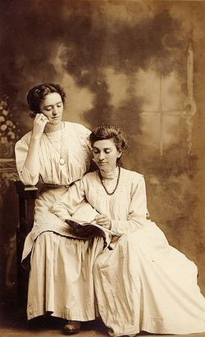
Michael Field: pseudonym for Aunt/Niece lesbian couple—Katharine Bradley (1846-1914) and Edith Cooper (1862-1913).

John Addington Symonds: English poet and critic (1840-1893). Wrote: A Problem in Greek Ethics published posthumously (1901), and A Problem in Modern Ethics (1896).

Christina Rosetti: English poet (1830-1894).

There is a passion, or a perversion of appetite, which, like all human passions, has played a considerable part in the world’s history for good or evil; but which has hardly yet received the philosophical attention and scientific investigation it deserves. The reason for this may be that in all Christian societies the passion under consideration has been condemned to pariahdom […] only one great race in past ages, the Greek race, to whom we owe the inheritance of our ideas, succeeded in raising it to the level of chivalrous enthusiasm. Nevertheless, we find it present everywhere and in all periods of history […] sometimes it assumes the calm dignified attitude of conscious merit, as in Sparta, Athens, Thebes. Sometimes it stalks in holes and corners, hiding its abashed head and shrinking from the light of days, as in the capitals of modern Europe.

--- From John Addington Symonds, A Problem in Modern Ethics, Being an Inquiry into the Phenomenon of Sexual Inversion, Addressed Especially to Medical Psychologists and Jurists (1896)

Explaining Female Homosexuality

It is noteworthy that a considerable proportion of the number of cases in which inversion has led to crimes of violence, has been among women […] A congenital sexual invert, Alice Mitchell, planned a marriage with Freda Ward, taking a male name and costume. This scheme was frustrated by Freda’s sister, and Alice Mitchell cut Freda’s throat. There is no reason to suppose that she was insane at the time of the murder. She was a typical invert of a very pronounced kind. Her mother had been insane and had homicidal impulses. She herself was considered unbalanced, and was masculine in her habits from her earliest years. Her face was obviously unsymmetrical and she had the appearance of youthfulness below her age. She was not vicious, and had little knowledge of sexual matters, but when she kissed Freda she was afraid of being seen, while Freda could see no reason for being ashamed. (119-20)

This kind of homosexuality is specially fostered by those employments which keep women in constant association, not only by day, but often at night also, without the company of men […] the circumstances under which numbers of young women are employed during the day in large shops and factories, and sleep in the establishment, two in a room of even two in a bed, are favourable to the development of homosexual practices (127)
[…]
Niceforo points out “these couples for mutual masturbation are never Lesbian couples. Tribadism is altogether absent from the factories and workrooms [of Rome].” He even believes that it does not exist among girls of the working class. He further describes how, in another work room, during the hot hours of the day in the summer, when no work is done, some of the girls retire into the fitting room, and having fastened chemises around their legs and thighs with pins, so as to imitate trousers, play at being men and pretend to have intercourse with the others. [These remarks] bring out the very important distinction between a merely spurious homosexuality and true inversion. (128)

Homosexual relationships are also a cause of suicide among women […] finally, when the obstacles become insurmountable, the younger woman took a revolver and deliberately shot herself in the temple, in the presence of her mother, dying immediately. Though sometimes thought to act rather strangely, she was a great favourite with all, handsome, very athletic, fond of all out-door sports, an energetic religious worker, possessing a fine voice, and was an active member of many clubs and societies. (120-21)

Homosexual women love more faithfully and lastingly than homosexual men (146)

- Why, according to Havelock Ellis, has female homosexuality not attracted much critical attention?
- How does Havelock Ellis navigate the discourses of pathology and physiology in relation to female homosexuality?
- How do theories of sexual inversion incorporate and blur ideas about homosexual, bi-sexual, transgender, and gender-queer individuals?
- What is the relationship between homosexuality and environment?
- How does Havelock Ellis relate what he calls the ‘stronger need for affection and self-devotion’ in girls to homosexuality?
- How does Havelock Ellis classify women, and what the relation between their given ‘class’ and their appearance? (see: 133-34)

Representing Homosexuality

Although Oriental manners render it impossible for such women to wear men’s clothes openly, they do so in private, and are recognised by other women by their man-like bearing, as also by the fact that women’s clothes do not suit them. (Havelock Ellis, 123)

There is a very pronounced tendency among sexually inverted women to adopt male attire when practicable. In such cases male garments are not usually regarded as desirable chiefly on account of practical convenience, or even in order to make an impression on other women, but because the wearer feels more at home in them. (Havelock Ellis, 140-1)

[Niceforo] further describes how, in another work room, during the hot hours of the day in the summer, when no work is done, some of the girls retire into the fitting room, and having fastened chemises around their legs and thighs with pins, so as to imitate trousers, play at being men and pretend to have intercourse with the others. [These remarks] bring out the very important distinction between a merely spurious homosexuality and true inversion. (Havelock Ellis, 128)

- What is the significance of cross-dressing to understandings of homosexuality? (You might want to also think about the descriptions of cross-dressing in The Sins of the Cities of the Plains).
- Consider the power relations within portrayals of homosexuality.

Homosexuality has been observed in women from very early times, and in very wide-spread regions […] The passion of women for women has, also, formed a favourite subject with the novelist, who has until lately been careful to avoid the same subject as presented in the male. It is certain that homosexuality is by no means less common in women than in men […] Diderot’s famous novel, La Religieuse […] Balzac […] in La Fille aux Yeux d’Or […] Gautier […] Zola […] a popular novelist, A. Belot, […] Among other novelists of higher rank who have dealt with the matter may be mentioned, Guy de Maupassant, Bourget, Daudet, and Catulle Mendes. Among poets […] Lamartine, Swinburne and Verlaine. (Havelock-Ellis, 119)
[…]
That homosexual relationships are common enough among Indian women is evidenced by the fact that the Hindustani language has five words to denote the tribade […] the Hindustani poets, Nazie, Rangus, Jan Suhat, treat of lesbian love very extensively and sometimes very crudely […] so much for the literary evidence as to the prevalence of what, mirable dictu, Dr Buchanan’s gaoler was ignorant of. (Havelock Ellis, 124)

[Bradley and Cooper] simultaneously long for ancient Greece and desire modernity. “Mid-Age” modulates into a strikingly eccentric rhetorical question: “Why, indeed,” they ask, “should looking forward be synonymous with anticipation, and looking backward with regret? Prehistoric vision, one would fancy, cannot fail to be more nebulous than memory, life’s gendered dream”. This is no simple exhortation to remember the past. Here, the past is put into creative dialogue with present and future — each shaping the other — memory creating (“gendering”) life and the dream of life creating memory. In what might be called a poetics of metalepsis and prolepsis, Field’s petition that “looking back” can be an “anticipatory” gesture is demonstrated by their poetry, which throughout all its incarnations (they move through pagan, psychic, and Catholic periods), insistently tropes both historic era and poetry as media for transcending the banality of the contemporary world into the future. (Thomas, 343-44)

- What role does literature play in understanding sexuality?
- How are homosexuals represented by, or explored through queer poetics?
- What is the significance of the pseudonym ‘Michael Field’ and the authors’s identities as ‘Poets and Lovers evermore’?
- What does Kate Thomas mean when she talks of Michael Field’s ‘queer temporality’ or ‘queer futurity’?
- How do the previous two questions relate to the construction of queer (and artistic) identity?
- How do inter- and trans-textuality function within these poems? What is the significance of these phenomena?
- How do these poets renegotiate gender relationships?

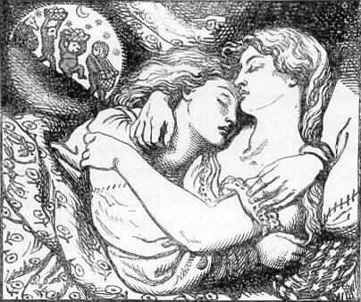
From: Rossetti: Goblin Market

She thought of Jeanie in her grave,
Who should have been a bride;
But who for joys brides hope to have
Fell sick and died.
[…]
Be welcome guest with us,
Cheer you and rest with us.”—
“Thank you,” said Lizzie: “But one waits
At home alone for me:
[…] They began to scratch their pates,
No longer wagging, purring,
But visibly demurring,
Dante Gabriel Rosetti’s illustration for Goblin Market
Grunting and snarling.
One call’d her proud,
Cross-grain’d, uncivil;
Their tones wax’d loud,
Their looks were evil.
[…]
Hug me, kiss me, suck my juices
Squeez’d from goblin fruits for you,
Goblin pulp and goblin dew.
Eat me, drink me, love me;
Laura, make much of me;
For your sake I have braved the glen
And had to do with goblin merchant men.”

From: ‘Clifton and a Lad’s Love’ by John Addington Symonds (1893)

III.

This time it is no dream that stirs
The ancient fever of my brain:
The burning pulses throb again,
The thirst I may not quench recurs.
In vain I tell my beating heart
How poor and worthless were the prize:
The stifled wish within me dies,
But leave an unextinguished smart.
It is not for the love of God
That I have done my soul this wrong;
'Tis not to make my reason strong
Or curb the currents of my blood.
But sloth, and fear of men, and shame
Impose their limit on my bliss:
Else had I laid my lips to his,
And called him by love's dearest name.

From: Michael Field—SAINT SEBASTIAN ANTONELLO DA MESSINA

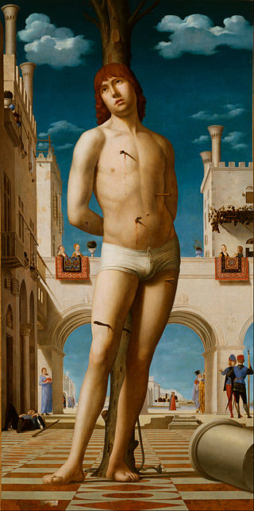

61 Captive, stricken through by darts, yet armed with power
62 That resents the coming on of its last hour,
63 Sound in muscle is the boy,
64 Whom his manhood fills
65 With an acrid joy,
66 Whom its violent pressure thrills.

67 But this force implanted in him must be lost
68 And its natural validity be crossed
69 By a chill, disabling fate;
70 He must stand at peace
71 While his hopes abate,
72 While his youth and vigour cease.

73 At his feet a mighty pillar lies reversed;
74 So the virtue of his sex is shattered, cursed:
75 Here is martyrdom and not
76 In the arrows' sting;
77 This the bitter lot
78 His soul is questioning.

79 He, with body fresh for use, for pleasure fit,
80 With its energies and needs together knit
81 In an able exigence,
82 Must endure the strife,
83 Final and intense,
84 Of necessity with life.

85 Yet throughout this bold rebellion of the saint
86 Noonday's brilliant air has carried no
complaint.
87 Lo, across the solitude
88 Of the storm two white,
89 Little clouds obtrud
90 Storm-accentuating light

From: Michael Field— A PEN-DRAWING OF LEDA
SODOMA
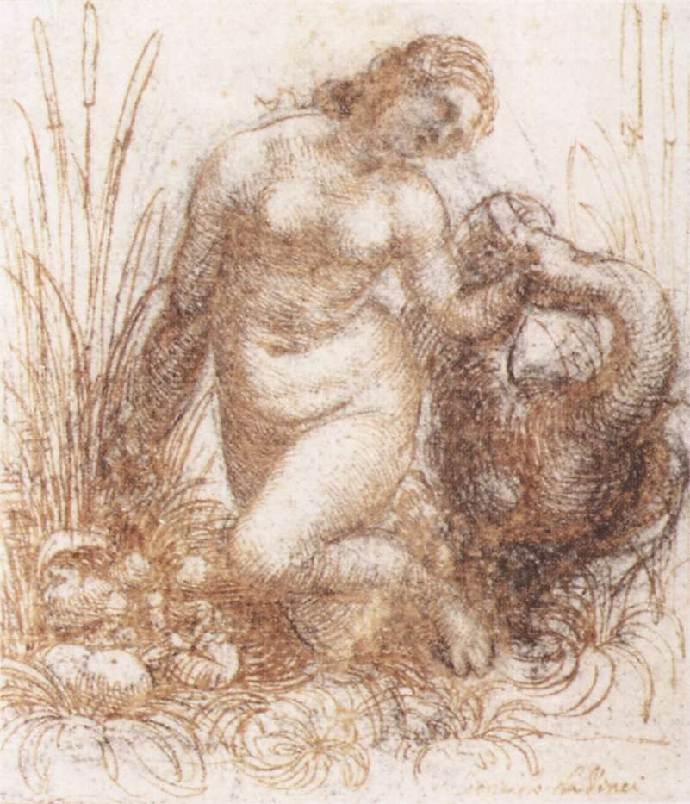

1 'Tis Leda lovely, wild and free,
2 Drawing her gracious Swan down through the grass to see
3 Certain round eggs without a speck:
4 One hand plunged in the reeds and one dinting the downy neck,
5 Although his hectoring bill
6 Gapes toward her tresses,
7 She draws the fondled creature to her will.
8 She joys to bend in the live light
9 Her glistening body toward her love, how much more bright!
10 Though on her breast the sunshine lies
11 And spreads its affluence on the wide curves of her waist and thighs,
12 To her meek, smitten gaze
13 Where her hand presses
14 The Swan's white neck sink Heaven's concentred rays.

From: Michael Field— THE SLEEPING VENUS GIORGIONE

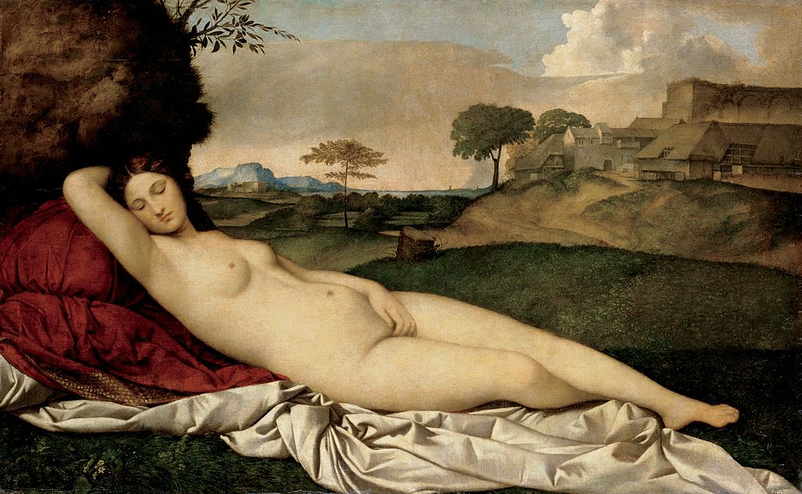
1 Here is Venus by our homes
2 And resting on the verdant swell
3 Of a soft country flanked with mountain domes:
4 She has left her arched shell,
5 Has left the barren wave that foams,
6 Amid earth's fruitful tilths to dwell.
7 Nobly lighted while she sleeps
8 As sward-lands or the corn-field sweeps,
9 Pure as are the things that man
10 Needs for life and using can
11 Never violate nor spot---
12 Thus she slumbers in no grot.
13 But on open ground,
14 With the great hill-sides around.

15 And her body has the curves,
16 The same extensive smoothness seen
17 In yonder breadths of pasture, in the swerves
18 Of the grassy mountain-green
19 That for her propping pillow serves:
20 There is a sympathy between
21 Her and Earth of largest reach,
22 For the sex that forms them each
23 Is a bond, a holiness,
24 That unconsciously must bless
25 And unite them, as they lie
26 Shameless underneath the sky
27 A long, opal cloud
28 Doth in noontide haze enshroud.

29 O'er her head her right arm bends;
30 And from the elbow raised aloft
31 Down to the crossing knees a line descends
32 Unimpeachable and soft
33 As the adjacent slope that ends
34 In chequered plain of hedge and croft.
35 Circular as lovely knolls,
36 Up to which a landscape rolls
37 With desirous sway, each breast
38 Rises from the level chest,
39 One in contour, one in round---
40 Either exquisite, low mound
41 Firm in shape and given
42 To the August warmth of heaven.

43 With bold freedom of incline,
44 With an uttermost repose,
45 From hip to herbage-cushioned foot the line
46 Of her left leg stretching shows
47 Against the turf direct and fine,
48 Dissimilar in grace to those
49 Little bays that in and out
50 By the ankle wind about;
51 Or that shallow bend, the right
52 Curled-up knee has brought to sight
53 Underneath its bossy rise,
54 Where the loveliest shadow lies!
55 Charmed umbrage rests
56 On her neck and by her breasts.

57 Her left arm remains beside
58 The plastic body's lower heaves,
59 Controlled by them, as when a river-side
60 With its sandy margin weaves
61 Deflections in a lenient tide;
62 Her hand the thigh's tense surface leaves,
63 Falling inward. Not even sleep
64 Dare invalidate the deep,
65 Universal pleasure sex
66 Must unto itself annex---
67 Even the stillest sleep; at peace,
68 More profound with rest's increase,
69 She enjoys the good
70 Of delicious womanhood.

71 Cheek and eyebrow touch the fold
72 Of the raised arm that frames her hair,
73 Her braided hair in colour like to old
74 Copper glinting here and there:
75 While through her skin of olive-gold
76 The scarce carnations mount and share
77 Faultlessly the oval space
78 Of her temperate, grave face.
79 Eyelids underneath the day
80 Wrinkle as full buds that stay,
81 Through the tranquil, summer hours,
82 Closed although they might be flowers;
83 The red lips shut in
84 Gracious secrets that begin.

85 On white drapery she sleeps,
86 That fold by fold is stained with shade;
87 Her mantle's ruddy pomegranate in heaps
88 For a cushion she has laid
89 Beneath her; and the glow that steeps
90 Its grain of richer depth is made
91 By an overswelling bank,
92 Tufted with dun grasses rank.
93 From this hillock's outer heaves
94 One small bush defines its leaves
95 Broadly on the sober blue
96 The pale cloud-bank rises to,
97 Whilst it sinks in bland
98 Sunshine on the distant land.

99 Near her resting-place are spread,
100 In deep or greener-lighted brown,
101 Wolds, that half-withered by the heat o'erhead,
102 Press up to a little town
103 Of castle, archway, roof and shed,
104 Then slope in grave continuance down:
105 On their border, in a group,
106 Trees of brooding foliage droop
107 Sidelong; and a single tree
108 Springs with bright simplicity,
109 Central from the sunlit plain.
110 Of a blue no flowers attain,
111 On the fair, vague sky
112 Adamantine summits lie.

113 And her resting is so strong
114 That while we gaze it seems as though
115 She had lain thus the solemn glebes among
116 In the ages far ago
117 And would continue, till the long,
118 Last evening of Earth's summer glow
119 In communion with the sweet
120 Life that ripens at her feet:
121 We can never fear that she
122 From Italian fields will flee,
123 For she does not come from far,
124 She is of the things that are;
125 And she will not pass
126 While the sun strikes on the grass.

